Monitoring, Evaluation and Reporting Framework for Bushfire Management on Public Land

© The State of Victoria Department of Environment, Land, Water & Planning 2015



This work is licensed under a Creative Commons Attribution 3.0 Australia licence. You are free to re-use the work under that licence, on the condition that you credit the State of Victoria as author. The licence does not apply to any images, photographs or branding, including the Victorian Coat of Arms, the Victorian Government logo and the Department of Environment, Land, Water & Planning logo. To view a copy of this licence, visit http://creativecommons.org/licenses/by/3.0/au/deed.en.

Print managed by Impact Digital, Brunswick.

ISBN 978-1-74146-126-8 (print)

ISBN 978-1-74146-127-5 (pdf)

**Accessibility**

If you would like to receive this publication in an alternative format, please telephone the DELWP Customer Service Centre on 136186, email   
customer.service@delwp.vic.gov.au, or via the National Relay Service on 133 677 www.relayservice.com.au.   
This document is also available on the internet at   
www.delwp.vic.gov.au

**Disclaimer**

This publication may be of assistance to you but the State of Victoria and its employees do not guarantee that the publication is without flaw of any kind or is wholly appropriate for your particular purposes and therefore disclaims all liability for any error, loss or other consequence which may arise from you relying on any information in this publication.

Front cover image: Epicormic growth on mixed species eucalypts, taken on Binns Rd North of Walhalla following the 2006/07 Great Divide Fire © Steve Platt

Other photos courtesy of Emma Proctor, Glenn Rudolph, Michelle Ibbett, Natasha Schedvin, Lucas Bluff and Shannon Treloar.

1 Introduction

1.1 The Bushfire Monitoring, Evaluation and Reporting Framework

The Bushfire Monitoring, Evaluation and Reporting (MER) Framework (The MER Framework) guides the Department of Environment, Land, Water & Planning (DELWP) and partner agencies to monitor, evaluate and report on the effectiveness of bushfire management on public land.

Effectiveness is measured against the primary objectives for bushfire management outlined in the Code of Practice for Bushfire Management on Public Land (2012) (the Code):

• To minimise the impact of major bushfires on human life, communities, essential and community infrastructure, industries, the economy and the environment. Human life will be afforded priority over all other considerations.

• To maintain or improve the resilience of natural ecosystems and their ability to deliver services such as biodiversity, water, carbon storage, and forest products.

The MER Framework communicates DELWP’s priorities for MER to stakeholders, staff and partner agencies. MER is a necessary part of bushfire management that enables greater understanding of the effects of bushfires and bushfire management across public land. This helps DELWP to improve their bushfire management strategies and actions over time and more effectively and transparently report on bushfire management outcomes to government and the community.

The MER Framework is consistent with the DELWP Monitoring, Evaluation and Reporting Framework for Land, Water and Biodiversity. It is underpinned by the principles of AS/NZS ISO31000:2009 Risk Management – Principles and Guidelines (ISO31000:2009).

This is the first version of the MER Framework and it is the first document developed for the MER Toolkit. The MER Framework will be implemented through regional MER Plans as the Victorian Bushfire Monitoring Program (VBMP). The VBMP includes all activities undertaken in line with the MER Framework and MER Plans to measure, review and improve the bushfire management strategies within DELWP’s Strategic Bushfire Management Plans. The Code acknowledges bushfire management activities across the Preparedness, Prevention, Fuel Management (including planned burning), Response and Recovery (PPFRR) spectrum. The initial scope of the MER Framework however, is limited to fuel management. This is driven by the Victorian Government’s response to the recommendations of the 2009 Victorian Bushfire Royal Commission (2010) and the current focus of the bushfire planning framework. The MER Framework supports an expanded program of planned burning and aligns with the risk-based approach to bushfire management. The Framework includes monitoring, evaluation and reporting on performance against objectives at activity, management effectiveness and outcome levels.

The MER Framework also only focuses on one component of each of the primary objectives within the Code as a priority, rather than each objective in its entirety. These are risk to life and property, and resilience of biodiversity. They represent two out of the six emergency impact categories presented in the PIPE$S Framework as detailed in the Code. As the planning framework expands to incorporate the full PIPE$S spectrum and PPFRR so will the MER Framework.

DELWP is also developing a Performance Management Framework to assess compliance with operational standards for PPFRR. This will be incorporated into the evaluation of outcomes as required by the MER Framework. Figure 1 shows the relationship between the MER Framework and the Performance Management Framework and how they will support each other.

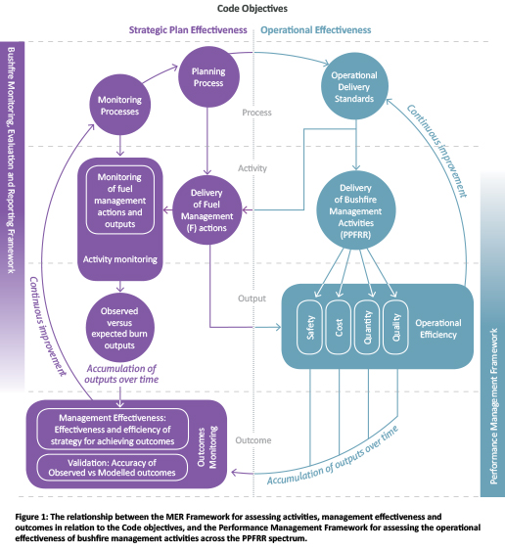

1.2 Policy context

Bushfire management in Victoria aims to reduce the impact of fires on communities and the environment whilst acknowledging that the risk of bushfire cannot be completely eliminated. The Code and the Victorian government’s response to the recommendations made in the Victorian Bushfires Royal Commission (2010) provide the context for developing the MER Framework.

The Code states that DELWP will undertake bushfire management planning within a risk-based framework to better manage fire in the landscape. To measure the effectiveness of bushfire management against the primary objectives the Code specifies that DELWP will prepare a framework for monitoring, evaluating and reporting on its bushfire management program. The Victorian Bushfires Royal Commission (2010) also made two recommendations that specifically relate to improving DELWP’s monitoring, evaluation and reporting:

• Recommendation 57: that DELWP report annually on planned burning outcomes in a manner that meets public accountability objectives, including publishing details of targets, area burnt, funds expended on the program   
and impacts on biodiversity.

• Recommendation 58: that DELWP significantly upgrade its program of long term data collection to monitor and model the effects of its planned burning programs and   
of bushfires on biodiversity in Victoria.

The MER Framework supports DELWP to meets its MER requirements under the Code and to address Recommendations 57 and 58.

1.3 Bushfire Management Planning in Victoria

1.3.1 Bushfire management planning

In Victoria, bushfire management planning occurs at three levels (Figure 2). Planning uses a risk-based approach aligned to the ISO31000:2009 guidelines. These guidelines define risk as the effect of uncertainty on objectives and accept, along with DELWP’s risk-based planning approach, that risks such as bushfires can never be completely eliminated. However, they can be managed, and the impacts minimised with a high-quality risk management approach.

The risk assessment process aims to determine the likelihood and consequence of a major bushfire impacting key values by using models to predict and project expected outcomes of bushfire management strategies to protect those values. These models have been largely built through research and expert knowledge. They provide the best available science to develop long-term management strategies as well as a basis for validating our understanding of how the systems we manage work through effective MER.

The landscape strategies are a means for measuring performance against the objectives of the Code. They have been designed around the important values identified within the landscape that represent the different components of the Code objectives. They provide a basis for targeting monitoring and evaluation to measure the success of those strategies for achieving the Code objectives. The primary objectives are not equal in that human life takes priority over all other considerations. When setting the landscape objectives, trade-offs will be made between the components of the Code objectives. These trade-offs are identified through the risk assessment process.

The long-term strategies developed through the risk-based approach are described in Strategic Bushfire Management Plans (SBMPs) being developed for Victoria using the steps outlined in Figure 3. The MER Framework sets the priorities and scope to develop the MER section of the SBMPs. While the plans themselves are long-term plans, monitoring and review will occur frequently during the life of the plans so they can be continually improved as new knowledge and information become available.

To support continuous improvement, MER is required at each level of planning. MER is critical for identifying and reducing uncertainty over time. It provides a consistent framework to work from and supports continuous improvement.

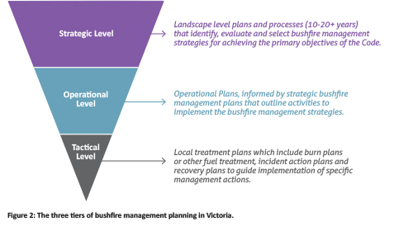

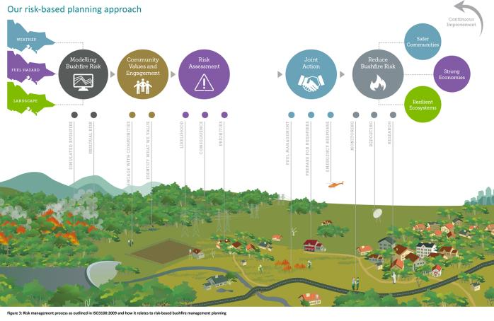

1.3.2 The role of monitoring, evaluation   
and reporting in bushfire management

Monitoring, evaluation and reporting allows land managers to quantify the success of their bushfire management actions and strategies for achieving objectives. This in turn supports transparent reporting to government and the community on the outcomes of bushfire management.

MER supports continuous improvement through value based and evidence informed decision-making. It is a key component of adaptive management and a more outcomes focused approach to bushfire management. Adaptive management is a framework for managing natural resources (Figure 4). Also referred to as ‘learning by doing’, it provides a framework where knowledge gaps are identified as part of the strategy and planning phase and addressed through targeted monitoring and evaluation. New knowledge is then communicated through reporting and used to inform future decision making.

By applying this ‘learning by doing’ approach to bushfire management planning through adopting ISO31000:2009 DELWP recognise the importance of MER to learn from and improve their management over time.

The risk-based approach relies on using predictive models which are based on a combination of real data and expert opinion. As such they have limitations that can affect reliability. MER plays an important role in validating and testing the accuracy of these models for predicting the outcomes of different management strategies. The priority components being considered by the MER Framework; risk to life and property and resilience of biodiversity, therefore provide a solid basis on which to focus MER as a way to test the assumptions of the models from which the strategies have been developed. Data collected through monitoring will be used to update and improve these models over time. Monitoring will also measure if the bushfire management strategies have achieved their desired outcomes and help identify new questions that need to be addressed through research.

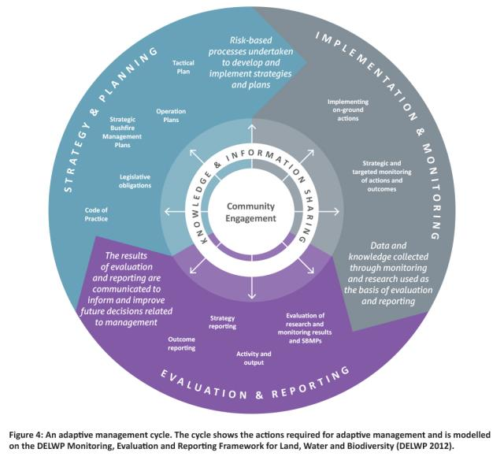

Since 2006, DELWP has invested in developing fire and biodiversity monitoring protocols and collecting monitoring data. Major monitoring programs include:

• pre and post fire flora monitoring (since 2006) on the effects of planned burning on flora species to improve predictions about their response to fire;

• landscape fire and environmental monitoring (since 2009) on the effects of planned burning on flora, fauna, habitat, fuel hazard and fire severity to better quantify the outcomes of landscape mosaic burning;

• hawkeye monitoring and modelling (2010-2014) on the long-term effects of planned burning and bushfires on biodiversity on public land in Victoria; and

• planned burn severity mapping (since 2007) on trial and development of methods for mapping the planned burn extent and severity.

Aligning these programs under the MER Framework will lend to a more efficient and effective approach to MER in meeting our current policy and operational needs under the Victorian Bushfire Monitoring Program.

1.4 MER Toolkit

The MER Framework sets the long-term scope and purpose to guide MER activities for the bushfire management program on public land. It is the first in a suite of MER documents that form the MER Toolkit to support the development and implementation of Bushfire Risk Landscape MER Plans and the Victorian Bushfire Monitoring Program (Figure 5).

The MER Toolkit consists of monitoring, evaluation and reporting Standard Operating Procedures (SOPs), work instructions and templates. These documents contain detailed information to guide Bushfire Risk Landscape (BRL) teams to develop landscape level MER Plans. An MER Plan is used to communicate the MER priorities in a BRL. It identifies the monitoring, evaluation and reporting activities to be implemented so that the success of the fuel management strategies can be measured and communicated and the models used to inform decision making can be improved.

The MER Toolkit contains a template identifying what an MER Plan should include and guidance to support the development of each section in the template. These include guidance on how to:

• develop monitoring questions;

• evaluate data to review and refine strategies and incorporate new knowledge into management decisions; and

• report against the primary objectives in the Code.

A set of SOPs for data collection, data management, evaluation and reporting will also support the BRL teams to develop and implement their MER Plans.

The MER Framework and the MER Toolkit will evolve over time with continuous improvement and will be reviewed more frequently in the first years after the initial roll-out of the Bushfire MER Program.

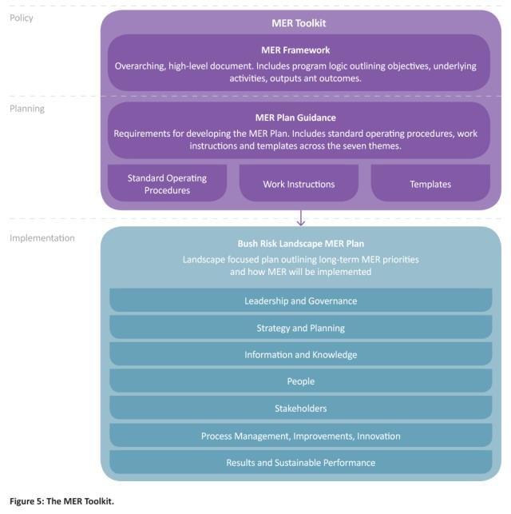

2 Key elements of the MER Framework

The MER Framework is underpinned by a set of principles and built around a group of key elements which establishes the framework for the VBMP. These elements are Program Logic, Models and Assumptions, Key Evaluation Questions, Monitoring, Evaluation, Reporting and Continuous Improvement and Adaptive Management and are described below.

2.1 Principles of MER

The principles of MER support the improvement of bushfire management and ensure the quality of the VBMP. The first five are adapted from the Code’s principles for bushfire management on public land, ISO31000:2009’s principles of risk management and the principles from DELWP’s Monitoring, Evaluation and Reporting Framework for Land, Water and Biodiversity. The last two are principles developed specifically for the VBMP.

• Public accountability - land managers should be accountable to government and the community for performing bushfire management activities in accordance with policy and by reporting on their performance.

• Integration of learning and knowledge - fuel management activities must be part of a risk management approach to address knowledge gaps and make decisions based on best available knowledge. Outcomes must be monitored to assess the achievement of management objectives, test assumptions and improve understanding of the system at different spatial and temporal scales. Establishing effective monitoring methods and feedback loops for reducing uncertainty and improving models is essential for continuous improvement.

• Integrated management - decisions are not made in isolation as any system is inter-connected with other systems. MER must acknowledge this and be flexible to accommodate the interconnection.

• Collaboration - meaningful and effective communication amongst all members of the community with shared responsibilities and constructive partnerships to better manage bushfire on public land. MER contributes to this collaboration by providing data to inform evidence-based discussions.

• Scalability - ecological and management processes operate on a range of temporal and spatial scales. MER must acknowledge this range and be flexible to accommodate them.

• Consistency - a state-wide approach is required for monitoring, evaluating and reporting that follows an agreed set of standards and methods to enable a more meaningful interpretation of monitoring data collected from across the state.

• Quality and excellence - data collected as part of monitoring activities must address defined monitoring questions and be collected using tested procedures and methods based on the best available science.

2.2 The Program Logic

The Program Logic describes the relationship between activities and outcomes at different timeframes. It allows for assumptions to be documented, which can help to target effective monitoring and research, and provides a basis for change to be evaluated against.

Program Logic is used to visually represent the inter-relationship between elements. An example Program Logic using fuel management is shown in Figure 6.

An important component of a Program Logic is identifying assumptions that link the elements. These assumptions are often captured in models that link the expected cause-effect relationships between activities and outcomes. Program Logics are important because they articulate management objectives and the critical activities, outputs and outcomes required to meet the objectives. The assumptions expressed as Key Evaluation Questions, involve uncertainties that provide a basis to target monitoring and evaluation.

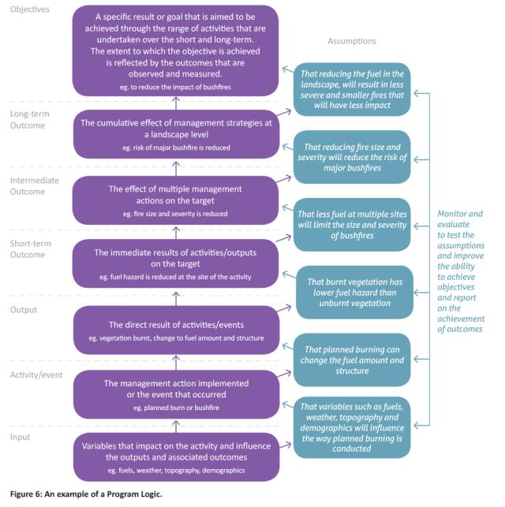

2.3 Models and Assumptions

The Program Logic is the visual representation of the models and assumptions underpinning a program while the Key Evaluation Questions (KEQs) are the questions used to evaluate the assumptions and improve those models.

A conceptual model of how the system works is an important component of an effective MER approach. Defining the model at the beginning forces ideas to be formulated into a theory of how a system works, and identify the critical knowledge gaps. Models and assumptions guide predictions about how a system might behave under different management options and supports the development of targeted questions to reduce knowledge gaps. These questions and predictions can then be validated through monitoring and evaluation.

2.4 Key Evaluation Questions

Key Evaluation Questions (KEQs) are carefully focused questions used to guide evaluation activities. They provide the basis for data collection to assess a program’s effectiveness for achieving objectives and validate assumptions that underpin the Program Logic.

KEQs address assumptions underpinning the outcomes in the Program Logic. Their evaluation provides direction for subsequent planning. They are not the same as monitoring questions, which are more targeted and provide a basis for conducting surveys as part of monitoring within the MER Framework. The information collected through monitoring however, will contribute to answering the KEQs.

2.5 Monitoring

Monitoring is focused on measuring outputs and outcomes within the Program Logic and testing underlying assumptions. Focused monitoring questions are derived from the KEQs to implement monitoring.

Monitoring is “the collection and analysis of repeated observations or measurements to evaluate changes in condition and progress toward meeting a management objective” (Elzinga et al. 2001). It exists on a continuum with research.

A monitoring program should have a clear and relevant purpose, should answer specific management questions or provide evidence to demonstrate the effectiveness of a specific management action or set of actions.

Key features of effective monitoring programs adapted from Lindenmayer and Likens (2010) are:

• questions that set measurable objectives against which progress can be measured;

• the use of conceptual models to guide the selection of appropriate metrics;

• robust study design;

• well-developed partnerships between practitioners, scientists and policy makers;

• frequent use of data; and

• maintenance of data quality and consistency of field methods.

Data gathered from long-term monitoring is valuable for developing baselines against which changes to ecosystem structure and function can be evaluated following natural or experimental disturbances. It can be used to identify unexplained ecological outcomes which can form the basis for new research questions. And most importantly it can be used to test and improve conceptual and empirical models that provide improved knowledge to support decision-making.

Figure 7 depicts the four types of monitoring recognised by this Framework and their relationship to research and planning. The four types of monitoring are:

• Condition Monitoring - Passive monitoring that focuses on identifying trends rather than identifying or understanding the mechanisms influencing change in a system.

• Activity Monitoring - Active monitoring that focuses on monitoring the delivery of management actions and the results of those actions.

• Management Effectiveness Monitoring - Active monitoring that focuses on assessing the performance of management strategies against objectives. It includes repeat observations of fuel management activities and their outcomes over space and time.

• Validation Monitoring - Monitoring guided by a conceptual model of a system that provides a basis to make predictions for testing, as part of monitoring. This includes repeat observations with replication and controls over space and time.

Monitoring and research are both necessary for an effective bushfire management program. They both inform and are informed by each other. Monitoring within this MER Framework, enables DELWP to evaluate the effectiveness of its fuel management strategies and validate the assumptions of the models on which those strategies are developed. While the monitoring is likely to identify statistical and ecological trends, where casual relationships need to be established monitoring needs to be supported by research.

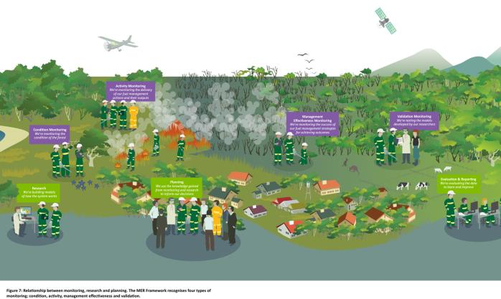

Limitations exist in monitoring and caution is required when interpreting data. Measurements that are not considered to be monitoring include:

• Inventory, which is measuring of a resource to determine location or condition at a point-in-time, and may be repeated at these points or one off. An inventory may need to occur before monitoring commences to establish baseline conditions.

• Research, where studies are designed to determine the cause of an occurrence, event or trend. These questions may need answering before effective monitoring can occur as they form the basis of management actions and models tested by monitoring. Research may also be required if deviations are greater than expected or modelled.

Research that aligns with the Bushfire Science Strategy should be initiated where monitoring identifies new knowledge gaps, or where not knowing the specific cause or effect relationship presents a priority risk to meeting set objectives. In this way, the MER Framework supports making smart investment decisions about which questions to address through research.

2.6 Evaluation

Evaluation is the process of collating, synthesising and analysing information. Evaluation considers what was or wasn’t achieved against each of the KEQs, tests assumptions and considers alternative strategies that might improve the future performance of the activity or program.

Evaluation can create new knowledge and identifies critical knowledge gaps. It ensures continuous improvement and utilises all information available, such as monitoring data, reports, assumptions and external influences. Evaluation includes benchmarking data from other areas and industries to assist in assessing the effectiveness of the bushfire management program. It is also used to track progress against strategies so as to improve their effectiveness.

The KEQs should drive the type of evaluation conducted which will determine the type of information required. The evaluation must address the processes underpinning the bushfire management program and the outcomes achieved through the program, as assessed against the Program Logic.

The evaluation recognised by the MER Framework falls into three main categories:

• evaluation of the results of the bushfire management strategies (outcomes evaluation);

• evaluation of the processes underpinning the risk-based approach (process evaluation), and;

• evaluation of the MER program and its ability to measure outcomes and process (program evaluation).

2.7 Reporting

Reporting is the process of formally communicating information. Monitoring and evaluation inform reports to provide information on activities, outputs and outcomes. The VBMP and this MER Framework supports DELWP to move from activity and output focused reporting to meaningful reporting on bushfire management outcomes.

The MER Framework recognises reporting as stated in the Code to include activity and output reporting, strategy reporting and objective reporting. Reporting on the bushfire management program is the exchange of knowledge and information to meet the MER principles for public accountability and to communicate outcomes and challenges to the government, community and agencies. Reports must address the different monitoring and evaluation undertaken, and be prepared at appropriate timeframes and levels.

2.8 Continuous improvement and adaptive management

Monitoring, evaluation and reporting is viewed as a continuous cycle of participation rather than as a single event. MER promotes learning that enables improvement in program design and achievement of desired outcomes.

Identifying monitoring, evaluation and reporting activities that will lead to improving the program and achieving outcomes over time is a critical component of the MER Framework. Adopting the risk standard allows monitoring and review to be embedded in the planning process rather than seen as an extra activity. This promotes a culture of reflection and improvement. While the desired outcomes may take time to achieve, it is important to review and revise them and the processes used to determine them, as new knowledge becomes available through monitoring and evaluation.

3 Applying the MER Framework

To support consistent implementation of the VBMP the next section outlines how the elements of the MER Framework are to be used in practice to address the priorities for MER; measuring the success of fuel management for reducing the risk of bushfire to life and property and maintaining resilience of biodiversity

3.1 The Bushfire MER Program Logic

The knowledge gained through monitoring, evaluation and reporting informs and improves the approach to bushfire management. The Program Logic in this MER Framework focuses on the fuel management activities of planned burning, slashing and construction of strategic fuel breaks, to achieve the primary objectives within the Code. It identifies the activities and associated outputs from fuel management and describes desired outcomes at short, intermediate and long-term time scales for the primary objectives.

The Program Logic in Figure 8 identifies fuel management as the focus for this MER Framework and how our management impacts on the achievement of the Code objectives. The coloured boxes represent human life and property and ecosystem resilience as defined by the Code. The grey boxes represent the other aspects of the PPFRR spectrum outlined in the Code that are currently out of the scope of this MER Framework. Some of these are being addressed by other projects and will be incorporated as the planning framework expands to incorporate the broader PPRR spectrum. The light green and blue boxes represent other components of the primary objectives that may be incorporated into the MER Framework over time.

The current working version of the Program Logic for the VBMP is described in Appendix 1. This Program Logic describes desired outcomes for bushfire management that DELWP aim to achieve through fuel management. Other factors however, such as fuel on private land, suppression efforts, drought and predation will all contribute to achieving the outcomes identified. While focusing on fuel management is a limitation of the MER Framework this targeted approach is also valid as it will support DELWP to quantify the role of fuel management in achieving the outcomes. DELWP will also rely on working with partner agencies and the community to fully achieve these outcomes.

The Program Logic will be maintained on the DELWP website as a living document that can be updated as the priorities for MER change and expand in alignment with the planning framework.

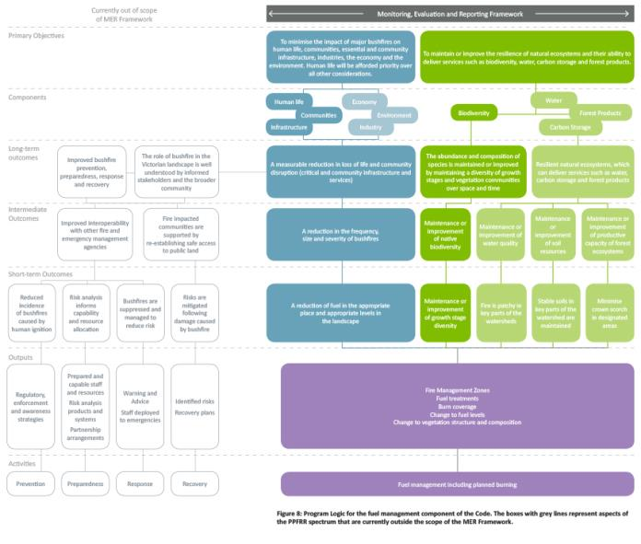

3.2 Models and Assumptions

The assumptions and models related to life and property and ecosystem resilience are part of the Program Logic. They will be tested over time by analysing and evaluating the monitoring data to validate their contribution towards achieving the desired outcomes and Code objectives.

DELWP have developed a number of decision support tools that represent conceptual and empirical models of how fuel and biodiversity change in response to bushfires and fuel management. DELWP uses these models to predict the outcomes of their fuel management strategies for achieving the primary objectives. This approach provides a basis against which to test the assumptions of those models through monitoring. The models and assumptions identified below are those that are the highest priority and that can be addressed and improved by DELWP through the VBMP. The assumptions are different for each objective of the Code.

3.2.1 Life and Property Models and Assumptions

DELWP uses a model called PHOENIX RAPIDFIRE which characterizes fire in a spatially and temporally explicit way. Phoenix uses modelled understanding of fuel accumulation for broad fuel types, time since fire and fire behaviour to model where fires will start, spread and impact with assets in the landscape. This enables analysis of fire-spread paths, origins and downstream effects of fuel reduction treatments.

The Victorian Bushfire Risk Profiles Report outlines in more detail how PHOENIX RAPIDFIRE is being used to support strategic bushfire management planning as well as a full list of the assumptions and limitations of the approach. The critical assumptions that are being targeted through this MER Framework for life and property are:

Assumptions

• Reducing the size and severity of bushfires will minimise their impact on life and property.

• Reducing fuel hazard in the right places will reduce the risk of major bushfires.

• Reducing fuel hazard through planned burning will reduce the size and severity of bushfires.

• Planned burning can positively change the fuel structure and amount.

• Fuel accumulation is an important input into predicting bushfire risk.

• Fire severity and extent is an important input into predicting bushfire risk.

• Phoenix is a statistically robust scientific model for characterising bushfire hazard across the landscape.

• Benchmark scenarios e.g. Ash Wednesday and Black Saturday conditions, are appropriate for modelling bushfire risk.

• Our current fuel classification system adequately describes fuel hazard.

DELWP’s fuel management program is largely restricted to public land, however the Victorian Bushfire Risk Profiles Report demonstrates that there are significant amounts of fuel and risk on private land in some parts of the landscape. The inherent assumption of the fuel management program is that reducing fuel on public land will reduce the level of risk. The level of risk remaining in the landscape is referred to as residual risk. The level of acceptable residual risk is determined though the Strategic Bushfire Management Planning process. Monitoring and evaluation can help validate the predictions made by Phoenix to determine if the fuel management strategies being implemented are reducing fuel to the desired level and whether this in turn reduces the size, severity and impact of bushfires on communities.

3.2.2 Ecosystem Resilience Models and Assumptions

DELWP has defined ecosystem resilience in the context of bushfire management planning as an ecosystem’s capacity to absorb natural and management imposed disturbance but still retain its basic structure – in terms of species abundance and composition – function and identity over space and time, and has identified three metrics for measuring and reporting on ecosystem resilience:

• Tolerable Fire Interval

• Vegetation Growth Stage Structure

• Geometric Mean Abundance of species in a community as a means of determining the optimal growth stage distribution and departure from it

The DELWP Policy Position – Measuring ecosystem resilience in strategic bushfire management planning provides more detail on each of the metrics of resilience.

Models have been developed for each metric that support staff to use these measures to make bushfire management planning decisions. These include species distribution models, species response curves and growth stage accumulation models. Much of the data underpinning these models relies on expert opinion and data limited to more frequently assessed species. The critical assumptions being tested through this MER Framework for ecosystem resilience are:

Assumptions

• The three proposed metrics of ecosystem resilience and the conceptual models that underpin them, adequately describe ecosystem function and resilience.

• EVCs and EVDs adequately classify our ecosystems and their response to fire.

• The optimal growth stage distribution defined by maximising GMA will promote the resilience of biodiversity.

• Minimising the amount of landscape sitting outside Tolerable Fire Interval (TFI) will result in a more resilient landscape.

• Key Fire Response Species are a suitable surrogate for evaluating the effect of the fire regime on biodiversity.

• Key habitat attributes can be used as a surrogate for fauna distribution and abundance.

• The growth stages adequately describe changes to habitat structure and function.

• Appropriate fire regimes will improve or maintain biodiversity.

Ecological systems are complex and respond to many factors, not just bushfire management. It is important to recognise this as a limitation of the bushfire MER Framework. The MER Framework will seek to quantify the role of fuel management in maintaining resilience of biodiversity but will need to remain cognisant of other factors such as predation, competition and other disturbances that may also be influencing the system. Some of these other factors are being explored through research projects under the Bushfire Science Strategy and may be incorporated into the MER Framework over time.

3.2.3 Process Assumptions

The MER Framework will also support DELWP to evaluate the effectiveness of the risk-based approach and make improvements to it over time. The critical assumption being targeted though this MER Framework in relation to the risk-based approach is:

Strategic bushfire management planning process

• The risk-based approach is the most effective method for identifying priority risks and provides a suitable framework within which to determine treatment options.

3.3 Key Evaluation Questions

The Key Evaluation Questions in this MER Framework are overarching questions that must be used to evaluate the desired outcomes identified in the Program Logic and the critical assumptions identified above. A set of KEQs to guide evaluation of the processes underpinning the risk-based approach have also been developed. The focus for monitoring and evaluation activities must be to address the KEQs.

The KEQs (shown in Appendix 2) have been developed to support DELWP to address the outcomes identified in the Program Logic in Appendix 1. They have been developed to guide evaluation of the impact and effectiveness of the management strategies and to improve the models and assumptions underpinning them.

As our knowledge improves through monitoring and evaluation and our bushfire management outcomes are reviewed and revised, DELWP will update the KEQs to reflect these changes. To enable this flexibility, the current KEQs will also be maintained as a separate ‘living’ document on the DELWP website so they be updated as required. This reflects DELWP’s commitment to continuous improvement.

3.4 Monitoring

Monitoring activities must address the KEQs identified in the MER Framework. As the KEQs are broad questions that can be addressed in a number of ways, developing a monitoring question will help focus where monitoring effort should be directed and what type of data will be collected.

These monitoring questions may vary between locations depending on local priorities but should all relate back to the KEQs identified in the MER Framework. Monitoring seeks to address the questions identified in the KEQs by collecting data about variables that represent those metrics on the ground. These are referred to as measures. The method is the procedure used to collect the information about those measures.

The MER Toolkit provides more detail on developing monitoring questions specific to individual landscapes and choosing appropriate measures and methods to assess them. The MER Toolkit also contains methods for assessing the priority measures required to evaluate the metrics and outcomes in the Program Logic (see Appendix 1).

Four types of monitoring are recognised by this MER Framework. These are listed in priority order for addressing the primary objectives:

Management effectiveness monitoring

• Repeated monitoring across space and time to monitor the effectiveness of fuel management strategies to achieve landscape objectives. Monitoring must target a range of fuel treatment areas and non fuel treatment areas (controls), and measure changes to fuels and biodiversity to address the KEQs as a priority.

Validation monitoring

• Repeated monitoring across space and time to improve or validate the data underpinning existing predictive models, such as fuel accumulation curves and species response curves. Monitoring should target fuel types, vegetation types or faunal communities where an existing model describes the response to fire, but where uncertainty about the data used to develop that model is high.

Activity monitoring

• Short-term and targeted monitoring of specific fuel management activities to determine if objectives have been met. Monitoring must target activities that represent the range of management actions being implemented. Some measures such as fuel and habitat require monitoring both pre and post burn to measure the immediate change while other measures such as severity are only measured post-burn. Any repeat monitoring at the same site over time will contribute to management effectiveness monitoring. Data collected through activity monitoring will also contribute to evaluating the effectiveness of fuel management strategies for achieving the landscape objectives.

Condition monitoring

• Repeated monitoring at defined time intervals rather than in response to a management action. This monitoring provides a baseline against which changes in condition can be measured. It includes the state-wide fuel moisture monitoring network and the Victorian Forest Monitoring program.

Prioritisation of monitoring effort should be targeted to understanding the effects and effectiveness of management strategies in landscapes where bushfires have the highest potential to impact communities; ecosystems that are most vulnerable to the effects of major bushfires and inappropriate fire regimes, now and over time; and areas that will provide the opportunity to gain the greatest knowledge that can be transferred to other areas.

As per the Code, monitoring will also focus on measuring the effectiveness of different burning strategies which is reflected in the KEQs. A critical input into measuring effectiveness is through mapping the extent and severity of bushfires and planned burns.

Each type of monitoring should exist in some form in each BRL, however resources allocated across the four monitoring types may not be the same for each landscape area. Allocating resources must be based on the ability of the monitoring type to meet the requirements specified in the Code and the landscape objectives arising from the SBMP and then set in the MER Plan. It is impossible to monitor the landscape in its entirety. Monitoring must therefore be targeted and seek to monitor a representative sample of the landscape.

Allocating resources in each landscape must be guided by the strategies being implemented and target the areas of greatest risk as identified by the risk assessment. The MER Toolkit provides greater detail on making investment decisions based on a consistent set of criteria.

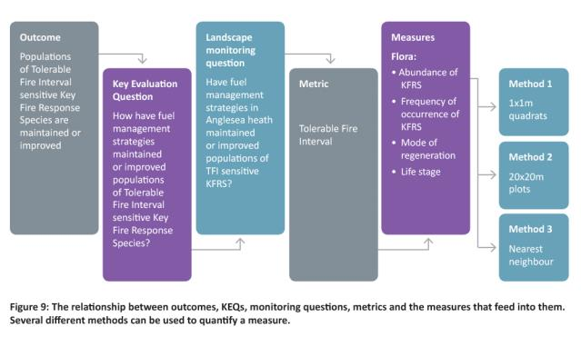

3.5 Evaluation

Evaluation assesses policies, programs and projects against the Code’s primary objectives. It is driven by the KEQs and aims to identify new knowledge and quantify knowledge gaps.

Information being evaluated as part of this MER Framework will mostly come through monitoring. Where possible however, data collected through research should also be included in the evaluation. The type of evaluation undertaken depends on the KEQ being addressed.

Under this MER Framework, process and outcome evaluation will be led by the BRL teams. Evaluation of the VBMP will be coordinated centrally to determine its efficiency and effectiveness for addressing the Code objectives. The results of process and outcome evaluation must inform bushfire management planning, while the results of the program evaluation must inform the shifting of priorities, allocation of resources for future monitoring and identification of areas requiring research. Evaluation is vital for identifying new knowledge and priority knowledge gaps. Incorporating the outcomes of the evaluation into decision making is important in improving the program over time.

The MER Toolkit will provide guidance to BRL teams for identifying their process and outcome evaluation requirements, and reflecting this in their MER Plans.

3.5.1 Outcomes evaluation

The main focus for evaluation for this MER Framework is outcomes evaluation. The KEQs guide the focus for the evaluation and identify the type of monitoring data that will predominantly be used to evaluate the KEQ. Some examples of questions to guide outcomes evaluation are:

Condition evaluation

• What was observed? Was there a positive, negative or no shift trend observed?

Activity evaluation

• Did the outputs of the activities meet the objectives? Were the outputs observed, the same as those predicted? Evaluation should address the Impact KEQs.

Management effectiveness evaluation

• What were the outcomes of the management strategies? Did they meet the objectives? And if not, why didn’t they? Evaluation should address the Effectiveness KEQs.

Model evaluation

• Did the observed outcomes match those predicted by the models? How has monitoring and research data been used to refine and improve the models? Evaluation should address the Improvement KEQs.

These evaluations will mainly be undertaken internally at the BRL level, with the results aggregated at a state level for reporting and improvement purposes. External statistical assistance may be needed to support BRL teams to evaluate the effectiveness of bushfire management strategies and models but the KEQs must drive the evaluation. Outcomes evaluation should occur annually to ensure new information is continually incorporated, but the questions being addressed will be driven by the timeframes identified for each KEQ. This is because some KEQs operate over longer time frames and will be unable to be addressed on an annual basis.

3.5.2 Process evaluation

Evaluating the processes underpinning the risk-based approach as well as the desired outcomes is critical to supporting continuous improvement. This is because outcomes are the product of the processes used and any uncertainty in the processes will result in uncertainty around the outcomes. As discussed in Section 1, the risk-based approach identifies the steps used to develop bushfire management strategies for the landscape (see Figure 3).

BRL teams must undertake process evaluation annually to incorporate new information collected through monitoring and research into the planning process. Figure 10 identifies the elements to be evaluated for each step of the risk-based approach. The KEQs in Appendix 2 guide the evaluation so that improvements can be made to the processes over time.

3.5.3 Program evaluation

The effectiveness and efficiency of the Bushfire MER Program for measuring DELWP’s performance against the primary objectives will be evaluated at the state-level. Working groups will drive this type of evaluation and an external independent party will undertake the main part of the evaluation.

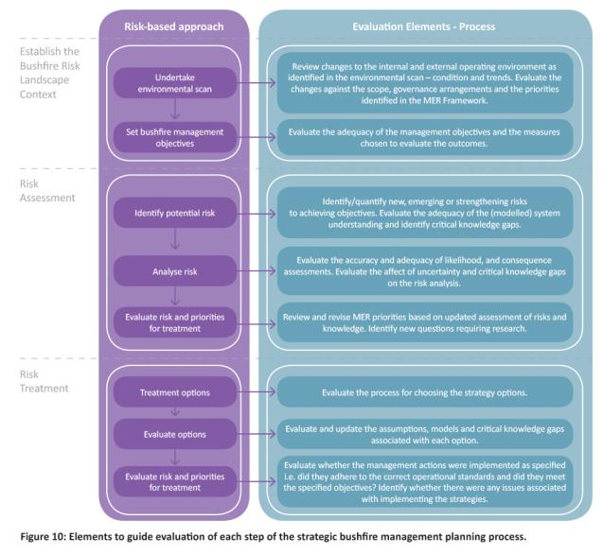

3.6 Reporting

The Code sets the minimum reporting requirements for this MER Framework.

Three types of reports and the timeframes in which they are to be produced have been identified.

Activity and output reporting: annually

• Outlines the achievements of strategies and objectives, information gained from monitoring and evaluation activities, and how well bushfire management actions and strategies are achieving the two primary objectives for bushfire management on public land. An example of this is DELWP’s Fuel Management Report.

Strategy reporting: at least every five years

• Focuses on the effectiveness of bushfire management strategies for achieving bushfire management objectives.

Outcome reporting: at least every 10 years

• Focuses on the achievement of outcomes for the management of bushfire management on public land identified to achieve the Code objectives.

Reporting allows for transparently sharing knowledge on bushfire management activities, outputs and outcomes. Sharing knowledge supports DELWP to learn and improve the approach to bushfire management planning and in turn, supports improved bushfire management outcomes. It is important, therefore, for reporting to occur outside of the regular reporting timeframes if:

• it has become clear that the chosen strategy cannot be implemented, possibly due to lack of resourcing or lack of knowledge;

• there has been a major event such as a bushfire, that requires strategies to be reviewed and updated to incorporate the changes to the landscape; or

• there has been a significant increase in knowledge or science underpinning the models.

DELWP will aim to continually learn from and improve its practices. It acknowledges that a range of parties that include the government, community, interest groups, other agencies and land managers, are interested in this too.

3.7 Continuous improvement and adaptive management

The MER Framework supports DELWP to measure the effectiveness of fuel management activities for reducing risk to life and property, and maintaining or improving ecosystem resilience, as well as evaluate the effectiveness of the risk-based approach. This enables DELWP to continually improve and adapt bushfire management practices as part of the adaptive management cycle.

Knowledge gained through monitoring and evaluation of bushfire management outcomes must feed back into future planning to determine if the fuel management strategies are still effective or need to be updated. This ensures a cycle of adaptive management where improvements are made, especially when activities are no longer effective. Outcomes may also need to change as they may have been achieved, may be unable to be achieved or no longer represent the desired outcome. These changes will occur as part of the planning process.

New knowledge will also reduce or change knowledge gaps. This may have implications for the assumptions underpinning the Program Logic and may require a change to both the Program Logic and KEQs to reflect where the focus for MER activities should be directed. New knowledge gaps are also likely to identify areas requiring further research.

Figure 11 shows how MER supports evidenced based changes to the program and identifies the need for new research. The MER Toolkit and the BRL MER Plans will contain more specific detail to guide the final stages of the adaptive management cycle.

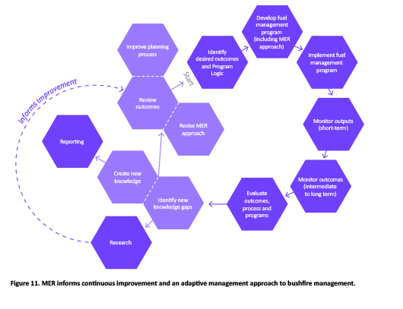

4 Data management

Effective data management is essential for supporting and delivering the evaluation and reporting requirements of the MER Framework.

Data management supports collection, curation, storage, analysis and accessibility to the data collected through monitoring and research. As part of the MER program, a data management theme has been identified and is being developed in parallel with the realignment of the VBMP. This includes developing guidance on the collection, handling and usage of data as part of the MER Toolkit. A system to store the data and support consistent evaluation and reporting is also under development.

5 Capability

Delivering this MER Framework will rely on having the right capabilities to support the requirements outlined in the MER Framework and in the MER Toolkit.

The BRL MER Plans will identify specific capabilities required for implementation and who will perform them. Some of these include data collection and curation; GIS and spatial analysis; analytical and evaluation skills; training; and knowledge translation.

The MER Plan will identify whether the capability requirements will be met by using existing internal skill sets, investing in training to skill up internal staff or by seeking external support to deliver specific components.

6 Quality assurance

Quality assurance is central to ensuring that the effectiveness and efficiency of the Bushfire MER program is measured accurately.

Regularly reviewing, learning and adapting processes and procedures result in continuous improvement. It is important to review whether existing processes and procedures are being adhered to and where they are not, assessing why this is the case. Monitoring data and evaluation reports will highlight what is and is not working, and changes to program direction can be made based on reflecting on these results and reports.

The MER Toolkit outlines tools to support a structured approach to continuous improvement. Implementing the Bushfire Science Strategy 2013-17 will also inform quality assurance by enabling the delivery of research evidence that informs monitoring actions. It will help develop a research program that responds and prioritises research of high priority issues and ensures research is shared with all stakeholders. Quality assurance and continuous improvement of KEQs will occur as part of the program evaluation.

7 References

Department of Sustainability and Environment (2012) Code of Practice for Bushfire Management on Public Land, Department of Sustainability and Environment, East Melbourne, Victoria, Australia.

Elzinga, C.L., Salzer, D.W., Willoughby, J.W. and Gibbs, J.P. (2001) Monitoring plant and animal populations, Blackwell Science Inc. Massachusetts, USA.

Lindenmayer, D. B. and Likens, G. E. (2010) ‘The science and application of ecological monitoring’, Biological Conservation, 143, pp. 1317-1328.

Lucas, C., Hennessy, K., Mills and Bathols, J. (2007) Bushfire weather in southeast Australia: recent trends and projected climate change impacts, Consultancy report prepared for the Climate Institute of Australia, Bushfire CRC and Australian Bureau of Meteorology, Melbourne, Victoria.

Victorian Bushfires Royal Commission (2010) 2009 Victorian Bushfires Royal Commission Final Report, Parliament of Victoria, Victoria, Australia.

8 Appendix

Appendix 1. Program Logic

Program Logic for the priority components being addressed by the MER Framework, impact of fuel management activities on risk to life and property, and resilience of biodiversity.

The Program Logic will be maintained as a separate ‘living’ document on the DELWP website and be updated as the planning framework is expanded and priorities change.

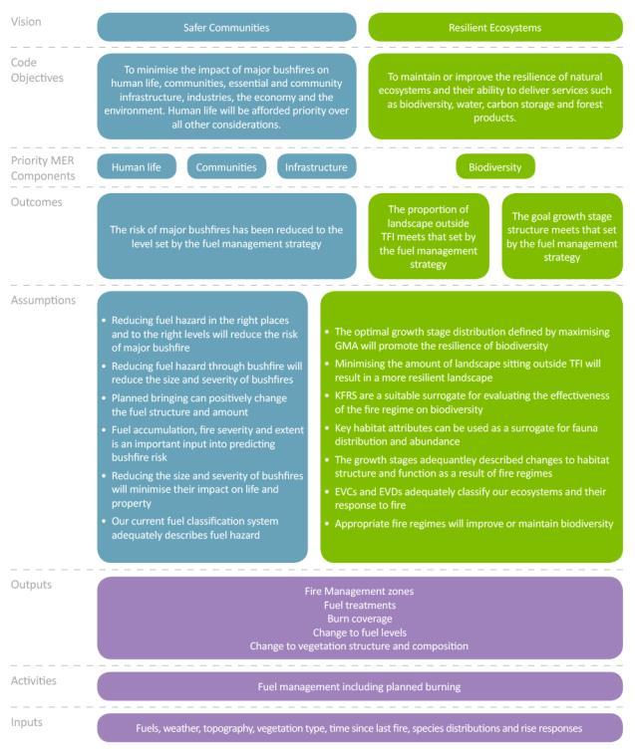

Appendix 2. Key Evaluation Questions

Current priority KEQs.

The Key Evaluation Questions must be used to evaluate the impact and effectiveness of the management strategies and to improve the models and assumptions underpinning them. They must also be used to evaluate the processes underpinning the risk-based approach. Only some KEQs will require on-ground monitoring to be established. These are shown in teal text. The other KEQs can be addressed through desktop evaluation, which will be informed by the data collected through on-ground monitoring.

The KEQS will be maintained as a separate ‘living’ document on the DELWP website and will be updated as the Program logic is updated.

|  |  |  |
| --- | --- | --- |
| KEQs relating to outcomes for life and property | | |
| Outcomes | Related KEQs | |
| The risk of major bushfires has been reduced to level set by the fuel management strategy | Impact  • How has fuel management changed fuel levels within the landscape?  Effectiveness  • How has the fuel management strategy reduced bushfire risk?  Improvement  • How does fuel re-accumulate after fire?  • Is fuel hazard an adequate measure of risk?  • Does Phoenix adequately characterise bushfire hazard across the landscape?  • Is the current fuel classification system appropriate for predicting changes to fuel hazard across the landscape? | |
|  | | |
| KEQs relating to outcomes for ecosystem resilience | | |
| Outcomes | Related KEQs | |
| The proportion of the landscape outside Tolerable Fire Interval meets that set by the fuel management strategy | Impact  • How has fuel management changed the proportion of vegetation sitting below the minimum or above the maximum Tolerable Fire Interval?  Effectiveness  • How has the fuel management strategy maintained or improved populations of Tolerable Fire Interval sensitive Key Fire Response Species?  • Has the fuel management strategy maintained the desired amount of the landscape sitting within Tolerable Fire Interval?  Improvement  • Are Key Fire Response Species that set minimum and maximum Tolerable Fire Intervals appropriate species for determining Tolerable Fire Intervals?  • How appropriate are the current Tolerable Fire Intervals for maintaining species composition and relative abundance within each Ecological Vegetation Division across the landscape?  • Is the reproductive capacity of species that set minimum Tolerable Fire Interval consistent with the current Tolerable Fire Intervals?  • How appropriate are the current thresholds for management action for avoiding fundamental change in each Ecological Vegetation Division? | |
| The goal growth stage structure meets that set by the fuel management strategy | Impact  • How has the abundance of key habitat attributes changed as a result of fuel management?  • How has fuel management changed the occupancy of fire sensitive species within their preferred habitat?  Effectiveness  • How has the fuel management strategy changed the deviation from the goal growth stage structure?  • How has the fuel management strategy effectively maintained key habitat attributes and critical growth stages for minimising the deviation from the goal growth stage structure?  • Has the fuel management strategy contributed to the maintenance of populations of fire sensitive species across their distribution in Victoria, through the maintenance of appropriate growth stage structures?  Improvement  • Are the availability of key habitat attributes reflected in the growth stages and linked to occurrence and abundance of species reliant on these attributes?  • Do key habitat attributes regenerate as expected following fire?  • Do the current Ecological Vegetation Division growth stage intervals reflect changes in the abundance of species over time?  • Do the species response curves adequately predict the response of at-risk and fire sensitive species  to fire?  • Does the measured Geometric Mean Abundance of Species match the modelled Geometric Mean Abundance of Species derived from modelled species response curves? | |
| KEQs relating to the processes underpinning the risk-based approach | | |
| Process | | Related KEQs |
| Strategic Planning Outcome  Bushfire management planning decisions are supported by landscape risk and ecological modelling systems and procedures, and informed by research and monitoring | | • To what extent are risk assessments applied systematically, repeatedly and consistently across the risk landscape?  • How are bushfire management objectives at the landscape scale defined?  • How are monitoring and research used to inform and improve bushfire management strategies?  • How are monitoring and research used to validate and update models? |
| Operational Planning Outcome  Fire Operations Plans (FOP) are informed by the strategies developed by the BRL teams | | • How is the FOP informed by the current long-term fuel management strategy? |
| Tactical Planning Outcome  Burn objectives are consistently met and show a clear link to the landscape objectives | | • To what extent are the burn objectives informed by the fuel management strategy?  • To what extent did the burn meet its operational objectives? |
| KEQs relating to the Monitoring, Evaluation and Reporting program | | |
| Programs | Related KEQs | |
| MER Program Outcome  The effectiveness and efficiency of the Bushfire MER Program is improved overtime | • How are monitoring, evaluation and reporting activities aligned to and effectively measuring and reporting on performance, against the primary objectives?  • How has investment of time, budget and people been allotted across monitoring, evaluation and reporting activities?  • How has investment of time, budget and people been allotted across the different outcomes?  • How well have the outcomes of the MER Program and research been integrated into the strategic bushfire management planning and decision making processes? | |