|  |
| --- |
| Parks and Forests Closures on Catastrophic Fire Danger Rating days |
|  |

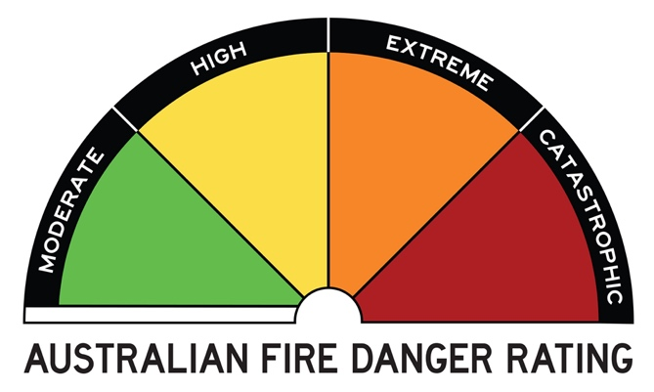

Many of Victoria’s parks and forests are in bushfire prone areas. While they are great places to enjoy, during some weather conditions they are not safe places to be.

You need to read this information carefully, as fires   
that start under some weather conditions may be fast moving, unpredictable and uncontrollable. You may   
not receive an official warning of a bushfire and you should not expect a fire truck.

Victoria has adopted the national system of Fire Danger Ratings. On days of forecast Catastrophic Fire Danger Rating, the Department of Environment, Land, Water and Planning (DELWP) and Parks Victoria will close parks and forests (including state forests and national parks) in the bushfire prone areas of the relevant weather district for public safety.

On Catastrophic Fire Danger Rating days, parks and forests are not safe places to be and they will be closed to the public.

For your own safety, do not enter parks or forests and if you are already there you should leave the night before or early in the morning.

You may not receive a personal warning or   
see signage that the park or forest is closed.

For more information on the Fire Danger Ratings system and Total Fire Bans visit [www.cfa.vic.gov.au](http://www.cfa.vic.gov.au/)   
or call the VicEmergency Hotline on 1800 226 226.

Bushfire safety is a personal responsibility and anyone entering parks and forests during the bushfire season needs to stay aware of forecast weather conditions   
and remain alert to signs of fire such as smoke or emergency vehicles.

## Will a ranger come and tell me to leave?

Due to the sheer size and geographic spread of Victoria’s parks and forests, it will not be possible for every visitor to personally receive a warning. It is your responsibility to remain alert and aware of the current weather conditions. DELWP and Parks Victoria need to focus on being prepared for fighting any fires that begin.

When preparing to leave ensure any campfires are properly extinguished – using water, not dirt – so they cannot start a bushfire.

## Will all parks and forests be gated or fenced off to stop access on Catastrophic Fire Rating days?

Gated entries will be closed at relevant parks or visitor sites. However, it is not possible to gate or fence off all parks and forests, as these are often vast areas of land, sometimes with roads running through them. People need to act responsibly and safely and stay out of parks and forest a­reas on these days.

## How do I find out what the forecast Fire Danger Rating is?

Fire Danger Ratings feature in weather forecasts   
on radio and television and in newspapers. You can also check online at [www.cfa.vic.gov.au](http://www.cfa.vic.gov.au/) or call the VicEmergency Hotline on 1800 226 226.

## What should I do on days of Extreme or Severe Fire Danger Rating?

On days of Extreme and Severe Fire Danger Ratings you should reconsider plans to visit parks and forests, and if you are already within a park or forest the safest option is to leave early in the day.

## How do I find out which district I am in?

The Fire Danger Rating forecasts are issued according to weather districts. You can view more detailed maps of the districts online at [www.cfa.vic.gov.au](http://www.cfa.vic.gov.au/) or call the VicEmergency Hotline on 1800 226 226.

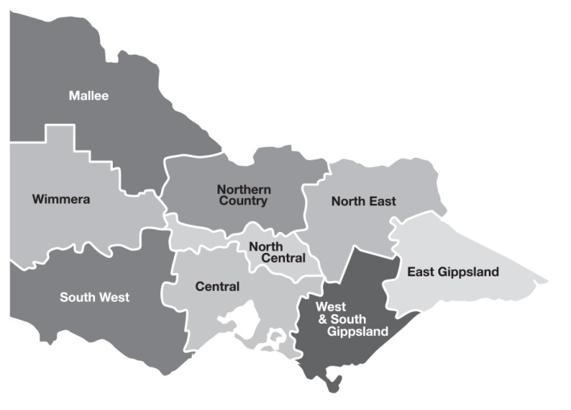

## If I leave the forest or park where should I go?

Visitor Information Centres in regional locations   
can suggest alternative tourism opportunities.

## What if I don’t want to leave?

Parks and forests are not safe places to be and you will be putting yourself at risk by remaining in these areas.

If a fire starts on a Catastrophic Fire Rating day, you can expect that it could be unpredictable, uncontrollable and fast moving. You should not expect a fire truck.

It is an offence to knowingly enter parks or forests which are closed, and penalties may apply.

## Are there any parks or forests which won’t be closed on Catastrophic Fire Danger Rating days?

All state forests and forest parks will be closed   
on Catastrophic Fire Danger Rating days.

Some parks or visitor areas which are judged to be   
at a lower risk of bushfire may remain open, such as those in inner-urban areas or areas which have been recently burnt.

Visit the Parks Victoria website [www.parks.vic.gov.au](http://www.parks.vic.gov.au/)   
to view a complete list of park closures.

## What if I usually access my property through park or forest?

If you access your property through park or state forest, you will be allowed to enter the area for the purpose   
of entering or leaving your property.

On a Catastrophic Fire Rating day, the safest option   
if you live in a bushfire prone area is to leave your home the night before or early in the morning.

## What if the park or forest I’m in spans more than one Fire Danger Rating district?

Visit [www.parks.vic.gov.au](http://www.parks.vic.gov.au/) or call 13 19 63   
for a complete list of park closures.

## Where can I go if I need more information about bushfire?

For current bushfire information:

### Tune into

ABC Local Radio, commercial radio stations   
across Victoria and SKY News television.

### Call

VicEmergency Hotline on 1800 226 226

### Go online

[www.cfa.vic.gov.au](http://www.cfa.vic.gov.au/), [www.emergency.vic.gov.au](http://www.emergency.vic.gov.au/)  
or download the VicEmergency app. For more information about camping or hiking in Victoria,  
call Parks Victoria on 13 19 63 or visit [www.parks.vic.gov.au](http://www.parks.vic.gov.au)

For emergencies dial “000”

|  |  |
| --- | --- |
| © The State of Victoria Department of Environment, Land, Water and Planning 2022  LogoThis work is licensed under a Creative Commons Attribution 4.0 International licence. You are free to re-use the work under that licence, on the condition that you credit the State of Victoria as author. The licence does not apply to any images, photographs or branding, including the Victorian Coat of Arms, the Victorian Government logo and the Department of Environment, Land, Water and Planning (DELWP) logo. To view a copy of this licence, visit http://creativecommons.org/licenses/by/4.0/  ISBN 978-1-76136-131-9 (pdf/online/MS word)  Disclaimer  This publication may be of assistance to you but the State of Victoria and its employees do not guarantee that the publication is without flaw of any kind or is wholly appropriate for your particular purposes and therefore disclaims all liability for any error, loss or other consequence which may arise from you relying on any information in this publication. | Accessibility  If you would like to receive this publication  in an alternative format, please telephone the DELWP Customer Service Centre on 136186, email [customer.service@delwp.vic.gov.au](mailto:customer.service@delwp.vic.gov.au),  or via the National Relay Service on 133 677 [www.relayservice.com.au](http://www.relayservice.com.au). This document is also available on the internet at [www.delwp.vic.gov.au](http://www.delwp.vic.gov.au). |