Understanding and managing Victoria’s forest carbon
  - Research Fact Sheet
Forests, Fire and Regions Group invests in the Integrated Forest Ecosystem Research (IFER) agreement with The University of Melbourne (UM), which delivers critical science projects to support policy and operational practices. The core research themes of IFER include biodiversity, carbon, hazards, socio-economic, vulnerability and water. Understanding and Managing Victoria’s Forest Carbon is the core IFER carbon project. The project commenced in July 2010 and the current project cycle is due to be completed by June 2019.

The Project
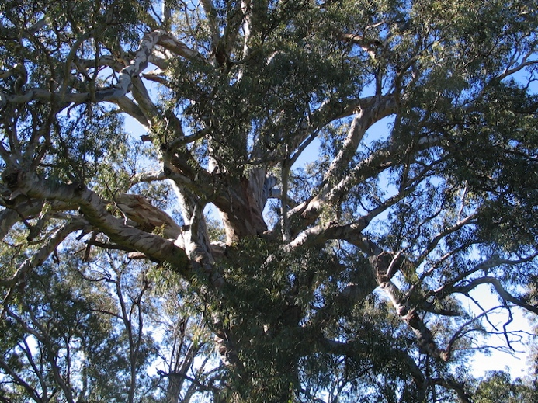
The Understanding and Managing Victoria’s Forest Carbon project will improve DELWP’s capacity to estimate how much carbon is stored in Victoria’s forests, and how those stores will be affected by bushfire, forest management practices, and other natural phenomena. The carbon stored in our forests is an important part of the global forest carbon reservoir, which is critical to removing carbon dioxide from the atmosphere. Forest carbon is a product of forest growth, so understanding forest carbon is also central to sustainably managing the health and vitality of our forests. The project’s aims are to:
- Measure the carbon stored in Victoria’s highly variable natural forests, encompassing the two major stores of carbon present in forests-trees and soil, across a range of forest types and fire regimes.
- Quantify relationships between the forest carbon stores and key drivers, both natural (climate and bushfires), and management (e.g. planned burning practices).
- Develop a framework for modelling carbon to explore how the drivers and their interactions will influence the forest carbon stored into the future at landscape scales.
The project’s current research builds on these initial aims by addressing the following questions:
- What are the largest remaining uncertainties in estimating Victoria’s forest carbon stores?
- How resilient are our forest carbon stores and underlying forest productivity (the rate of growth as a measure of vitality), to changing climate and fire regimes?
- What are the main risks to Victoria’s forest carbon and where are the strongest opportunities to identify and to mitigate those risks?
The project will provide a platform for examining the influence of different management scenarios on Victoria’s ever-changing forest carbon stores. An IFER Carbon Supplementary project: Integrating Carbon into Modelling Frameworks for Bushfire Risk Management Reporting, will also improve DELWP’s capacity to explicitly compare carbon alongside other forest values in annual fuel management reports.
Image 1: Large trees store most of Victoria’s forest carbon (Photo: L. Bennett)

Project Outputs
The IFER carbon project will provide DELWP with:
- A stronger basis for estimating and monitoring the size of Victoria’s forest carbon stores, including a comprehensive Forest Carbon Database.
- Estimates of carbon losses associated with planned burning regimes and recommended practices to minimise those losses.
- Estimates of the comparative carbon losses associated with bushfires over a range of severities.
- Improved understanding of the rates of change in Victoria’s forest carbon stores, including the influence of climate variations.
- Carbon stability indicators and risk measures for interpreting and communicating the many ways fire and climate regimes influence forest carbon stores.
- A Forest Carbon Modelling Framework to examine the influence of forest management scenarios on changes in forest carbon stores at landscape scales.
Overall, the project will provide a firm basis for predicting change in Victoria’s forest carbon stores and for identifying risks and opportunities in forest carbon management.

Policy and Operational Implications
This work will improve the scientific basis for predicting Victoria’s forest carbon stores across a range of forest types. The project will identify forest carbon stores most vulnerable to decreases under emerging fire and climate regimes and provide a basis for examining the effectiveness of mitigation and adaptation practices in addressing that vulnerability.

The Research Team
The IFER Understanding and Managing Victoria’s Forest Carbon project is being delivered through The University of Melbourne’s School of Ecosystem and Forest Sciences. The University researchers, led by A. Prof Lauren Bennett, work closely with a range of collaborators, particularly DELWP and the Arthur Rylah Institute, to assess carbon stores and to explore management scenarios.
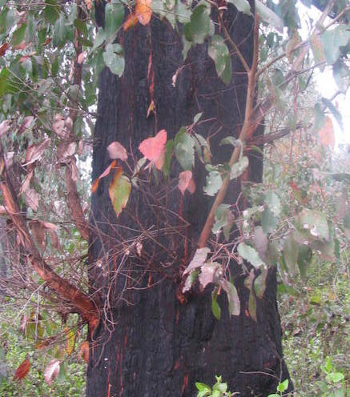

Image 2: Eucalypt resprouts help recover carbon lost in fires (Photo: L. Bennett)
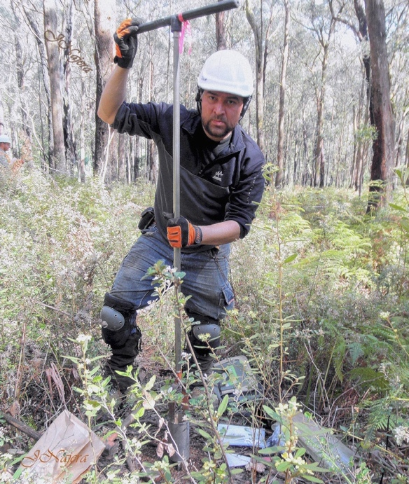
Image 3: Sampling soil to measure carbon stores
(Photo: J. Najera)

Project Status (August 2018)
The Victorian Forest Carbon Database has been developed and currently contains estimates of forest carbon stores for over 730 field plots. Analyses of this comprehensive dataset have quantified the carbon costs of different fire regimes and revealed patterns in carbon storage associated with forest diversity.
The Carbon database underpins the IFER Carbon Modelling Framework, which is being used to examine effects of stakeholder-defined management scenarios on forest carbon stores in a test landscape.
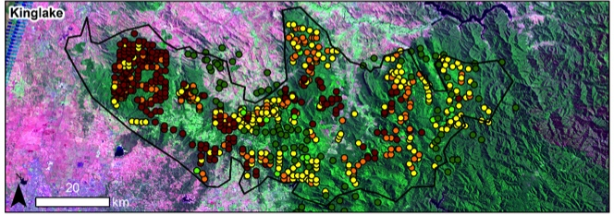
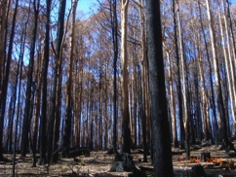
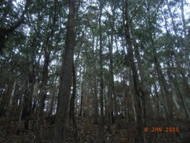
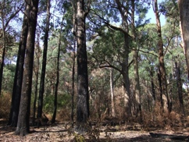
Carbon stability indicators and risk measures have been clearly defined and their integration into a broader modelling framework that examines multiple forest values is currently underway.
Fire severity

Figure 1: Upscaling of fire effects on carbon stores from stands to landscapes. Coloured dots represent sites either not burnt by bushfire (green), or burnt by bushfire at low (yellow) to high (red) severities (Image: C. Aponte)

