Integrating carbon into modelling frameworks for bushfire risk management reporting
  - Research Fact Sheet
Forests, Fire and Regions Group invests in the Integrated Forest Ecosystem Research Agreement (IFER) with the University of Melbourne (UM), which delivers critical science projects to support policy and operational practices. The core research themes of IFER include biodiversity, carbon, hazards, socio-economic, vulnerability and water. Integrating Carbon into Modelling Frameworks for Bushfire Risk Management Reporting is an IFER Carbon Supplementary project. It commenced in July 2016 and is due to be completed by June 2018.

The Project
IFER’s Integrating Carbon into Modelling Frameworks project will enhance DELWP’s capacity to identify, manage, and report against risks to Victoria’s forest carbon stores. The project’s principal aim is to provide the scientific basis for integrating forest carbon into bushfire and forest management and reporting by addressing the following questions:
- What forest carbon metrics and associated measures make sense in the context of bushfire risk and forest management planning and reporting?
- How can carbon knowledge be best captured and integrated into IFER and DELWP forest and fire management models, to predict responses of these carbon metrics to fire regimes and forest (including harvesting) management options?
- How can we best implement these refinements to provide predicted outcomes for forest carbon measures, that are compatible with DELWP’s annual fuel management reports?
This project’s focus and methods strongly align with the primary research questions of the IFER Landscape Carbon Core project (2016-2019):
- What are the largest remaining uncertainties in estimating Victoria’s forest carbon stores?
- How resilient are our forest carbon stores and underpinning forest productivity to changing climate and fire regimes?
- What are the main risks to Victoria’s forest carbon and where are the strongest opportunities to identify and to mitigate those risks?
By explicitly integrating carbon metrics in IFER and DELWP modelling frameworks, this project has clear links to modelling inherent in each of the IFER core themes, as well as IFER’s Integrated Landscape Decision Support System (see Fact Sheet).
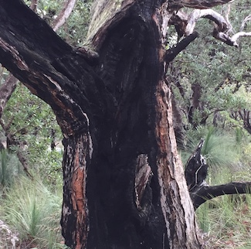
Image 1: Bushfires can decrease the carbon stored in trees (Photo: L. Bennett)

Project Outputs
IFER’s Integrating Carbon into Modelling Frameworks project provided DELWP with:
- Scientific rationale for forest carbon metrics and measures relevant to bushfire risk management reporting.
- Defined forest carbon response functions relevant to forest carbon metric/ measures modelling at landscape scales, including identification of linkages with input/output variables from existing modelling frameworks, as well as data gaps and uncertainties.
- Operational integration of forest carbon metrics/ measures in IFER’s developing meta-modelling frameworks.
Overall, the project provided new capacity to understand and describe carbon as a forest value, and to assess and communicate potential connections and trade-offs with other forest values posed by bushfire and forest management options.

Policy and Operational Implications
This project provided DELWP with the basis to describe desirable outcomes and associated metrics for forest carbon in bushfire risk and forest management reporting. The project will integrate forest carbon as a value in current modelling frameworks and improve capacity to assess and report the potential impacts of different fire and forest management options.

The Research Team
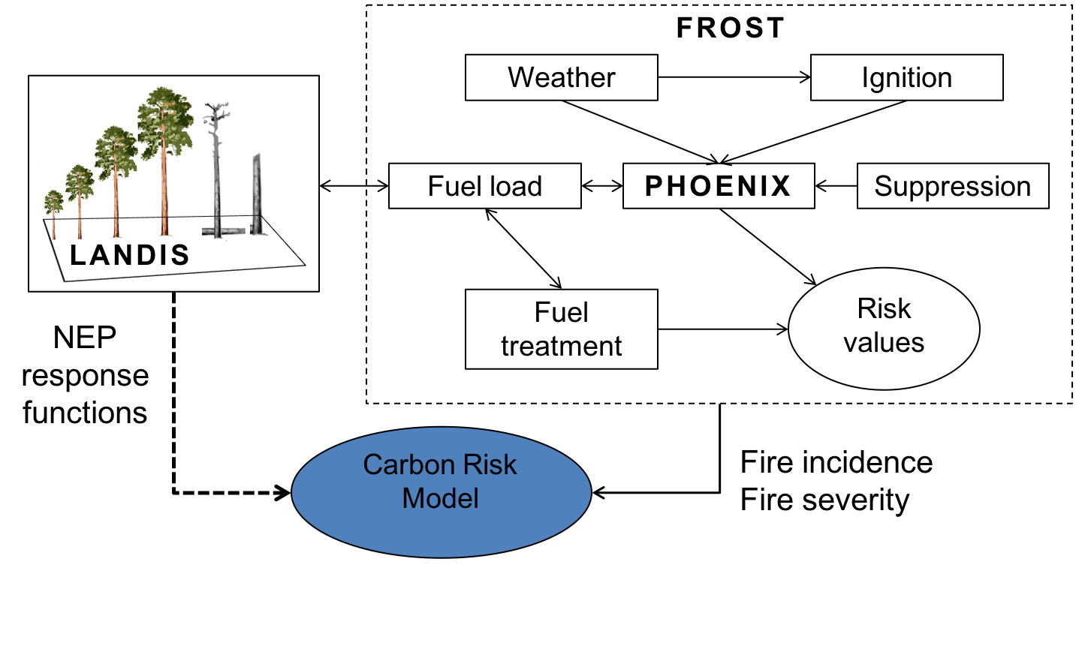
Integrating Carbon into Modelling Frameworks project was delivered through The University of Melbourne’s School of Ecosystem and Forest Sciences. The project was led by IFER carbon researchers Associate Professor Lauren Bennett and Dr Cristina Aponte, working with the IFER Hazards and IFER Vulnerability core project teams, and in close consultation with DELWP.
Figure 1: Forest carbon risk modelling will be integrated into meta-modelling frameworks that link fire regime (FROST) and forest succession (LANDIS) models.

Project Status (August 2018)
Novel carbon risk measures have been defined, and their potential relationships with fire regime and fire management variables have been described. These relationships were parameterised using the IFER Carbon Modelling Framework, which is underpinned by the IFER Victorian Forest Carbon Database.
The carbon risk measure relationships provided the foundations of a Bayesian Network, which sits at the centre of the Carbon Risk Model. Links between the Carbon Risk Model and other models in the IFER meta-modelling framework (Figure 1) have been programmed and are being refined in an ongoing iterative fashion. The project has provided a proof-of-concept demonstration of carbon measure outcomes from bushfire risk management strategies for a test landscape, and extensions to other landscapes are being planned as part of future projects.
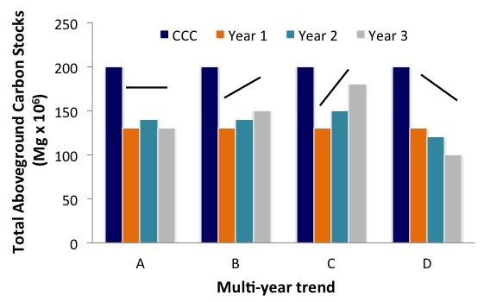

Figure 2: Annual trends in a forest landscape’s total carbon stocks relative to a long-term mean (‘CCC’, carbon carrying capacity) is one way of interpreting changing risks to forest carbon.

A Bayesian Network is a framework for linking relationships between multiple variables in a sequence to provide probability distributions for the final output measure.

