Landscape water: Climate and fire regime; feedbacks, ecohydrology and water resources
  - Research Fact Sheet
Forests, Fire and Regions Group invests in the Integrated Forest Ecosystem Research Agreement (IFER) with the University of Melbourne, which delivers critical science projects to support policy and operational practices. The core research themes of IFER include biodiversity, carbon, vulnerability, hazards, socio-economic and water. This Fact Sheet reports on ‘Landscape water: Climate and fire regime; feedbacks, ecohydrology and water resources’ which commenced in July 2016 and is due to be completed by June 2019.

The Project

Streamflow from forested areas provides most of Victoria’s water supply. Streamflow is the difference between rainfall and the water forests evaporate or use for growth (evapotranspiration). Streamflow can account for more than 75% of rainfall in our water supply catchments and higher in other areas. Any change to forest density, species mix, stand structure and age can alter the amount of streamflow from forested catchments. Reduced forest cover also leaves the landscape vulnerable to soil erosion and nutrient loss, and we know the biggest drivers of forest change are climate (e.g. drought) and fire.
South eastern Australia is currently experiencing higher temperatures and lower rainfall than the norm, and this trend is expected to continue for at least several decades. In this changing climate, a higher proportion of this reduced rainfall may be evapotranspired, reducing streamflows even further.
Lastly, the frequency of drought and bushfire may also be increased, and the potential for these to change forest attributes is significant. While we have learnt much about the effect of individual fire events on forests and water supplies, the combined effect of multiple fires and/or droughts is unknown.
For example:
- Will repeated fire mean more open forests, leaving them prone to fuel drying and more fire?
- Could decreases in forest stand density, structure or a species change lead to lower evapotranspiration; inadvertently reducing the impacts of decreased rainfall on streamflow?
- How does planned fire interact with bushfire and climate change in terms of vegetation changes and hydrology?
- How might increased fire and climate variability impact on mass erosion and subsequently, water quality?

The Landscape Water project seeks to understand how potential changes to forest type and structure will affect the hydrologic outputs in years to come.
The key research questions are:
- How will the combined system interactions and feedbacks, forced by fire regime and climate, effect key forest hydrologic processes?
- How will the combined interaction between climate and fire regimes impact on the security of Victoria’s water supplies?
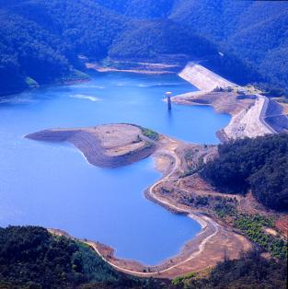

Image 1: Thomson Dam; Melbourne’s largest water supply reservoir (Photo: Pat Lane)

Policy and Operational Implications

This work will develop a model that can be used to assist decision makers in areas such as forest management, water supply planning and catchment management; on activities, such as planned burning, in an increasingly dry and warming climate.

Project Outputs
- Models that capture critical interactions and feedbacks between climate, fire, vegetation and hydrology, which can then be integrated into a fire regime model.
- Improved models for evaluating future hydrologic states of Victoria’s forests, including water supply and resilience.
- Modelling tools that can be integrated with other IFER projects to develop a broader Decision Support System.

The Research Team
The project is being delivered by the Forests and Water group at the University of Melbourne, led by Prof Patrick Lane and Dr Gary Sheridan. The project team includes PhD students and Research Fellows.

Project Status (August 2018)
- The experimental program investigating the relationship between evapotranspiration, climate and stand structure in mixed-species forests is well advanced. This work has revealed systematic relationships between aspect and drainage position that are proving useful for predictive modelling and scaling up tree water use.
- An extensive experimental program on Acacia water use (a species likely to increase in response to more frequent fire) is underway.
- New hydro-geomorphic risk models developed in the Landscape Water project have been integrated into a new fire regime model developed within the IFER Hazards project, providing the capacity to model multiple risks simultaneously.
- Completion of analyses displaying the relationship between landscape position, energy and climate inputs and soil properties; plant available water and erodibility.

- Scaling up of evapotranspiration and fuel moisture data from plot measurements to landscape-scales is underway, utilising models and drones to collect the required data.
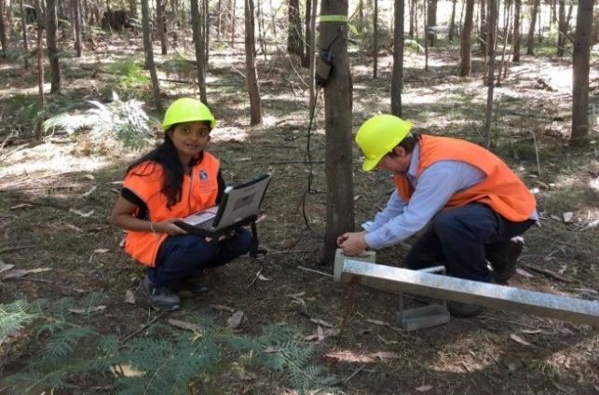
- Work is continuing to better understand the drivers of mass erosion events following fire and high rainfall.

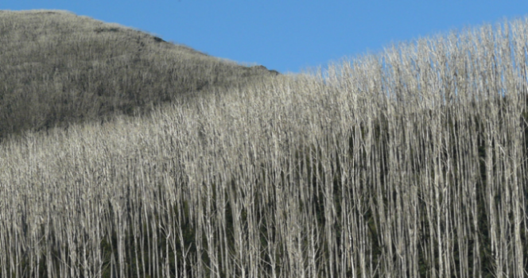
Image 2: PhD student Shyanika Lakmali measuring the water use of a young Acacia stand (Photo: Pat Lane)

Image 3: Dead mountain ash following Black Saturday. A fire interval < 15 -20 years would result in species loss and possible hydrologic change (Photo: Pat Lane)
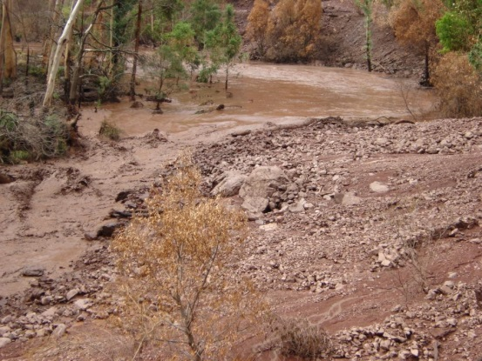

Image 4: Post fire debris flow erosion in the Victorian uplands (Photo: Pat Lane)

