Using fire to manage biodiversity in fragmented landscapes
  - Research Fact Sheet
Forests, Fire and Regions Group invests in the Integrated Forest Ecosystem Research Agreement (IFER) with the University of Melbourne (UM), which delivers critical science projects to support policy and operational practices. The core research themes of IFER include biodiversity, carbon, hazards, socio-economics, vulnerability and water. Using fire to manage biodiversity in fragmented landscapes is an IFER Biodiversity Supplementary project. It commenced in January 2017 and is due to be completed by January 2021.

The Project
Land-use change has fragmented Australia’s natural landscapes, and habitat fragments remain at risk from multiple human interventions, including increases in managed and unplanned fire frequency and intensity. These are a potential risk to biodiversity. This research project addresses two key knowledge gaps in understanding this risk:
- The combined effects of habitat fragmentation and fire on native animal movement.
- The implications of current and future fire regimes, including bushfire and planned burning, for native animal populations.
Fire alters both the suitability of habitat patches for species (habitat suitability), and the capacity of species to move within and among patches (connectivity), both of which are critical to species’ survival and long-term persistence. As a management tool, planned burning has the capacity to improve both habitat suitability and connectivity, and ultimately promote species’ persistence.
Using the fragmented stringybark woodland of southwest Victoria and southeast South Australia as a study system, this research combines field surveys of reptiles, mammals and insects, with innovative genetic techniques and fire risk modelling.
This will be used to develop an approach to ecological fire management that accommodates:
- The spatial configuration of vegetation patches and fire regimes.
- The ability of species to move around the landscape.
- The influence of current fire regimes on future survival and persistence of species. It will enhance DELWP’s ability to improve ecosystem resilience.

Project Outputs
This project will help DELWP better understand ecosystem processes and their interactions, enabling management that sustains biodiversity in fire-prone fragmented ecosystems, by providing DELWP with a spatially and temporally explicit approach, that enables fire managers to make decisions regarding where and when to apply fire to enhance connectivity.
It will also provide high-resolution genetic data from selected species, that will provide early warning signs of future extinction risk many years before population declines are apparent in field survey data. This will allow DELWP to identify species that may benefit or be at risk from a particular fire regime, enabling prioritisation of species for monitoring into the future.
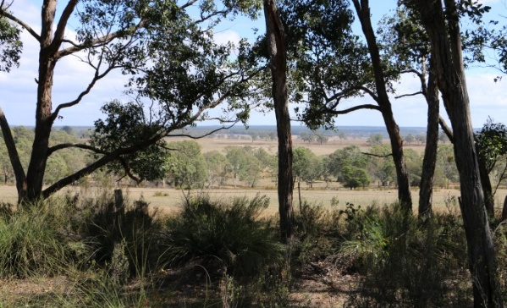
Image 1: Fragmented stringybark woodland in western Victoria Photo: Holly Sitters

Policy and Operational Implications
A primary objective of DELWP’s Code of Practice for Bushfire Management on Public Land 2012 is to maintain or improve the resilience of natural ecosystems. In the long-term, this requires understanding of the ecological and evolutionary processes underlying patterns in species abundance, such as the movement of individuals and genes.

The Research Team
This Australian Research Council Linkage Project is run by the Fire Ecology and Biodiversity Group at the UM in partnership with DELWP, Parks Victoria, Monash University, the South Australian Department for Environment and Water, SA Water, the CFA, the Glenelg-Hopkins CMA and Trust for Nature.
It is also supported by Forestry SA, HVP Plantations, PF Olsen and Timberlands Pacific.
The project is coordinated by Dr Holly Sitters with A/Prof Alan York, Dr Julian Di Stefano, Dr Matthew Swan and A/Prof Trent Penman (all University of Melbourne), Dr Nevil Amos (DELWP), Prof Paul Sunnucks (Monash University), Dr David McKenna and Mike Wouters (South Australian Department for Environment and Water).

Project Status (October 2018)

Preliminary findings highlight the value of long-unburnt vegetation for several ground-dwelling mammal species and that mammal functional diversity may be enhanced through conservation of older vegetation. Two Honours students completed their theses in 2017: Lauren Delaney studied the responses of individual mammal species to spatial pattern in fire history measured at multiple scales, and Zahlia Payne explored the responses of mammal functional diversity to landscape context, fire history and vegetation structure.
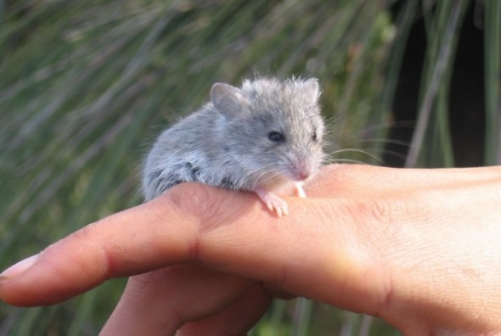

Image 2: High-resolution genetic data will be collected from six species, including the silky mouse (Pseudomys apodemoides), a species of conservation significance.
Photo: Laura Owen

Kelvin Doyle is currently comparing the capacities of infra-red and white-flash wildlife cameras to detect different mammal species as part of his Masters research.

PhD students Annalie Dorph and Sarah Mulhall have completed a season of reptile surveys, with help from Zahlia and a team of volunteers. Seventeen reptile species were detected, and their occurrence will be related to aspects of habitat fragmentation, fire history and vegetation structure.

Five students: Amanda Lo Cascio, Rachel Nalliah, Taylor Reid, Amy Smith and Saumya Wanniarachchi commenced projects in early 2018.

For further information, please visit the project website:
http://fireecologyandbiodiversity.com/fire-and-fragmentation-project.html
Project contact: Holly Sitters
Holly.Sitters@unimelb.edu.au
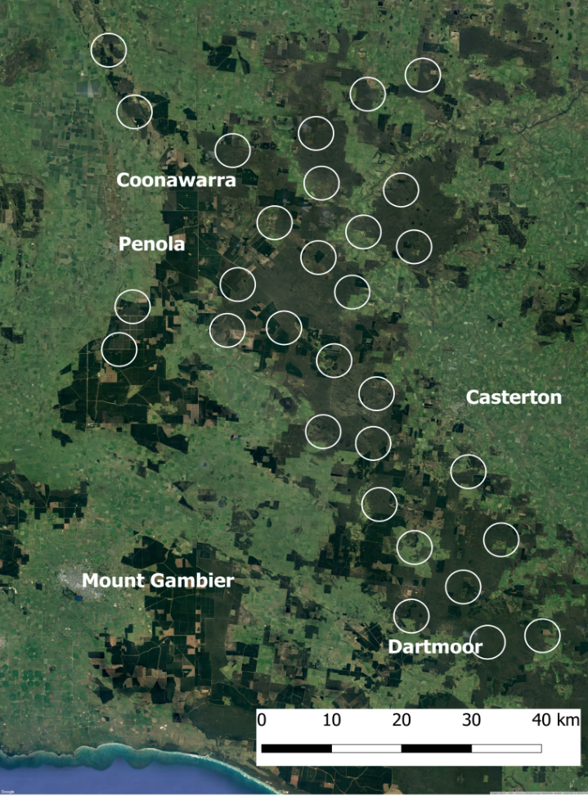
Figure 1: Mammals, reptiles and insects will be surveyed in 30 landscape sampling units.

