Planned Burn Notification System: Trouble Shooting Guide

- What burns appear on the map and lists?
When selecting a location, the area shown on map and the corresponding list will vary depending on the device you are using, for example on a mobile phone you may only see an area within 3 km of the selected location (due to limited screen size) and only burns in that 3km radius will appear on the map and on the list.
Subscribing to that location will, however, automatically subscribe you to all burns within 10km.
You may see the message saying there are ‘no planned burns found’ – this does not mean there are no burns within 10km, just that there are no burns within the visible radius on the device you are using. It pays to subscribe to a location that you are interested in, even if it says ‘no planned burns found’.

- Why haven’t I received any SMS / email messages?
It may be that no burns that you have subscribed to have occurred because conditions have not been suitable, or the burns may not be scheduled to occur this year but are planned for the second or third year of the Fire Operation Plan.
Go into your account and check your account set up - check that your email and mobile phone details are correct. Also check that you have ticked the boxes for the status (within 10 days, next 24 hrs, in progress) and type of message (SMS or email) that you wish to receive notifications for.
Log in to your account and go to ‘My location’, then make sure that the box ‘Disable Notifications’ is not ticked.
Also check that your phone is able to receive messages – make sure you have mobile phone coverage, that your phone has sufficient credit to receive messages and that your phone is not in ‘Flight’ mode.

- How do I change my account details (including mobile phone or password)?
To change your mobile phone number or password – Log in to your account and go to ‘My details’ section. Make any changes you need to, then remember to click ‘Update my details’ before logging out.

- Can I change my email address?
You are unable to change your email address in the PBNS as your email address is the same as your user ID. If your email address changes you need to create a new account using your new email. Remember to also delete your old account.

- I can’t remember my password.
If you forget your password you can simply ask for a temporary password to be sent to you by clicking the ‘I forgot my password’ link in the ‘Login’ window. You can ask for a temporary password to be sent to the email address or mobile phone number you use for your account details.

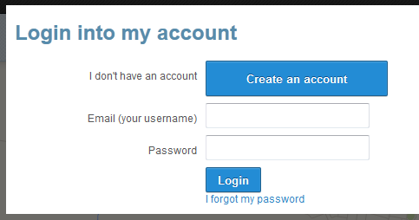

Use the temporary password to log into your account. You will then need to go into ‘My details’ to reset your password. To do so, just insert your new password , confirm it and then click ‘Update my details’ .
If you have multiple accounts using the same mobile phone number you will need to request that the temporary password is sent to your email address as the system won’t know which account to reset if there is more than one account using the same mobile number.

- I am experiencing difficulties logging in.
Your email address is your user ID. Please check you have entered it correctly and that you are using the same email address you used when registering in the system.
You may be typing in the wrong password. Try asking for a temporary password to be sent to you by clicking the ‘I forgot my password’ link (refer to 6 above).
If you are experiencing difficulties logging in from your smart phone or tablet it may be because you have blocked cookies in your browser settings which can prevent successful log in to the PBNS. Try changing your browser settings to allow cookies." Also if your phone has a “Do not track” feature make sure it is turned off. The next section provides instructions how to carry out these steps.

Cookies
With iOS8:
- Go into your Settings
- Go to Safari
- Go to the Privacy and Security section
- Under “Block Cookies” select “Always allow cookies".
With iOS7:
- Go into your Settings
- Go to Safari
- Go to the Privacy and Security section
- Under “Block Cookies” select “Never".
Do not track:
iOS7 and iOS8
- Go into your Settings
- Go to Safari
- Go to the Privacy and Security section
- Turn off “Do not track”.
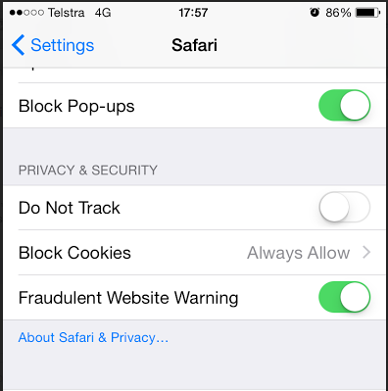

- I have trouble using the system on my iPhone.
Apple mobile phones using iOS7 have memory limitations and cannot display the map layers fully. So you may receive the below message:
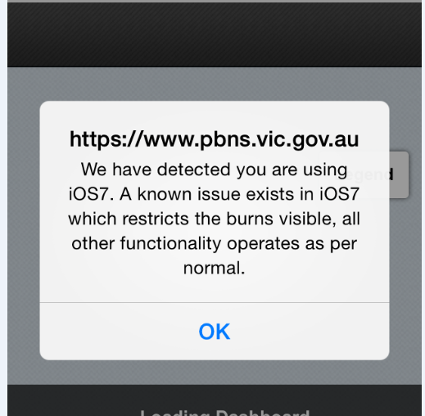
Just click OK and this will allow you to enter the site.

The system will detect that your phone has iOS7. It will alert you that iOS7 restricts which burns are visible on both the maps and lists but all other functionality operates as normal. The lists and map will only show burns that are at ONE of the following statuses: Within 10 days, Next 24 hrs and In progress. However, there is no limit to searching and subscribing to locations and/or burns or creating an account on Apple mobile phones.

- The system isn’t working properly using Internet Explorer 8 or earlier versions.
There are some memory capacity issues with Internet Explorer version 8 or earlier versions. There may be many hundreds of burns on the three year FOP. If you try to see all of these burns by filtering on All districts the following prompt may appear. If you click Yes the system will try to search and display all burns, which will result in the system getting stuck on searching.
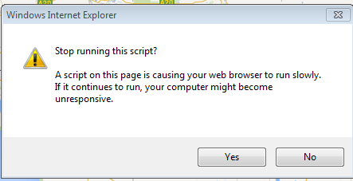
When using Internet Explorer 8, avoid choosing All districts.
To experience full functionality of the system it is recommended that you upgrade Internet Explorer to the current version or use the current version of another web browser such as Firefox or Google Chrome: these have larger memory capacity and can cope with searching across All districts.

If you have queries that are still not answered in this guide, or if you have a different query, please contact the Victorian Bushfire Information Line on 1800 240 667.

