Major Fires across Western Victoria
February 2024
  - Research report no. 107
Table of Contents
Executive summary 3
General findings 4
Key findings 4
Key learnings 6
Introduction 10
Climate and underlying fuel conditions 12
Fires of 13 February 2024 18
Introduction 18
Fire Behaviour at the Mt Stapylton Fire 22
Fire behaviour at the Bellfield Fire 25
Initial suppression at the Bellfield and Mt Stapylton fires 29
Fire behaviour at the Staffordshire Reef fire 34
The Bayindeen fire – 22 February 2024 37
Introduction 38
Bayindeen 38
Fire behaviour at the Bayindeen fire 39
Suppression and fuel treatment interactions at the Bayindeen fire 46
The Dereel fire – 28th February 2024 47
Introduction 47
Dereel fire (Midlands 108 – Dereel – Kleins Road) 47
Fire behaviour, suppression and fuel treatment interactions at the Dereel fire 48
Publication information 62

Executive summary
During February 2024, western Victoria experienced a series of bushfires under extreme fire weather conditions, significantly impacting both public and private land. These fires, including Mt Stapylton, Bellfield, Bayindeen and Dereel, collectively burned over 28,000 hectares (ha) and caused substantial community and environmental damage. The most substantial impact was the loss of 45 residences in Pomonal during the Bellfield fire. The Bayindeen fire, the largest in the Midlands District in 30 years, caused significant disruption, including evacuation of residences and resulted in economic losses into the tens of millions of dollars.
Over 350 fires ignited across the Western Districts in February 2024, with 5 becoming major under extreme fire weather conditions across both public and private land, causing significant impacts to community and environment. These bushfire events were of interest because of the anomalous fire conditions during the summer period and impacts on communities. In addition, the fires represent the type of fires that much of fire agency response is optimised for, particularly in readiness because they occurred on days of forecast ‘Catastrophic or Extreme Fire Danger.’ Analysis of fire behaviour was conducted for the following fires in chronological order:
13 February 2024
- Mt Stapylton (Wimmera 20 – Grampians NP – Mt Stapylton)
- Bellfield (Wimmera 21 – Grampians NP – Bellfield)
- Bellfield West (Wimmera 23 – Grampians NP – Bellfield West)
- Staffordshire Reef Road (Midlands 99 – Staffordshire Reef – Staffordshire Reef Road)
22 February 2024
Bayindeen (Midlands 104 – Bayindeen – Rocky Road) – 22 February 2024
28 February 2024
- Dereel (Midlands 108 – Fire – Dereel – Kleins Road)

General findings
The reconstructions provided important data and observations to support fire management across Victoria. While the fire behaviour was elevated and exceeded suppressible limits at times, it did not represent the worst fire behaviour conditions possible in south eastern Australia. Suppression in initial attack was limited by access as much as fire behaviour and aerial firefighting slowed but could not stop the fires without ground resourcing. Fuel treatments had effects on fire behaviour but showed the complexity and nuance of the treatment objectives. Time since implementation and nature of implementation were all highly relevant in evaluating treatment effectiveness. This was reflected in the performance of the operational simulator as well, wherein input data in relation to type and fuel treatments (fire history) were overrepresented in their ability to moderate fire behaviour. This was compounded by the difficulty the simulators had in simulating interactions with terrain and long-distance spotting, which were relevant to actual fire progression.

Key findings
Fire behaviour: Across all fires, incipient fire development was not well profiled by available data and remained a barrier to understanding the early evolution of the events. The fires exhibited rapid rates of spread, particularly in forested areas, with short-duration peak rates reaching 7-9 km/hr. Long-distance spotting (20 km), and fireline intensities (10-60 MW/m) combined with these rates of spread contributed to significant impacts. Grassfire spread was abated by the variability in landscape grass fuel conditions (curing, structure and continuity) with effective suppression fragmenting the fire into patterns worthwhile of further study.
Weather and fuel conditions: The fires were driven by strong north-north-westerly winds, high temperatures and low humidity levels, followed by a south-westerly wind change. While rainfall and soil moisture from previous wet seasons initially moderated fire dangers in early summer, a drying trend in late summer increased forest fuel availability by February.
Suppression: Suppression efforts were hampered by various factors, including terrain, fuel characteristics, fire behaviour, and in some cases, multiple simultaneous fires drawing on the same common pool of resources. Fires in inaccessible areas relied heavily on firefighting aviation resources with mixed results. The effectiveness of these resources varied depending on fire behaviour and weather conditions, and at certain key periods, smoke and wind conditions prevented effective aerial suppression. Cost effectiveness was not considered as a part of the analysis.
Fuel treatment effectiveness: Where the fire passed through an area that had been previously burnt, generally lower severity was observed in comparison to areas that had not been previously treated. The effectiveness of fuel treatments on fire behaviour was not always clear cut however, influenced by post-treatment climate conditions, species specific regrowth and elevated fire weather. Although fuel treatments did not always mitigate fire behaviour, in some cases they did provide strategic opportunities for actively suppressing and containing fires, including in an area that had previously been prepared and treated for hazardous trees. This report only provides preliminary insights into the fire and fuel treatment interactions (including mechanical treatment) as these have been assessed in more detail in Research Report No. 106: Fire and fuel treatment interactions during the Bayindeen Rocky Road fire 2024.
Fire modelling: The Australian Fire Danger Rating System (AFDRS) is used to calculate and communicate fire danger to support community and agency decision-making. In analysis from the 2023-24 fire season, models in AFDRS generally overestimated fire danger in grasslands and underestimated fire danger in forests, driven by the intertwined role that suppressibility, rate of spread and topography played in the fire events. Monitoring and improving the implementation of the AFDRS in Victoria is an ongoing project within Victorian fire agencies.
Agencies use a separate tool to simulate the spread of individual fires once an ignition event has occurred, this tool is called Phoenix RapidFire Automated (RapidFire). RapidFire is related to, but separate from, the implementation of Phoenix for calculating statewide bushfire risk. The automated fire behaviour simulator tool faced challenges in capturing extreme bushfire progression in complex terrain, particularly when there were apparent weather and fuel treatment interactions. Overall, the automated PHOENIX RapidFire simulation tool tended to under-predict fire spread and potential impact zones. This is attributable to a range of factors, including limitations in simulator models and the need to rely on automated inputs for initial, rapid forecasts. Reconstructions such as those detailed in this report support ongoing learning and improvement for these types of tools.

Key learnings
The 2023-2024 fire season in western Victoria highlighted the complex interplay of weather, fuel conditions and suppression efforts in shaping fire behaviour and impacts. The lessons learned from these fires underscore the need for continued research and undertaking bushfire reconstruction reports such as this, improved modelling tools and adaptive strategies to mitigate the risks and impacts of future bushfires.
The lessons from this reconstruction highlight the need for continual improvement. The reconstruction showed that our simulators, models and risk interventions are challenged the most under the conditions when fires are most destructive. The limitations of simulators and models, both of input data in models and in the models themselves, are only refined by primary data collection efforts such as those undertaken through this reconstruction process.
Because multiple lightning ignition events share initial attack suppression resources, it is difficult to directly apply lessons learned to our agencies’ response policies without clear alternative scenarios. For example, would one more aircraft have helped? What if this fire was suppressed first? Despite these challenges, primary data collected through this reconstruction process support agencies’ to optimise and test alternative resource models, ensuring their robustness for future application, which supports organisational learning and change.
In the second half of 2024, presentations on the reconstruction were utilised in pre-season briefings and some public forums to combined audience numbers made up of hundreds of people. In many instances, presenting an objective narrative of the event to agency and community members involved was an effective method to support lessons learning processes.
Large fires in the regions where the 2024 fires occurred are not a new occurrence, with recent major fires in the Grampians region including Southern Grampians (2013) Stawell (2014), Northern Grampians complex fires (2014) and Moyston (2015). The last major fire near Bayindeen was the Lexton bushfire in 2019. Bushfire reconstruction reports such as this ensure that these events are documented and available to support individual and organisational learning after major bushfires.
Box 1: Estimated total losses of the western Victoria fires of 2024
Estimated total losses:
Area (ha):
- Public land: 17,940
- Private land: 10,506
Buildings:
- Residential: 52
- Commercial: 1
- Outbuildings: 1
Fencing (km): 923
Agriculture:
- Total area affected (ha): 6,480
- Pasture (ha): 4,389
- Cropping (ha): 100
- Horticulture (ha): 28
- Hay (t): 228
- Livestock 990
Cumulatively, the February 2024 fires burnt over a variety of topography and vegetation types and resulted in a total of 28,446 ha burnt with considerable impact to assets and community. The impacts of the 2024 western Victoria bushfires were significant.

The loss of 45 primary residences in a single day at the Bellfield fire in the community of Pomonal on 13 February will have significant and lasting community impacts. By area, the Bayindeen fire was the largest in the last 30 years within the Midlands district, with little local living memory of larger or more impactful fires. The disruption in the town of Beaufort itself was significant, with an evacuation of an aged care facility and hospital, and small businesses having trade impacted for multiple weeks. As a precautionary measure, Langi Kal Kal Prison saw the relocation of prisoners and staff on 28th January as containment was threatened. Approximately 1,200 ha of softwood plantation was impacted, with commercial losses estimated well in excess of $10M. Stock, asset and fencing losses provided in this report were obtained from Emergency Recovery Victoria and represent the best available data at the time of writing.
All fires analysed were associated with strong north-westerly winds, high temperatures and low humidity levels, followed by a south-westerly wind change – a typical pattern of dangerous bushfire conditions during summers in Victoria. Once the fires were established, rates of spread in forests generally ranged between 2 – 4 km/hr with observations of short duration peak rates of spread of 7 – 9 km/hr. The longest distance spotting was observed to be approximately 20 km while fireline intensities were estimated to range between 10 – 30 megawatts per linear metre (MW/m). These intensities led to significant canopy scorch and crowning in forest vegetation with little patchiness of unburnt or low severity, except in areas of recent (< 3 years) fire history. Grassfire spread was abated by the variability in landscape fuel conditions (curing and paddock state/grass height).

Introduction
Post-event fire reconstructions are essential for understanding fire behaviour, identifying fac-tors that contribute to impacts and developing learnings to better prepare for future incidents. The aim of this investigation was to document the fire behaviour chronology, suppression, cli-mate, weather and environmental factors from a scientific perspective to determine:
- chronology of fire travel between the time of detection until the time of impact
- bushfire simulator performance in comparison to documented chronology
- chronology of suppression actions taken at initial attack to suppress fire behaviour
effectiveness of recent planned burning on fire management actions.
The reconstruction was undertaken at the request of DCO – Fire, Risk Research & Community Preparedness (CFA) and DCFO – Director Bushfire Risk Reduction (DEECA). As part of this, a team comprising of CFA, DEECA, and EMV (Mapping and Predictive Services) staff was established. Volunteers and staff within CFA and DEECA involved in the incident management during and after the events provided their invaluable time and accounts. Regions and districts also gave access to sites, resources and information via incident management and ad-hoc arrangements to support the team.
Data collection was a major task in the reconstruction that included the collation and mapping of fire chronology based on available linescan, satellite and aerial photography (including AIG). Field visits to collect observations of vegetation and fuel condition was undertaken by the re-construction team. Eyewitness and personal accounts of key operational staff were also doc-umented through informal discussions. Consultation with CSIRO and Bureau of Meteorology (BoM) research staff and NSW Rural Fire Service AFDRS staff was also undertaken. The reconstruction team are indebted to these operational staff for sharing their insights.
This report only deals with the chronology of fire behaviour and key fire behaviour phenomena observed. The report briefly remarks on the performance of the automated fire simulator tool PHOENIX RapidFire and the effectiveness of fire management actions, with a view to document these components to support agency learning.

Climate and underlying fuel conditions
There are general and historical preconditioning of the vegetation landscape that help determine the outcomes of every bushfire season in Victoria. In the case of 2023–24, Victoria had experienced three seasons of La Niña which had resulted in soils that were significantly wetter than normal. However, the below average winter rainfall in combination with the above average heat throughout this period led to a drying out of vegetation across most of Victoria. This drying effect was most prominent across Gippsland, and with the onset of elevated fire weather conditions in September – earlier than normal. Bushfires were observed across eastern and western parts of Gippsland and southern NSW as early as mid-September – particularly in unburnt areas from the Black Summer bushfires. In early October, communities were impacted around Loch Sport, Rawson and Briagolong by significant fires before being impacted by floods on the following day.
Although eastern Victoria had some respite during the remainder of Spring, rainfall conditions remained below to very much below average across western Victoria. This short-term rainfall deficit meant that the high moisture availability associated with the three La Niña seasons likely lost its dampening effect on flammability. Further drying occurred in early summer as forecast by the BoM through until December and early January, when Victoria was subject to substantial rainfall. Average across the state, 68% to 124% above the 1961–1990 average rainfall totals occurred and thereby tempering Fire Danger Ratings across Victoria as visualised in Table 1.

Table 1: Occurrence of Fire Danger Ratings as issued by the CFA across Fire Weather Districts during the 2023–24 summer.
December 2023
 | Mallee | Wimmera | South West | Northern Country | North Central | Central | North  East | West and South Gippsland | East Gippsland
No Rating | 0 | 0 | 0 | 0 | 0 | 3 | 3 | 21 | 23
Moderate | 13 | 13 | 27 | 15 | 21 | 26 | 24 | 10 | 8
High | 15 | 16 | 4 | 15 | 10 | 2 | 4 | 0 | 0
Extreme | 3 | 2 | 0 | 1 | 0 | 0 | 0 | 0 | 0
Catastrophic | 0 | 0 | 0 | 0 | 0 | 0 | 0 | 0 | 0
January 2024
 | Mallee | Wimmera | South West | Northern Country | North Central | Central | North  East | West and South Gippsland | East Gippsland
No Rating | 0 | 0 | 1 | 0 | 0 | 3 | 1 | 18 | 22
Moderate | 16 | 9 | 30 | 25 | 28 | 28 | 29 | 13 | 9
High | 15 | 22 | 0 | 6 | 3 | 0 | 1 | 0 | 0
Extreme | 0 | 0 | 0 | 0 | 0 | 0 | 0 | 0 | 0
Catastrophic | 0 | 0 | 0 | 0 | 0 | 0 | 0 | 0 | 0
February 2024
 | Mallee | Wimmera | South West | Northern Country | North Central | Central | North  East | West and South Gippsland | East Gippsland
No Rating | 0 | 0 | 0 | 0 | 0 | 0 | 0 | 0 | 2
Moderate | 12 | 3 | 21 | 14 | 18 | 23 | 20 | 27 | 27
High | 13 | 22 | 6 | 12 | 9 | 3 | 9 | 2 | 0
Extreme | 4 | 2 | 2 | 3 | 2 | 3 | 0 | 0 | 0
Catastrophic | 0 | 2 | 0 | 0 | 0 | 0 | 0 | 0 | 0

Even though Victoria had received this timely rainfall, the messaging by the summer bushfire seasonal outlook produced by AFAC in November 2023 was clear in its assessment of the risk in Victoria – it noted:
“In western and central Victoria, including along the Surf Coast, a very dry winter and spring has led to significant rainfall deficits and very low soil moisture. Much of this is evident in terms of above-average fuel availability in dry forests, woodlands and heathlands which means above-average fire potential is expected in these areas through summer”.
Box 2: Summary of the basic information on the major fires reported on 13th February 2024.
Mt Stapylton
LGA: Northern Grampians
Time of fire report: 11:31 AEDT
Cause: Lightning
Estimated losses:
Area (ha):
- Public land: 1751
- Private land: 2339
Buildings:
- Residential: 1
- Commercial: 0
- Outbuildings: 0
Bellfield
LGA: Ararat
Time of fire report: 11:45 AEDT
Cause: Lightning
Estimated losses:
Area (ha):
- Public land: 1613
- Private land: 609
Buildings:
- Residential: 45
- Commercial: 1
- Outbuildings: 0
Staffordshire Reef Road
LGA: Golden Plains
Time of fire report: 15:27 AEDT
Cause: Unknown
Estimated losses:
Area (ha):
- Public land: 555
- Private land: 14
Buildings:
- Residential: 0
- Commercial: 0
- Outbuildings: 0
Summer conditions were realised across western Victoria in mid-late January with the onset of low severity heatwaves consisting of higher temperatures and an absence of rainfall. The last rainfall event (> 5mm) occurred on the 17 January. The BoM rainfall stations at Raglan and Stawell reported only 3.8 and 4.0 mm between 18 January and 29 February 2024.
In the Wimmera and Central Fire Weather Districts (FWD), soil moisture as represented by the one-metre rootzone soil moisture product was in average range during February and the Keetch-Byram Drought Index (KBDI) ranged between 25 and 50 points – meaning that the effect of early summer rainfall would be largely lost on the fine surface fuels but would be still significant in the larger fuel components (e.g. logs). The Drought Factor – a key determinant in forest fire spread models – ranged between 7 and 9 across western Victoria, thus the rate of spread, fire intensity, difficulty of control and potential for damage would be reduced since not all fuel strata were readily available for combustion. Anecdotally however, the growth of near-surface vegetation resulting from previous years above normal rainfall meant that fuels were flashy and highly responsive to changes in temperature and humidity.
Pastures in the Western Districts exhibited a tinge of greenness, largely from weed and grass re-growth following the December and early January rains. As a result, grass fuels were highly variable between paddocks with unirrigated sites generally varying between 60% to 100% suggesting that grass fire growth would be moderated.
Although the landscape was quite variable, the onset of heatwaves and a return to a normal summer weather patterns in February meant that the frequency of spike days increased with 4 Total Fire Bans and 2 Catastrophic FDR days declared across the Western and Central Districts.

Fires of 13 February 2024

Introduction
On the afternoon of Monday 12 February, a Catastrophic fire danger rating was declared for Tuesday 13 February in the Wimmera Fire Weather District (FWD) and an Extreme rating was set for the Mallee, Northern Country and Central FWDs. On 13 February, the 90th percentile (i.e. the value that is used to define the district rating) Wimmera District FBIs were forecast to be 101, while the 90th percentile FDI was forecast to be 80 (Extreme FDR). The FDR ratings were driven by the forecast of hot, dry and windy conditions ahead of a gusty south westerly wind change.
On the morning of 13 February, much of the state was at the end of a low-intensity heatwave, while isolated parts of Gippsland were under a severe heatwave. The morning thunderstorm forecast issued by the BoM suggested that thunderstorms and damaging winds were likely (>30% chance) to eventuate over the southwest of the state. The forecast thunderstorms were associated with the passage of a trough moving eastwards. The forecast was accurate and there was thunderstorm activity that resulted in lightning strikes that started several fires across western Victoria that included:
- the Mt Stapylton fire (Fire Number Wimmera 20): ignited by lightning in the Grampians Nation-al Park in inaccessible terrain, escaped initial attack by aircraft and went on to impact the broader community of Dadswell Bridge by the afternoon of 13 February
- the Bellfield fire (Fire Number Wimmera 21): ignited by lightning in the Grampians National Park, escaped initial attack by aircraft and went on to impact the community of Pomonal by the afternoon of 13 February. It is referred to as the Pomonal fire in some unofficial communications.
A third fire that started due to currently undetermined causes was:
the Staffordshire Reef Road fire (Fire Number Midlands 104): reported on private land in the afternoon south of Smythesdale and escaped initial attack but was contained in extended at-tack the following morning (i.e. within 24 hours).
In addition to these fires, notable examples of where agency response was able to keep the fires small despite the weather conditions were:
- the Bellfield West fire that grew to only 0.3 ha (Grampians NP, at -37.18, 142.53)
- Quambatook-Whychitella Road that grew to 20 ha in grassland (CFA District 20)
the Stockard Hill fire that was contained at initial attack to 8 ha (CFA District 16)
Key weather and fire behaviour information on the Mt Stapylton, Bellfield and Staffordshire Reef Road fires is summarised in Table 2. This was derived from the modelled BoM gridded forecast data as issued on the morning of 13 February. While forecast performance is not in scope of this report, the forecast windspeeds and gusts are unlikely to fully reflect the on-ground conditions observed along the elevated areas e.g. exposed ridge-tops. It must be noted that the BoM automatic weather stations on the day recorded wind speeds and wind gusts that were higher than forecast (e.g. Horsham AWS – recorded windspeeds of 50 km/hr, gusting to 60 km/hr at 11:50 AEDT). Intensities presented in the table and through the text are calculated using Bryam’s fireline intensity (IB) leveraging the AFDRS calculations for the model values, while observed IB uses observed rate of spread (IB = modelled fuel load x ROS x Heat coefficient).
In this section, the fire behaviour at the Mt Stapylton and Bellfield fires are covered separately, but the description of their initial suppression is covered together as they drew from the same set of initial response resources.
.
Table 2: Bureau of Meteorology morning issue of the gridded forecast weather and fire danger data related to the fires on the 12th of Feb 2024 with observations of key fire behaviour characteristics
Fire: Mt Staplyton
 | Weather |  |  |  | Vegetation |  | Fire Behaviour
Time Period | TEMP  (ºC) | RH  (%) | WD | WS (G)  (km/hr) | Fuel Type | Modelled Fuel  Load (t/ha) | HfROS  (m/hr) | Spotting Distance (m) | IB Obs  (MW/m) | IB Model  (MW/m) | FBI  (FDI)
11:26 – 12:01 | 30 | 36 | NNW | 27 (37) | Rock Outcrop | 5 | 100 | – | 0.2 | 0.3 | 7 (15)
1201 – 1250 | 35 | 26 | NW | 40 (56) | Rock Outcrop | 5 | 450 | – | 0.9 | 0.5 | 9 (34)
1250 – 1330 | 36 | 22 | NW | 44 (61) | Forest (3005) | 23 | 950 | 0 – 50 | 9.1 | 6.9 | 36 (45)
1330 – 1412 | 36 | 22 | NW | 44 (61) | Forest (3005) | 23 | 1050 | 100 – 350 | 10.0 | 6.9 | 36 (45)
1412 – 1500 | 37 | 20 | WNW | 44 (61) | Forest (3005) | 23 | 990 | – | 9.5 | 9.4 | 47 (49)
1500 – 1515 | 34 | 23 | SW | 44 (61) | Forest (3005) | 23 | 7600 | 100 – 200 | 72.8 | 8.5 | 43 (40)
1515 – 1535 | 34 | 23 | SW | 44 (61) | Forest (3005) | 23 | 5700 | 100 – 200 | 54.6 | 8.5 | 43 (40)
1535 – 1612 | 34 | 23 | SW | 44 (61) | Forest (3005 | 23 | 2850 | 100 – 1000 | 27.3 | 8.5 | 43 (40)
1612 – 1657 | 34 | 22 | SW | 50 (70) | Woodland | 6 | 2150 | – | 1.8 – 4.0 | 20.6 | 70 (45)
1657 – 1724 | 32 | 22 | SW | 52 (72) | Grass | 2 – 4.5 | 2600 | – | 2.1 – 4.9 | 20.0 | 66 (46)
1724 – 1754 | 32 | 22 | SW | 52 (72) | Grass | 2 – 4.5 | 2000 | – | 1.7 – 3.8 | 20.0 | 66 (46)
1754 – 1934 | 29 | 26 | SW | 49 (69) | Grass | 2 – 4.5 | 2750 | – | 2.2 – 5.1 | 16.3 | 46 (34)
1934 – 2029 | 26 | 36 | WSW | 44 (61) | Grass | 2 – 4.5 | 600 | – | 0.5 – 1.1 | 12.4 | 34 (26)

Fire: Bellfield
 | Weather |  |  |  | Vegetation |  | Fire Behaviour
Time Period | TEMP  (ºC) | RH  (%) | WD | WS (G)  (km/hr) | Fuel Type | Modelled Fuel  Load (t/ha) | HfROS  (m/hr) | Spotting Distance (m) | IB Obs  (MW/m) | IB Model  (MW/m) | FBI  (FDI)
1130 – 1204 | 31 | 31 | NNW | 27 (37) | Rock Outcrop | 6 | 50 | – | 0.1 | 0.5 | 10 (16)
1204 – 1309 | 33 | 28 | NW | 33 (46) | Rock Outcrop | 6 | 50 | – | 0.1 | 0.7 | 11 (22)
1309 – 1350 | 35 | 24 | NW | 38 (54) | Forest (3010) | 6 | 250 | – | 0.6 | 9.1 | 46 (30)
1350 – 1530 | 35 | 22 | WNW | 39 (56) | Forest (3005) | 6 – 29 | 1200 | 0 – 300 | 9.5 | 9.9 | 49 (33)
1530 – 1621 | 34 | 22 | SW | 38 (54) | Forest (3005) | 6 – 29 | 2600 | 100 – 1100 | 20.6 | 9.4 | 47 (31)
1621 – 1703 | 33 | 23 | SW | 42 (56) | Grass | 2 – 4.5 | 2300 | 100 – 600 | 1.9 – 4.3 | 13.2 | 37 (13)
Fire: Staffordshire Reef Road
 | Weather |  |  |  | Vegetation |  | Fire Behaviour
Time Period | TEMP  (ºC) | RH  (%) | WD | WS (G)  (km/hr) | Fuel Type | Modelled Fuel  Load (t/ha) | HfROS  (m/hr) | Spotting Distance (m) | IB Obs  (MW/m) | IB Model  (MW/m) | FBI  (FDI)
1537 – 1619 | 34 | 27 | NW | 44 (61) | Grass | 4.5 | – | 0 – 100 |  |  | 41 (34)
1630 – 1730 | 33 | 29 | WSW | 36 (50) | Forest (3063) | 24 | 350 | 0 – 100 | 4.3 | 6.3 | 34 (25)
1730 – 1830 | 31 | 26 | SW | 41 (56) | Forest (3063) | 24 | 850 | 100 – 300 | 10.5 | 7.7 | 40 (29)
1830 – 1930 | 28 | 29 | SW | 39 (54) | Forest (3063) | 24 | 1500 | 300 – 1000 | 18.6 | 6.6 | 35 (23)
1930 – 2000 | 23 | 41 | WSW | 34 (48) | Forest (3063) | 24 | 1100 | 300 – 500 | 13.6 | 2.8 | 19 (11)
2000 – 2100 | 20 | 52 | WSW | 32 (44) | Forest (3063) | 24 | 600 | 100 – 200 | 7.4 | 1.8 | 15 (7)
2100 – 2300 | 17 | 67 | WSW | 28 (39) | Forest (3063) | 24 | 250 | 0 – 100 | 3.1 | 1.1 | 13 (3)

Fire Behaviour at the Mt Stapylton Fire
Table 2 provides a detailed synopsis of the fire behaviour and respective forecast fire danger and fire weather conditions of the Mt Staplyton fire. The forecast compared well to the BoM’s automatic weather station network (AWS), though the Longerenong AWS measured slightly drier and windier conditions for the area. Temperatures were over 35°C and were accompanied by strong gusty winds and relative humidity, generally between 15% and 25%. A wind change was forecast to impact the vicinity of the Grampians at approximately 15:00 AEDT, however the escalation in fire behaviour was most heavily influenced by the strong westerly winds rather that the south-westerly change.
The vegetation was predominantly forest – heathy vegetation with overstorey stringy bark species in a regrowth phase following the 2014 fires. As a result, there were significant levels of near surface and elevated fuels. Near surface fuel heights varied between 30 cm and 80 cm (decreasing with elevation) while the elevated heights of the understorey (acacia, tea tree and Callitris) generally ranged between 2.5 m and 3.5 m. Surface fuel cover was on average 80% and surface fuel litter depth varied between 12 mm and 20 mm.
The Mt Stapylton fire first started at approximately 10:00 AEDT with the passage of lightning, though it is likely that the fire smouldered until the report time of 11:26 AEDT. The amount of rain that reached the surface with this storm passage is unknown. The fire was initially located in rocky outcrop. At the time it was found, fire behaviour was subdued with rates of spread of approximately 100 m/hr under the influence of north-westerly wind. These rates of spread were constrained by rock outcrops which blocked forward spread, but intermittent crowning was observed within the first 30 minutes in small areas with slope alignment. This rock outcrops explains the unburnt island seen in Figure 1, Inset Map 1.
Figure 1: Map of the progression of the Mt Stapylton fires, with the first and second phases emphasised in Inset Map 2 and Inset Map 1 respectively.
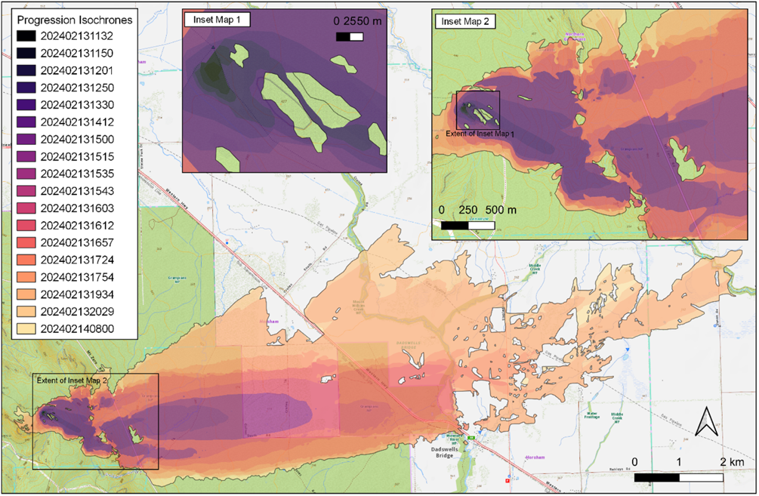
Box 3: Interaction of the Mt Stapylton bushfire with the Golton Creek planned burn
The Mt Stapylton fire interacted with the Grampians NP – Golton Creek planned burn on the east side of Mt Zero Road. The objective of the planned burn conducted in autumn of 2023 was to reduce the overall fuel hazard to Low – Moderate with 30-50%. Although the burn coverage objective was not fully met, the burn was part of a mosaic multi-year burn operation that had not been fully completed. Full crown consumption and leaf freeze on the west side of the road during the Mt Stapylton wildfire indicated that the planned burn area was impacted by crown fire. Given the fire size, amount of spotting and environmental conditions at the time, observations highlight that fire behaviour was moderated in some areas of the planned burn, limiting the fire’s ability to establish in multiple locations on the east side of Mt Zero Road. Rather, the fire re-established initially only in one area had particularly low burn coverage in the Golton Creek planned burn. Furthermore, there are several areas within the planned burn footprint that were unburnt by the bushfire.
The second phase of the Mt Stapylton fire was between 12:50 AEDT and 15:00 AEDT and is highlighted in Figure 1, Inset Map 2. During this period, the fire developed without restriction through the escarpment, aided by spotting.
The third phase of the fire behaviour occurred under the strong westerly, which started at approximately 15:00 AEDT for Mt Stapylton. After the westerly wind change, rates of spread increased to 6,600 m/hr with maximum fireline intensities up to 60 MW/m in the Mt Stapylton fire, with the peak rate of spread being 2.5 times greater than the average across the duration of active fire spread. It was during this period that the fire interacted with a the Golton Creek burn (see Box 3) along Mt Zero Road. For the period 15:30 – 16:12 AEDT, the Mt Stapylton fire spread at between 2,500 and 3,000 m/hr with fireline intensities between 20 and 30 MW/m resulting in crowning, while spotting frequency and range increased to over 1 km.
After entering grazed pastures with curing varying between 70% and 100%, the Mt Stapylton fire spread became discontinuous as evidenced by a fragmented fire scar pattern. Rates of spread continued to be between 2,000 and 3,000 m/hr before the headfire was halted in late evening by a combination of direct attack suppression and fragmenting of the fire by variability in the state of grass (curing, height, structure).

Fire behaviour at the Bellfield Fire
The Bellfield fire was initially reported at 11:20 AEDT with a very approximate location and likely started at 10:11 AEDT due to lightning (Box 4). The fire exhibited similar fire behaviour to the Mt Stapylton fire in its early phase, whereby headfire and flank fire development was limited due to the presence of rocky outcrop vegetation and aerial suppression (Figure 2). It is also possible that wind-terrain interactions assisted in holding the fire, with a lee-side rotor effect on the eastern aspect of the escarpment. The fuels on the escarpment at an elevation ~560 m had an understorey dominated by Callitris regrowth and overstorey dominated by stringybark (with generally 10 to 50% bark char from the last fire in 2006). Near surface fuel height was approximately 35 cm (High Near Surface Hazard), while elevated fuel height of 2.5 m was associated with a High elevated fuel hazard.
Box 4: Detection and reconnaissance of the Bellfield fire
The resourcing chronology for the Bellfield fire was affected not by its initial detection, but the localisation of the fire following the first report. Initial detection and attack for the Bellfield fire demonstrates the usefulness of redundancy in processes:
- A lightning strike close to the origin was recorded at 10:11 AEDT indicating a fire ignition may be possible
- A smoke sighting in the area was reported via 000 at 11:20 AEDT –70 minutes later
- At 11:45 AEDT, a CFA radio sitrep reported a small amount of smoke on the ridgeline with the suggestion it was on the western side of the ridgeline
The air observer platform from Horsham flew over the ridgeline at 12:00 AEDT and confirmed the fire location.
Detection from the latest satellite technology is often promoted as a solution to earlier detection and preventing fire. The best available geostationary satellite (Himawari-8, with 10-minute observation intervals) did not observe any thermal signature until 13:50 AEDT time, 2 hours and 30 minutes after the report by 000 excluding downlink and processing lags. By comparison, the first Himawari-8 detection of the Mt Stapylton fire was as 12:50 AEDT and the Bellfield West fire was not detected by the Himawari-8 satellite.
Figure 2: Map of the progression of the Bellfield fire

The second phase of the Bellfield fire was between 13:30 AEDT and 15:20 AEDT. During this period, the fuel discontinuities presented by the rocky outcrop fuels had less effect on fire propagation, allowing the fire to build up more rapidly. Rates of fire spread was between 900 to 1300 m/hr in a south-south-east direction with spotting generally between 50 and 300 metres, however some longer distance spots were recorded up to 600 metres. Towards the end of this period, crews reported 20 to 30 m flame heights as active crown fire spread downhill near the top of Church Road.
The third phase of the Bellfield fire was between 15:20 AEDT and 16:20 AEDT, which resulted in significant spread to the south-south-east, in part driven by an upslope run to Mt Cassell. Long distance spotting was associated with the fuels around 300 m elevation, being more mixed species eucalypt dominant, including stringybark (Very High bark hazard, < 10% charred stringybark) with ribbon bark species. Elevated fuel heights of approximately 3.5 m (High elevated fuel hazard, Moderate surface hazard).
Complex and localised wind-terrain effects were occurring by 15:00 AEDT because of a westerly wind shift, with aircraft experiencing strong windshear effects in proximity to the ridgeline. Once the fire moved further down from the ridgeline, a step change in fire behaviour occurred (see Box 5). During this period, headfire rate of spread increased to 2,600 m/hr, with some spot fires igniting 2 to 5 km ahead of the fire front, down to the town of Pomonal.
Shortly before impacting the community of Pomonal the fire spread through a burnt area from 2019, known as the Grampians Boronia Track planned burn. The Boronia Track planned burn was in an area of native vegetation on private property, treated with a combination of planned burning and mechanical fuel treatment. The planned burn severity outcome was not mapped with high accuracy. Analysis using Sentinel-2 satellite imagery suggested a reasonably high coverage (approximately 70%) with low crown scorch, the exception being the southeast corner of the burn unit adjoining houses which did not appear burnt. During the bushfire, the area was burnt with high canopy scorch when impacted with flanking fire, but as evident through leaf freeze, transitioned to a crowning head fire with greater canopy consumption when impacted by the westerly wind shift. The evidence available suggests that the planned burn area may have reduced the severity and rate of spread when the fire was flanking, with reduced influence observed when the fire transition to a crowning head fire after the wind change.
Fire severity within proximity to town was higher than upslope with near full canopy consumption, and leaf freeze in many directions indicative of a highly-turbulent wind environment as the fire impacted the town. On the eastern side of Ararat-Halls Gap Road, the fire spread 1-2 km further east but was within a suppressible range for direct attack with variability in grass fuel states (curing and height).

Initial suppression at the Bellfield and Mt Stapylton fires
Box 5: Understanding for the 15:00 AEDT step change in fire behaviour at the Bellfield fire.
Several hypotheses offer explanations for this step change in fire behaviour, which will be best evaluated in a coupled fire-atmosphere modelling approach in research currently underway.
Figure 3: Conceptual diagram illustrating the hypothesized wind and fire dynamics during the Bellfield fire. Reproduced with permission from Sharples et al. (2012).
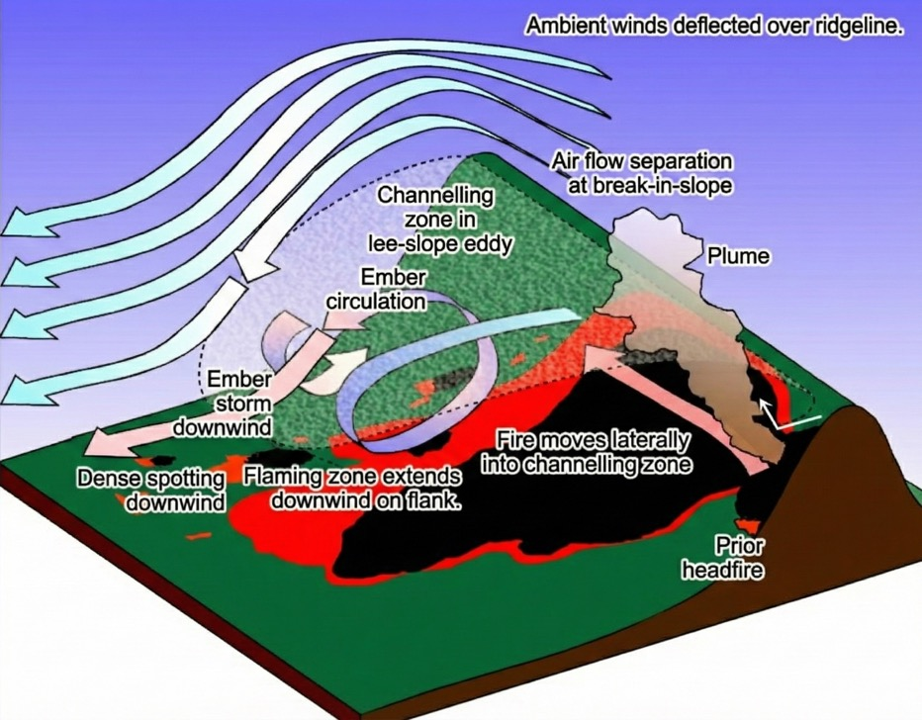
Figure 3 offers a broad conceptual model for the processes at play in the lee-side eddy interacting with fire behaviour. There are no published examples of fires in their incipient phase burning in a deceptively quiet area of ‘air flow separation’ which may have led to the rapid and hard-to-predict escalation in fire behaviour that occurred. The pilot of the heavy helicopter involved with the first few hours of attack on the upper slope reported strong lee slope eddy effects, requiring high caution when conducting drops and aborting several loads of water before delivery.
Due to the proximity of fire locations, the Mt Stapylton, Bellfield and Bellfield West fires were drawing from a common resource pool of initial attack resources and shared incident managements within the region. The nature of initial attack was exclusively aerial firefighting due to the topographic inaccessibility for the Mt Stapylton and Bellfield fires. In both cases the fire behaviour was subdued in the initial phase of development due to the arrangement of the rocky outcrops and potentially lingering moisture from the storm.
At Mt Stapylton, initial behaviour was right on the upper limit of effective aerial suppression, and capability of the tactical aircrafts working (2 single engine air tankers, (SEATs)) was not sufficient. Unburnt areas within the fire footprint near the point of origin could be linked to fire flanking into SEAT-retardant drops prior to 12:20, and these SEATs were achieving 30-minute turnaround times from the airbase. These, combined with outcrops, resulted in pinch points that limited the build-up of the fire, requiring it to slowly navigate through available fuels. However, where fuels were available and connectivity was high, torching and crowning headfire behaviour was observed. Due to the turnaround times of the SEATs and poor visibility from smoke, further drops by the SEATs on the head were prevented once the fire was actively crowning at approximately 12:30 and onwards. Large air tankers (LATS) were limited in their ability to undertake suppression activity throughout the peak of the afternoon due to safety concerns (i.e. strength of winds). With the high rates of spread and intensities of the fire spreading through the heathy woodland fuels between Mt Zero Road and Dadswell Bridge, there was no opportunity for direct suppression by ground or aerial resources. Initial air drops alone were unable to hold the fire in its first phase of development. However, late in the evening, the fire self-extinguished for the most part along the perimeters. It is hypothesised that lower fuel hazard in the 2014 fire history and higher moisture content of large and heavy fuels contributed to the likelihood of self-extinction. This meant that the perimeter could be partially contained with mineral earth control lines established overnight. In the grasslands, around and west of Dadswell Bridge, fire behaviour was within suppressible ranges for tankers (Figure 1 and Table 2).
Figure 4: An aerial photograph of the area around the point of origin for the Mt Stapylton fire indicating the locations first 6 drops by SEATs and later a large air tanker.
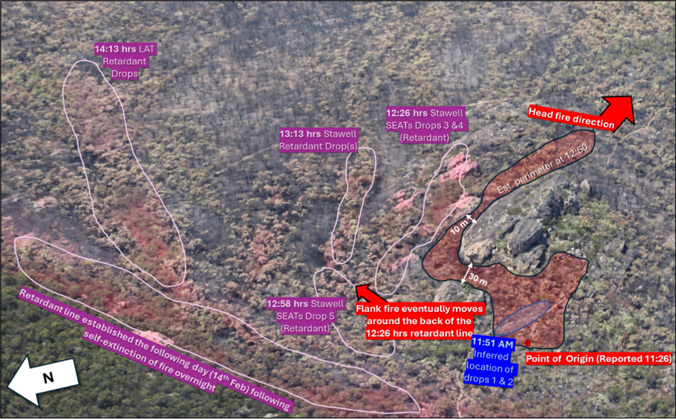
Suppression resources are finite, and in cases where there are multiple simultaneous ignitions close together, these ignitions draw on the same pool of resources. Initial attack on the Bellfield fire illustrates the important role of redundancy in suppression pre-positioning. The location was not accessible by ground crews, and the 2 default pre-determined dispatch SEATs were attached to the Mt Stapylton fire. A heavy helicopter had been positioned at Stawell as a surge resource and was dispatched to the Bellfield fire but encountered a technical issue with its bellytank drop system delaying its arrival. This meant the first drops on the Bellfield fire were from the SEATs at Hamilton. Once the heavy helicopter was working on the fire, it was achieving drop turnarounds from Lake Bellfield of 4.2 minutes, only interrupted at 13:20 AEDT to deliver 2 loads of water on to the Bellfield West fire. Predictions at the time showed a more imminent threat to life and property from the Bellfield West fire, and it was successfully subdued by these drops and later contained by ground crews walking in, aided by higher fuel moistures and lower surface wind speeds. Like the Mt Stapylton fire, the Bellfield fire escaped its aircraft-only initial attack, and as the winds increased, pilots reported the requirement to abort several loads owing to severe turbulence at the ridge.
As the Bellfield fire spread from the ridgeline towards the Pomonal township, defensive firefighting strategies in Pomonal were dictated by the extreme fire behaviour between 15:00 and 17:00 AEDT. During this same period, suppression effectiveness was limited by safety more than efficacy, both on the ground and in the air. Significant turbulence affected the ability of some aircraft to operate safely, and a burnover of a CFA tanker occurred in the town during this period. Important accounts from fireground leaders relating to the viability of the asset protection tactic taking place included the following:
- There was a limited period of time in which triage and planning of defensive action was possible before impact.
- Tree hazard was considerable even prior to impact with large limbs falling from trees, and many trees falling within 10-15 minutes of impact in the high winds.
- The amount of short-range spotting and timing of crown fire made decisions on safety challenging in a complex wildland-urban interface environment.
The fire behaviour and impacts on structures in the town of Pomonal is worthy of further study, as the progression was complex and driven by many short-distance spot fires. The complex and fragmented pattern of the fire as indicated in Figure 2 had many unburned islands in grassy areas despite considerable amounts of active crown consumptions where trees were present.

Fire behaviour at the Staffordshire Reef fire
The Staffordshire Reef Road fire was reported near the intersection of Jubilee Road and Staffordshire Reef Road at 15:27 AEDT. The fire spread towards Staffordshire Reef Road in an easterly direction with 0.5 m flame heights and crossed the road at multiple locations at 16:19 AEDT. Embers travelled up to 100 m and ignited spot fires in a private bush block on the eastern side of Staffordshire Reef Road that resulted in multiple embers establishing in the Ross Creek State Forest. By 17:30 AEDT, the fire had spread 350 m in an easterly direction with an approximate size of 10 ha (Table 2). The fire continued to develop over the next hour growing to a size of 80 ha with forward rates of spread of 1,050 m/hr when including the contribution of short distance spotting (100 – 300 m). Throughout this period, the fire burnt through long unburnt (20+ years) Forest with Shrub vegetation with fuel loads estimated to be 24 t/ha. Figure 5 shows the progression of the Staffordshire Reef fire.
Figure 5: Map showing the progression of the Staffordshire Reef Road fire on 13 February and into 14 February.
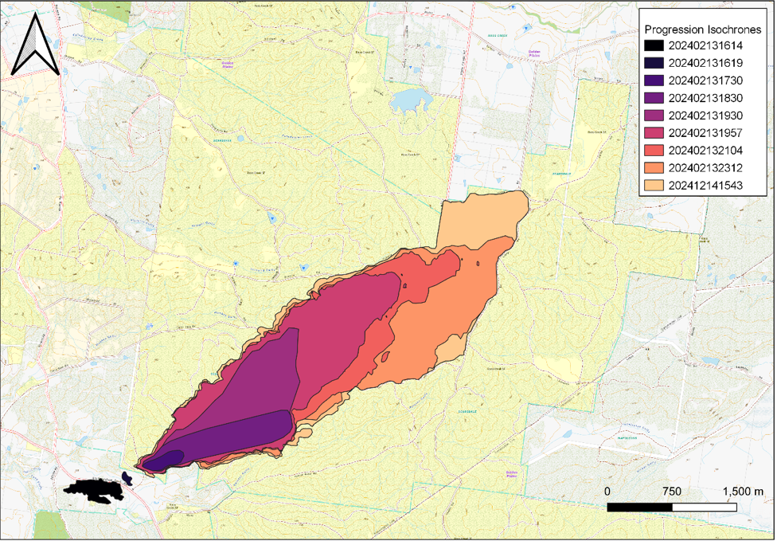
Between 18:20 and 18:30 AEDT, a southerly wind pushed through the fireground, whereby the downwind flanking fire became the head fire immediately after the wind change and increased the intensity through intermittent crowning. With the passage of the wind change, the fire burnt rapidly in a northeasterly direction at a rate of 1,500 m/hr until 19:30 AEDT with spotting up to 1,000m. For the next half hour, the fire continued in a northeasterly direction towards Victoria Road before the fire gradually slowed down and shifted in an east-north-east direction. Between 21:00 and 23:00 AEDT, the average forward rate of spread slowed down considerably.
Box 6: Observations on the interaction of the Staffordshire Reef Road fire with the 2023 Ross Creek – Carey Road planned burn
The Staffordshire Reef Road fire interacted with the Ross Creek – Carey Road planned burn at approximately 23:12 AEDT. The planned burn was conducted in 2023 with the objective of reducing fuel hazards from Extreme to Moderate with 50-90% coverage levels. Figure 6 shows this interaction taking place, with the 13th of Feb 23:12 (top right) showing the junction of the bushfire (red) and burn footprint (grey shading). The fuel conditions at the time of the fire where the fire interacted with the burn are described below. The burn was impacted by a headfire with minor incursion of the fire into the planned burn area (shown in Appendix 1).
Figure 6: Infrared linescan showing the junction of the 2023 planned burn and the Staffordshire Reef fire.
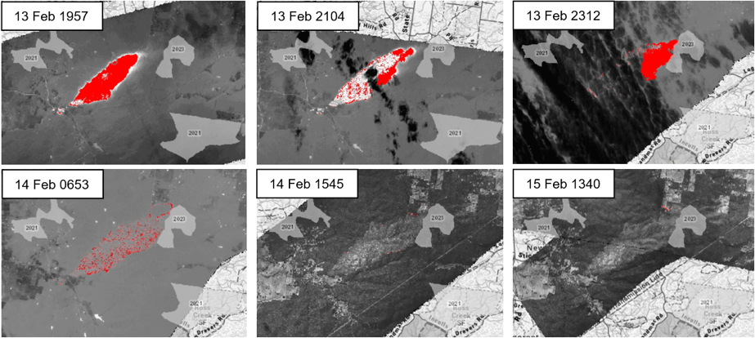
The lower fuel hazard within the burn in combination with decreasing fire intensities and increasing relative humidity overnight is hypothesised to have halted the fire’s spread to the east. This occurred through the multiplier effects of fuel reduction and suppression, whereby:
- crews were present on the interface of the fire and planned burn and reported effective ability to suppress any embers landing in the treated area,
- crews were able to operate efficiently and safely due to good track condition and known minimal tree hazard as a result of the planned burns preparation,
- the Staffordshire Reef operations team were able to leverage the presence of both the fuel-reduced area and other prepared blocks as the Ross Creek – Carey Road burn was planned as a multiple-operation treatment. The prepared blocks were used to undertake burning out operations overnight on 13-14 February which resulted in halting spread to the northeast.
Fuel Variable | 2023 Fuel  Treated Area | Modelled  Area | Non-treatment
Surface fuel depth | 2mm | NA
Surface fuel cover | 70% | NA
Surface fuel hazard | Moderate | Very High
Near-surface fuel height max | 40cm | NA
Near-surface fuel cover | 30% | NA
Near-surface fuel hazard | Moderate | Very High
Elevated fuel height | 3m | NA
Elevated fuel cover | 20% | NA
Elevated fuel hazard | Moderate | High
Bark hazard | High | Extreme
Overall fuel hazard | Moderate | Extreme

The Bayindeen fire – 22 February 2024

Introduction

Bayindeen
LGA: Ararat/Pyrenees
Time of fire report: 10:24 AEDT
Cause: Unknown
Estimated losses:
Land | Area (ha) lost
Public land | 13,966
Private land | 7,435

Buildings | Number lost
Residential | 6
Commercial | –
Outbuildings | –

Forestry | Area (ha) lost
Timber plantation | 1,200
On 22 February, 6 FWDs – Mallee, Wimmera, Northern Country, North Central, South West and Central – had an FDR rating of Extreme with Total Fire Ban declarations. The 90th percentile FBI values were forecast to range between 54 and 76. Under the McArthur FDR, only 2 FWDs, the Mallee and Wimmera, were above 50 (Severe rating), with 90th percentile FDI values of 64 and 86 respectively. Victoria was in a low-intensity heatwave with the potential for possible thunderstorms with dry lightning across central parts of Victoria. On the morning of 22 February, the Bayindeen-Rocky Road (previously known as Bayindeen-Mt Cole) fire started in the Mt Cole State Forest between Ararat and Beaufort. By 18:00 AEDT, the fire was impacting on the town of Raglan and threatening the town of Beaufort.

Fire behaviour at the Bayindeen fire
In the week leading up to this day, the automatic fuel moisture monitoring site near Beaufort was reporting a decreasing trend in subsurface and surface fuel moisture contents of 2% in absolute terms as reported by the 10-hour fuel stick. It is likely that the surface and subsurface fuels in the region were drier than normal, however the exact raw FMC values may be questionable due to insufficient site calibration. Table 3 presents the key fire behaviour observations and calculations for the fire. Intensities presented in the table and through the text are calculated using Bryam’s fireline intensity (IB) leveraging the AFDRS calculations for the model values, while observed IB uses observed rate of spread (IB = modelled fuel load x ROS x heat coefficient).
The fire was first reported at 10:24 AEDT from the Ben Nevis fire tower in the vicinity of Blackwood Road. In this initial phase, fire behaviour was moderate with rates of spread of 100 m/hr and area growth rates of 3 ha/hr in dry forest with no recent fire history. The fire started in an area where local topography to the north sheltered the incipient fire from the wind, helping to limit initial fire spread. Table 4 shows a series of images taken approximately 5 km from the point of origin. Following this first period of spread, in which the fire was protected from stronger wind with an upright plume, at 11:26 AEDT the fire escalated due to an uphill fire run across a WNW aspect, and within 11 minutes, the fire grew to a size of 25 ha. Over the course of the next hour, a notable plume developed through the dry forest as the fire escalated over the ridge across Wallaby Caves Road with spotting distances of 600 m reported. Between 12:47 and 13:20 AEDT, the fire expanded significantly towards the NNE and towards the SE with headfire spread rates observed to be 950 m/hr (Table 3).
Figure 7: Progression map of the Bayindeen fire between 22 and 29 February.
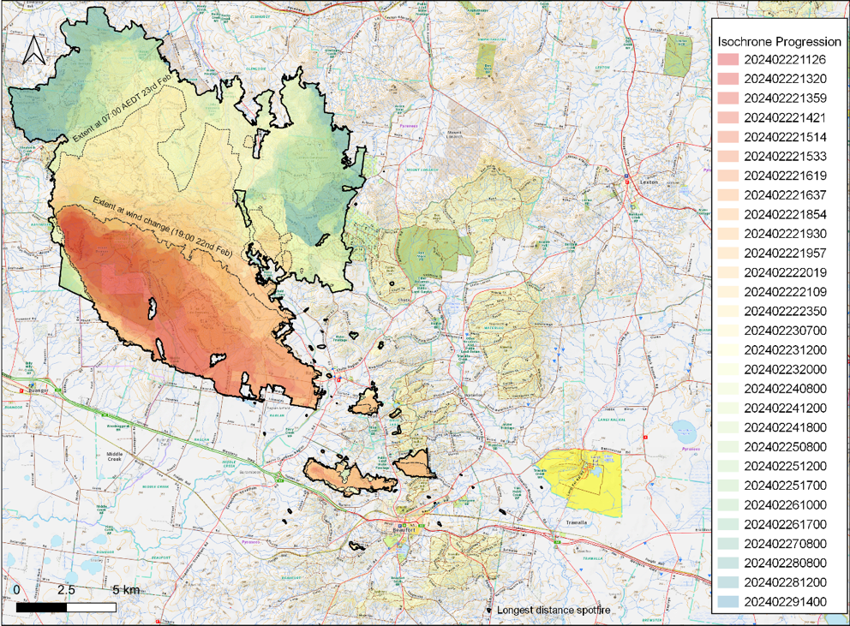
Table 3: Bureau of Meteorology morning issue of the gridded forecast weather and fire danger data related to the 2024 Bayindeen fire with observations of key fire behaviour characteristics.
 | Weather |  |  |  | Vegetation |  | Fire Behaviour
Time Period | TEMP  (ºC) | RH  (%) | WD | WS (G)  (km/hr) | Fuel Type | Modelled Fuel  Load (t/ha) | HfROS  (m/hr) | Spotting Distance (m) | IB Obs  (MW/m) | IB Model  (MW/m) | FBI  (FDI)
10:34 – 11:37 | 27 | 39 | N | 28 (33) | Forest (3007) | 25 | 480 | 500 | 4.8 | 5.1 | 28 (13)
11:37 – 13:20 | 30 | 33 | N | 33 (41) | Forest (3007) | 15 | 950 | 500 – 1,000 | 9.9 | 6.0 | 32 (20)
13:20 – 13:59 | 35 | 22 | NW | 38 (46) | Forest (3007) | 19 | 5300 | 20,000 | - | 11.6 | 38 (40)
13:59 – 14:21 | 37 | 19 | NNW | 39 (48) | Grass/Forest | 21 | - | 3,000 | - | 13.1 | 54 (48)
14:21 – 15:14 | 37 | 19 | NNW | 39 (48) | Forest (3007) | 21 | 2500 | 11,000 | 26.0 | 13.1 | 57 (48)
15:14 – 16:19 | 38 | 17 | NW | 38 (46) | Grass/Forest | - | - |  |  | 14.9 | 42 (18)
16:19 – 16:37 | 39 | 16 | NW | 38 (46) | Grass/Forest | - | - |  |  | 14.9 | 42 (19)
16:37 – 18:54 | 39 | 15 | NW | 38 (46) | Grass/Forest | - | - |  |  | 14.9 | 42 (20)
18:54 – 19:30 | 34 | 20 | W | 29 (37) | Grass/Forest | - | - |  |  | 11.1 | 30 (09)
19:30 – 19:57 | 34 | 20 | W | 29 (37) | Forest (3007) | 25 | 1800 |  | 19.0 | 7.1 | 37 (33)
19:57 – 20:19 | 30 | 24 | WSW | 30 (41) | Forest (3007) | 25 | 1900 |  | 19.6 | 5.7 | 31 (26)
20:19 – 21:09 | 30 | 24 | WSW | 30 (41) | Forest (3007) | 25 | 1200 |  | 12.5 | 5.7 | 31 (26)
21:09 – 23:50 | 26 | 36 | SW | 27 (37) | Forest (3007) | 25 | 700 |  | 7.4 | 3.2 | 20 (14)

Table 4: Images of the plume of the Bayindeen fire captured by Mount Langi Ghiran vineyard looking east.
(Photos: Damien Sheehan)
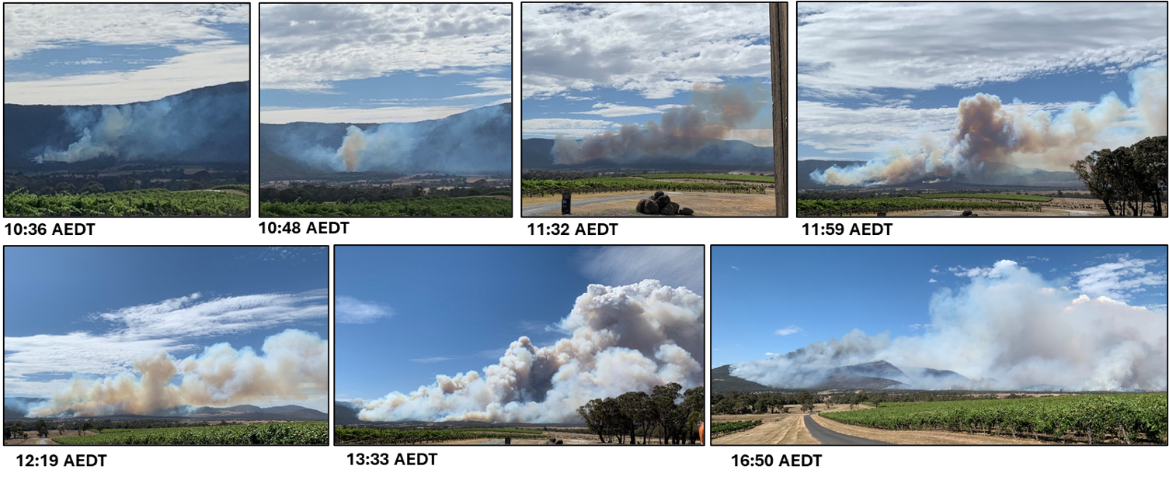
Figure 8: Progression of the Bayindeen fire, annotated with the extent of the progression at the time of the wind change on 22 February, and the extent when mapped on the morning of 23 February.
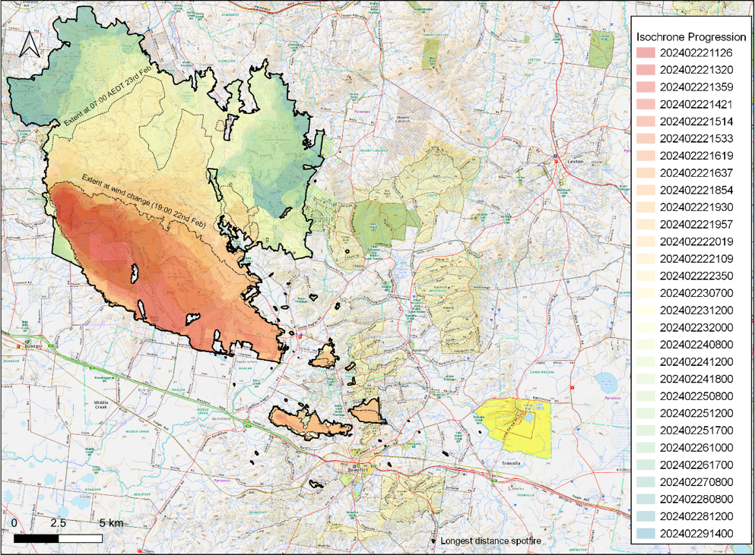
Between 13:20 and 15:33 AEDT, the fire size grew from 198 ha to 4331 ha, with rates of spread averaging 5,400 m/hr with an area growth rate of 1,864 ha/hr or 31 ha/min. Throughout this period, fire spread was dominated by spot fire coalescence. Deep flaming due to coalescing spot fires is likely to have instigated stronger updraughts in the plume resulting in long-range spotting distances of 10 – 20 km. While fireline intensities were likely to have been more than 30 kW/m, the absence of a clearly-defined headfire limits more concise estimates of fireline intensity. The firebrand material causing these spot fires likely originated from the wet forest gully around western end of Old Dairy Maid Road. These spot fires established 3 new running grass fires in private paddocks within the vicinity of the townships of Raglan and Beaufort to the southeast of the main head of fire.
Although there were many embers that established in private land, the grassland fuels were not continuous and curing values varied locally, resulting in variable rates of spread of between 400 to 2,600 m/hr. As a result, fireline intensities are likely to have varied between 0.4 and 6.0 MW/m. Given the amount and variety of suppression resources on ground and in air, many of these spot fires were suppressed prior to the SW wind change that arrived on the fireground shortly prior to 19:00 AEDT. As the winds swung around to the SW between 18:50 and 19:30 AEDT, the flanking eastern edge became a 15 km headfire and the fire spread in the forest vegetation slowed before rapidly escalating to 2,900 m/hr until 20:00 AEDT. Thereafter, the rates of spread through the forest generally varied between 800 m/hr and 2,000 m/hr until the morning of 23 February. This period of overnight spread was notable considering the humidity available, showing the significant contribution of fuel moisture lag and effect of altitude (through humidity) on the fire behaviour.
Box 7: Fire and fuel treatment interactions of the Bayindeen fire
On 23 and 24 February, the Bayindeen fire interacted with 3 planned burns (one-3 years since treatment). DEECA and CFA researchers conducted fieldwork in March 2024 to collect quantitative data on planned burn and wildfire interactions. The investigation included assessing fire behaviour, the fuel moisture at the time of the fire and resultant fire effects in the context of vegetation structure and fire severity. The study also explored the use of novel 3D remote-sensing products to understand fuel structure.
Given their significance, the data and findings of this investigation will be presented separately in a report entitled Fire and fuel treatment interactions during the Bayindeen Rocky Road fire 2024 (Research Report No. 106). Key findings from this report include the following:
- All 3 fuel treatments appeared to slow or halt the spread of the fire. In the case of 2 planned burns, the fire still burned through previously fuel-treated areas; however, this occurred after the main fire front had passed and from linescan analysis appeared to be at lower intensity.
- Where the fire passed through an area that had a recent fuel treatment, generally lower severity was observed in comparison to areas that had not been recently treated. Whilst out of scope for this work, it was observed that a patchwork of unburnt areas may contribute to refuge areas for flora and fauna.
- Areas where fuels were treated provided tactical opportunities to operational staff for active fire suppression, due to a reduced amount of fuel, lower fuel heights and the knowledge that hazardous trees had been assessed and treated.
The length of time that fuel-reduced areas may moderate fire behaviour varies depending on fuel type, fire severity and climate conditions. In the recent burns assessed in the report, a reduction in fire rate of spread and intensity and post-fire severity was observed. However, research and monitoring programs should be expanded to enhance our understanding of these interactions, as results will most likely vary across Victoria.

Suppression and fuel treatment interactions at the Bayindeen fire
The Bayindeen fire had a relatively remote point of origin, and the fire quickly built to a large area of operations for the protection of multiple townships. There were 2 initial SEAT drops that were effective at slowing but not stopping the fire, and access by CFA crews was slowed due to the accessibility of the location by medium or heavy tankers. After the first hour, fire behaviour in the forest was beyond a suppressible range, while in grasslands it was within suppressible and generally held on the forest/grass interface. After initial attack failure, strategy switched to a combination of offensive and direct in grassland, indirect in forest, and defensive in and around the threatened communities. Subsequent fire management operations took over a week and tens of thousands of resource hours to achieve containment.
In a number of instances, suppression was aided substantially by previous fuel management activities. At 17:00 AEDT, 3 spot fires in the bushland adjacent to Beaufort had grown larger – one intersecting Back Raglan Road, another in Main Lead and a third in Musical Gully State Forest. These fires saw some expansion to the north after the wind change but were generally within a suppressible range. A combination of direct attack in grassland and parallel attack in bushland was used, leveraging the planned burn history in the Musical Gully State Forest (Box 7). These were contained by the following morning, while the expansion to the northern flank of the main fire occurred unsuppressed along a 10 km front along the northern flank between the point of origin and the private lands north of Raglan on Raglan-Elmhurst Road.
The following week saw rolling day and night CFA strike teams and FFMV taskforces completing major burning out operations along with direct suppression to establish containment around the fire by 28th February, when multiple sides of the fire were tested under the extreme fire weather conditions as described in the context of the Dereel fire.

The Dereel fire – 28th February 2024

Introduction

Dereel fire (Midlands 108 – Dereel – Kleins Road)
LGA: Golden Plains
Time of fire report: 18:06 AEDT
Cause: Unknown
Estimated losses:
Land | Area (ha) lost
Public land | 13,966
Private land | 7,435

Buildings | Number lost
Residential | 0
Commercial | 0
Outbuildings | 1
On 28th February, the FDR in the Wimmera was Catastrophic and 5 FWDs including the Mallee, Northern Country, North Central, South West and Central had an FDR rating of Extreme with Total Fire Ban declarations. Parts of southwest Victoria were in a low-intensity heatwave and there was forecast potential for severe thunderstorms across the western half of the state. The continuous-Haines was elevated with potential for dry lightning and mixing down of upper-level winds to the surface. Significant strategic resourcing plans were underway on 28th February, associated with the threat of containment escape at the Bayindeen fire. NSW RFS strike teams and a large air tanker had been positioned in Ballarat. These responded to the Dereel fire with an extraordinary weight of attack.

Fire behaviour, suppression and fuel treatment interactions at the Dereel fire
The fire was first reported at 18:06 AEDT on private land as a paddock fire, before entering the bushland reserve adjacent to the Dereel Lagoon. Parts of the bushland reserve had been treated for fuels 3 years prior and had a thick understorey of bracken with stringybark and ribbon bark present. At 18:14 AEDT, a second fire was reported 500 m south of the first fire, and by 18:24 AEDT, the second fire was issuing a smoke plume. Both fires developed relatively quickly, exhibiting rates of spread of 640 m/hr and 860 m/hr between the time of report and 18:35 AEDT (Table 6). Given the hot, dry and windy conditions, surface FMCs were forecast to be 5%, which is indicative of the potential for spot fires to establish and spread. Both fires continued to develop through spotting of up to 500 m that accelerated the growth of the fire and spreading at 1,450 m/hr prior to the wind change. After the arrival of the south-westerly wind change at 19:15 AEDT, the fire doubled in size to 65 ha within a 20-minute period due to spotting. However, shortly after, the winds decreased in strength and the fire behaviour was moderated by fuel types and fuel availability on the private land, allowing for effective suppression to be undertaken.
Figure 9: Progression of the Dereel fire on 28th February.
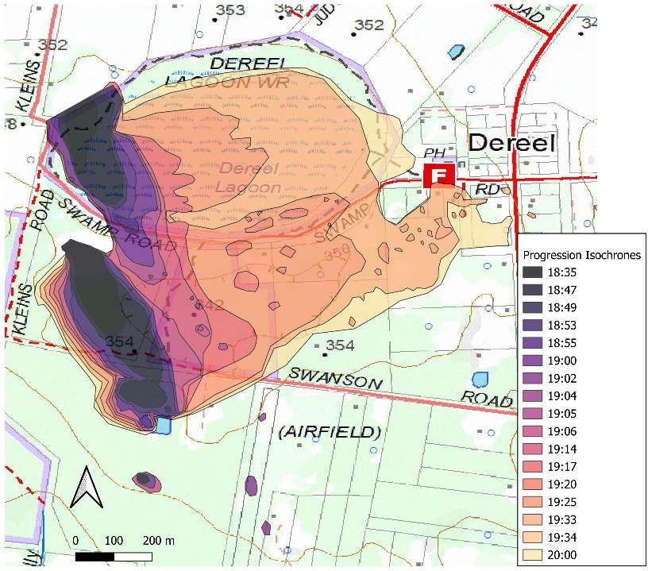
The suppression effort at this fire was undertaken by a combination of ground and aerial resources. Given the extreme fire weather on the day and heightened readiness for the Bayindeen fire, there was a rapid escalation of ground resources, with a request for 25 tankers within 10 minutes. However, initial containment work by tankers was limited by difficulties accessing the bush and swamp areas. Initial efforts by first arriving tankers and one SEAT were not successful at stopping forward progress to the south at Swamp Road for the northern fire or Swanson Road for the southern fire due to spotting.
With the passage of the SSW wind change impacting the fire at around 19:15 AEDT, ground resources worked on asset protection around Dereel, while containment work was still undertaken by aircraft. The spread of the fire was largely stopped by 20:00 AEDT due to the combination of suppression and abating fire weather conditions.
The Dereel – Kleins Road fire interacted with the Dereel – Swanson Road planned burn at approximately 18:35 AEDT. The planned burn was conducted in 2021 to achieve an objective of Moderate or Low fuel hazard with a 50-70% cover. Since the time of the burn, this region of Victoria had received 3 years of above-average rainfall. As a result, a thick bracken layer had re-established and was available as fuel (Table 6, Figure 10).
Table 5: Overall fuel hazard assessments for the Dereel fire in the 2 fire history areas
Overall Fuel Hazard Assessment | 2021 Fuel Reduction  Burn Area | Long Unburnt  (No Fire History)
Stringybark Fuel Rating | Moderate | High
Ribbonbark Fuel Rating | High | High
Elevated Fuel Rating | High | Extreme
Near Surface Rating | High | Very High
Surface Fuel Rating | High | Very High
Overall Assessment | High | Very High to Extreme
The planned burn area was impacted by a headfire under both the northerly wind direction and subsequent westerly wind change – although the evidence suggests this was not as an organised flame front due to disruptions and low fuel vegetation types preceding the planned burn interaction. The fuel reduction burn appeared to have limited influence on the rate of spread due to the re-establishment of the bracken fuel layer and high ribbon bark hazard, however the reduction in stringybark hazard from the planned burn appears to have reduced short distance (i.e. <500m) spotting.
Observations of mechanically fuel-treated areas around private residences were also made. In these areas, fuels were masticated and below 30 cm in height (Figure 10, left). The fire mostly impacted the treated area as flanking fire and fuel conditions caused flame heights to reduce and assist ground-based suppression and the effectiveness of aerial retardant drops.
Table 6: BoM morning issue of the gridded forecast weather and fire danger data related to the 2024 Dereel fire with observations of key fire behaviour characteristics.
Fire: DEREEL
 | Weather |  |  |  | Vegetation |  | Fire Behaviour
Time Period | TEMP  (ºC) | RH  (%) | WD | WS (G)  (km/hr) | Fuel Type | Modelled Fuel  Load (t/ha) | HfROS  (m/hr) | Spotting Distance (m) | IB Obs  (MW/m) | IB Model  (MW/m) | FBI  (FDI)
18:03 – 18:35 | 34 | 21 | NW | 45 (63) | Forest | 11 | 640 | 0 – 400 | 2.0 | 8.5 | 64 (47)
18:35 – 19:04 | 34 | 21 | NW | 45 (63) | Forest | 11 | 1460 | 0 – 400 | 4.5 | 8.5 | 64 (47)
19:14 – 19:34 | 25 | 42 | W | 24 (33) | Forest | 11 | 1470 | 400 – 1000 | 4.5 | 2.8 | 21 (10)
Figure 10: Photos of 3 relevant fuel-treated areas, showing a mechanically-treated area on private property (left), an area treated by a fuel reduction burn in 2021 (centre) and a long unburnt area (right). (Photos: Peter Ashton)
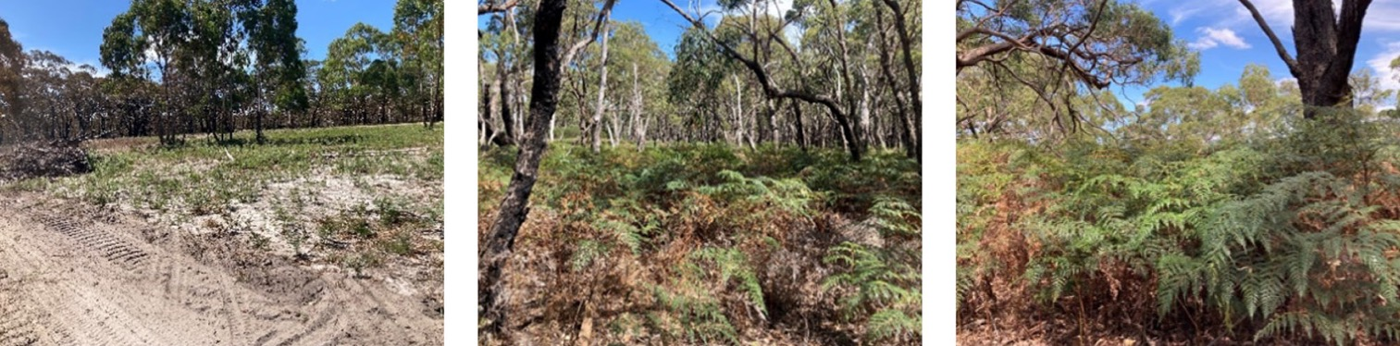

Discussion

Evaluation of the performance of PHOENIX Rapidfire (Automated)
PHOENIX RapidFire Automated (RapidFire for short) is a real-time, online fire behaviour simulation tool that automatically simulates and publishes fire spread simulations into agency operational spatial common operating picture systems. From these spatial systems, paper maps are printed, operational strategy is formed, situation awareness is gained and warnings are issued. These fire and emergency management functions leverage the predictions produced in RapidFire or issued manually into these same spatial systems when RapidFire predictions are not performing. A 6-hour spread RapidFire simulation is generated using the reported bushfire incident location and time of incident, forecast gridded weather and fuel inputs including fire history and small width disruptions (i.e. tracks, roads, rivers). This automated prediction is then reviewed, amended (as necessary) and endorsed by an accredited fire behaviour analyst (FBAN).
This section evaluates the performance of RapidFire in relation to accurately predicting the spread and potential impact zones of the major fire incidents in February 2024. It is important to note that the role of prediction tools is to convey levels of risk to support timely decisions. In recent research, it was found that timeliness was more critical than accuracy – and that personal relationships between FBANs and decision-makers was an important factor in utilising advice derived from fire spread predictions. RapidFire is a quick appraisal tool used by FBANs and is most valuable in scenarios with multiple concurrent ignitions, such as the fires on 13th February. Here we focus on the use of RapidFire predictions that were initially verified and issued by FBANs, noting some tweaking of inputs may have occurred. Also of note is that they were superseded in most cases by manual predictions produced by manual use of the PHOENIX simulator and/or manual predictions using spreadsheets and one-dimensional fire models, as is common in Victoria when simulators are not validating in an operational context.
On 13th, 22nd and 28th February, 125, 95 and 67 RapidFire predictions were produced and triaged respectively by fire behaviour analysts. It is likely that there were many duplications of the major incidents as reported by community members through triple zero calls. Figure 11 shows the RapidFire predictions endorsed on the day while Figure 12 shows the predictions that were rejected due to the potential under representation of risk. Table 7 highlights the differences of area estimates based on the 6-hour prediction and area observations from this this report.
Figure 11: PHOENIX RapidFire predictions for the Mt Stapylton (left, endorsed 11:55 AEDT), Bellfield (centre left, endorsed 12:57 AEDT), Bellfield West (centre right, endorsed 13:43 AEDT) and Staffordshire Reef (right, endorsed 17:51) fires.
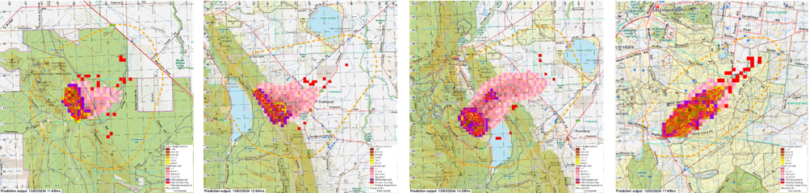
Figure 12: PHOENIX RapidFire predictions for the Bayindeen (left, rejected 11:20 AEDT), Dereel (right, rejected 19:06 AEDT) fires.
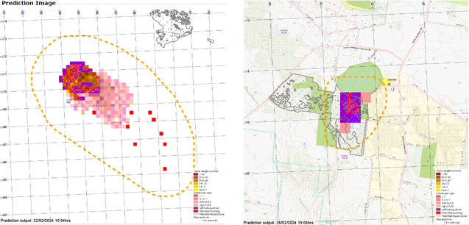
Table 7: Differences of area estimates based on the 6-hour prediction and area observations
Fire Name | Predicted Area (ha) | Observed Area (ha)
Mt Stapylton | 168 | 4133
Bellfield | 142 | 1762
Bellfield West | 226 | 0.1
Staffordshire Reef Road | 363 | 468
Bayindeen* | 218 | 4906
Dereel* | 4 | 100
* Denotes that the automatic PHOENIX RapidFire prediction was rejected by the fire behaviour analyst.
The PHOENIX RapidFire outputs suggest that for the Bellfield, Mt Stapylton and Staffordshire Reef Road fires, the potential impact zones were likely to be accurate enough to support decision making. For other fires, the potential impact zone was under or over-represented. However, regarding the fire spread mechanisms, all fires were under or over forecast by an order of magnitude except in the case of the Staffordshire Reef Road incident. The underpinning reasons for this amount of variability may be related to the compounding effects of the simulator inputs and simulator capability. In terms of simulator inputs, the considerations for the prediction performance are as follows:
- The fuel inputs into the simulator, which are categorical fuel types. These are not directly evaluated in this report and cannot be changed in the RapidFire system during fire events.
- The effects of the fire history on moderating fire behaviour by bushfire simulators were found to be disproportionate to the actual effect the burn had on observed fire behaviour. It is speculated that such effects may be exacerbated by unusually wet seasons preceding major fire events, but this is not easily quantifiable. While simulators and the underlying models only accept a naïve time since fire input and not a severity class of that last fire, low intensity and unburnt islands are mapped in footprints within fire history, and could be better resolved to reflect their limited impact under extreme fire weather conditions.
- The role of weather forecast performance. This is not evaluated as a part of this report, but typically one of the earliest steps by an FBAN to update an initial prediction or transition a prediction out of RapidFire is to validate the gridded weather forecast against nearby observations. Then the FBAN will update the prediction again once a BoM Incident Weather Forecast has been issued. During the 13th February fires, forecast performance was an issue noted, compounding simulator performance.
- Suppression is not accounted for in the simulations. This is only a reason for overestimation of likely scenarios, not underestimation, which occurred in several instances. The data collected will allow sensitivity testing in future work on the role of suppression for these case studies
In terms of simulator capability, the possible causes of performance issues for these cases are as follows:
Bushfire simulators do not capture the fire-weather interactions along ridgelines or other com-plex topographic interactions, which compounds any forecast uncertainty
Bushfire simulators are not designed to predict local scale (1 to 10 m2) fire behaviour due to the absence of intelligence and models that resolve interactions between fire and fuel avail-ability at such scales
The build-up phase of forest fires is highly uncertain making current operational models and simulators unable to accurately predict.
Unpacking the interactions between validity of inputs and simulator capability requires more rigorous sensitivity analysis than is presented here and is context dependent. Here we present it in an operational context, and document performance and data for this future evaluation. The insights, however, still hold value for the work of operational fire prediction, as well as strategic bushfire risk modelling that use the same simulators.

Evaluation of the Australian Fire Danger Rating System fire behaviour models
Figure 13: Documented fire behaviour from the February 2024 fires compared to previous fire events in relation to the AFDRS. The coloured shaded boxes are from the February 2024 fires represented by the forecast FDR, while the parentheses represent the fireline intensity calculated from the observations for the 2024 fires and major historic fires in grass and forest vegetation.
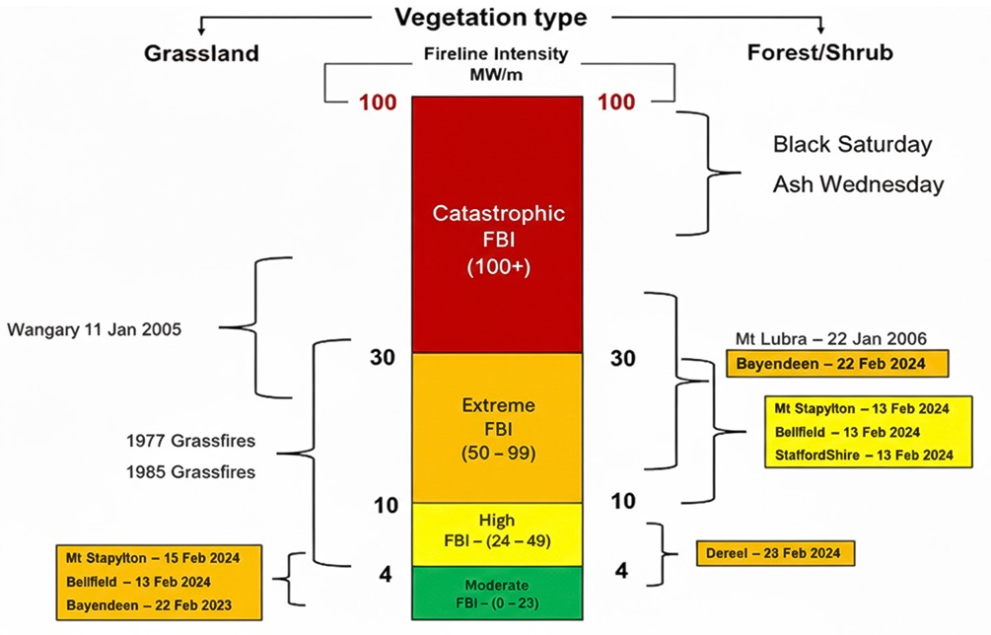
In general terms, the Australian Fire Danger Rating System (AFDRS) overestimated potential fire behaviour in grasslands and underestimated the potential in forests. Figure 13 shows the relative intensities for the fires against the rating categories with reference to other significant fires from Victoria’s history.
Fire behaviour as forecast by the AFDRS models in forest/shrub-dominated vegetation was under-forecast when compared to observations. The underlying causes of this modelling error are not known, resulting in an under-forecast of fire behaviour. Plausible explanations include:
fire behaviour through the AFDRS does not take topography into account, including the inter-actions with complex terrain that drove extreme fire behaviour for several of the fires stud-ied,
fuel availability and/or structural fuel hazard components were inadequately represented as part of the forest fuel hazard inputs within the fire behaviour model.
Grassfire spread was abated by the variability in landscape grass fuel conditions (curing, structure and continuity) with average headfire rates of spread well below that as forecasted by the AFDRS. As a result, the fire behaviour in grasslands had a fragmented pattern of fire spread that allowed for successful suppression activities to be undertaken. This speaks to the limitations of an intensity-based Fire Behaviour Index (FBI) for grasslands.

Lessons on incipient fires, aerial suppression and inaccessible terrain
The first phase of bushfire development is poorly understood in real-world environments, even during critical fire weather. This was highlighted in a fragmented style of fire spread when interacting with:
- the fuel disruptions in rocky outcrops and walking trails in the Grampians fires
- short distance spotting as a fire spread mechanism as evidenced during the Staffordshire Road and Dereel fires.
The analysis showed that in all cases, aircraft were able to slow the development of fires to a point but unable to stop fires completely in inaccessible terrain. The Bellfield and Mt Stapylton fires had long walk-in times for hand crews, and the turbulent winds would have made aerial insertion of crews unsafe should it have been an option on the day. The Bellfield West and Dereel fires were accessible by ground resources (arduous FFMV hand crews and CFA tankers respectively) and the ‘buying of time’ for these ground resources by aerial resources was quite effective in both cases. Firefighting aviation slowing but not stopping fires is in alignment with conventional wisdom from the fire management community about their use. However, simultaneous ignition events that split resources (Mt Stapylton, Bellfield, Bellfield West) are common for lightning ignitions and can further limit aerial capacity. The reality of simultaneous ignitions is an important consideration for agency doctrine and models of response. Terrain accessibility needs to be accounted for in this, and links to the understating of the role of topography in fire danger model calculations. These insights could be leveraged in initial attack models to go beyond ‘probability of success’ and incorporate resource typology into model design.

Lessons on fuels treatment interactions
While the analysis of the several fires that interacted with areas that had been previously fuel treated is ongoing, where the fire passed through an area that had been previously burnt, generally lower severity was observed in comparison to areas that had not been previously treated. Fuel treatments also provided tactical opportunities for actively suppressing the fire in an area that had previously been prepared and treated for hazardous trees. Importantly, these areas also provided an opportunity for efficiently implementing effective containment strategies after initial attack was unsuccessful.
The inputs provided to PHOENIX Rapidfire overstated the significance of Land Management Zone and Bushfire Moderation Zone fuel treatments in one to 3 year burn treatments in retarding fire behaviour under Extreme FDR conditions when coverage levels were variable after fuel treatments. As a result, PHOENIX Rapidfire predictions resulted in a large underestimate of risk potential. This is in part due to an absence of low-resolution severity mapping for planned burns being used as an input for PHOENIX or for manual fire predictions but linked is also the lack of data on how planned burn severity influences fuel and subsequent fire behaviour. This is a significant find for the modelling of risk in Victoria and speaks more broadly to the importance of fuel characteristic and structure monitoring after treatments for both strategic risk and operational prediction reasons.
From a methodological perspective, the high temporal resolution observations from aircraft (particularly from the raw 12-band linescans data), novel 3D remote sensing and ground truthing enabled an investigation into the nature of the interactions and the influence of previously-treated areas on altering fire behaviour. The datasets available to accompany this summary report will form the quantitative basis on which significant advancements in science will occur. This advancement in science is invaluable for agency policy and operations and is not possible without the underpinning datasets.

Publication information

Acknowledgements
The authors would like to acknowledge that the perspective presented here are a western perspective of fire knowledge and science. Victorian Traditional Owners have a long established and continuing connection to the landscapes discussed in this report, particularly in the Gariwerd Grampians landscape which was a key geography in the 2024 major fires in western Victoria.
The authors would also like to acknowledge Andy Ackland, Ambler Eutsler, Miguel Cruz (CSIRO), Mitch Stephen, and Glenn Rudolph for their contribution to fieldwork and analysis. The authors would also like to acknowledge Zed Senbergs, Saif Peerbux, Jason Yang, and Jack Thwaites provided mapping support to the reconstruction team. Numerous other SCC, ICC, Region and District staff contributed significantly to the reconstruction during challenging conditions, in some cases while response was still underway.
The authors are grateful to Trevor Howard (National Manager, Prescribed Burning Strategy) at the Australasian Fire and Emergency Service Authorities Council (AFAC) for review of this work.

Authors
Nick McCarthy, Musa Kilinc, Darcy Prior, Sam Hillman, Peter Ashton, Kristy Butler, and Tegan Brown

Photo credits
Tony Venes (Cover)
Nick McCarthy (P6, P14)
Mitch Stephen (P17)
Tegan Brown (P39)

Acknowledgements of Victorian Traditional Owners
We acknowledge and respect Victorian Traditional Owners as the original custodians of Victoria’s land and waters, their unique ability to care for Country and deep spiritual connection to it.
We honour Elders past and present whose knowledge and wisdom has ensured the continuation of culture and traditional practices.
DEECA is committed to genuinely partnering with Victorian Traditional Owners and Victoria’s Aboriginal community to progress their aspirations.

Copyright
© The State of Victoria Department of Energy, Environment and Climate Action, November 2025.

Creative Commons
This work is licensed under a Creative Commons Attribution 4.0 International licence. Visit the Creative Commons Attribution 4.0 licence page.
You are free to re-use the work under that licence, on the condition that you credit the State of Victoria as author. The licence does not apply to any images, photographs or branding, including the Victorian Coat of Arms, and the Victorian Government and Department logos.
ISBN 978-1-76176-684-8 (pdf/online/MS word)

Disclaimer
This publication may be of assistance to you but the State of Victoria and its employees do not guarantee that the publication is without flaw of any kind or is wholly appropriate for your particular purposes and therefore disclaims all liability for any error, loss or other consequence which may arise from you relying on any information in this publication.

Accessibility
To receive this document in an alternative format, phone the Customer Service Centre on 136 186, email customer.service@delwp.vic.gov.au, or contact National Relay Service on 133 677 or visit the National Relay Service website. Available on the DEECA website.
End of document.

