Fire, Landscape Pattern and Biodiversity
  - Research Fact Sheet
Forests, Fire and Regions Group invests in the Integrated Forest Ecosystem Research Agreement (IFER) with the University of Melbourne (UM), which delivers critical science projects to support policy and operational practices. The core research themes of IFER include biodiversity, carbon, hazards, socio-economic, vulnerability and water. Interactions between fire, landscape pattern and biodiversity is an IFER Biodiversity Core project. It commenced in July 2009 and is due to be completed by June 2019.

The Project
In 2008, DELWP introduced a landscape-scale mosaic burning program in Victoria. This type of burning creates a patchwork of vegetation types of varying post-fire ages. This is referred to as spatial heterogeneity.
In conjunction with this approach, DELWP wanted to understand if spatial heterogeneity in post-fire ages and vegetation types benefits biodiversity. To test this, UM established a research project in the Great Otway National Park in southern Victoria. The project has been undertaken in three phases.
In Phase 1 (2009-2015) UM examined how birds, ground-dwelling mammals, and vascular plants responded to spatial heterogeneity in post-fire ages and vegetation types across the landscape. The 100 ha sampling units, ‘land mosaics’, represented different combinations of post-fire ages and vegetation types.
In Phase 2 (2011-2014) UM examined the effects of single planned burns on bird and mammal populations.
The movements of invasive predators like foxes, which prey on native animals, particularly after fires when plant cover has been reduced and native animals are more vulnerable, was also examined.
In Phase 3 (2016-2019) UM are resampling the ‘land mosaics’ from Phase 1. Continued planned burning since 2015 has changed the nature of the spatial patterns in the landscape. Resampling will give the researchers the confidence to separate the effects of burning from vegetation type.
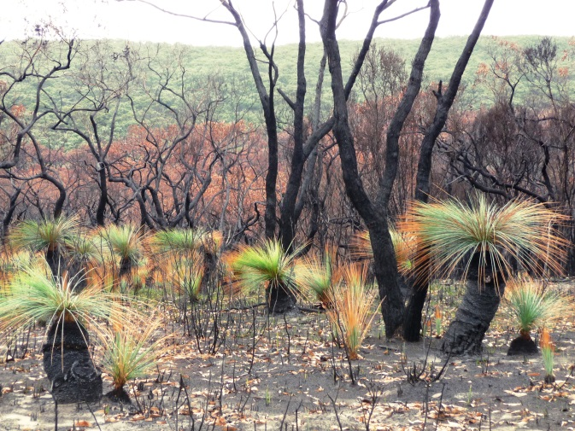
Image 1: Woodland regenerating after planned burning in the Otway Ranges (Photo: Alan York)

Project Outputs
The project will provide DELWP and its land management partners with:
- Knowledge on whether fire-associated spatial heterogeneity benefits biodiversity and contributes to ecosystem resilience.
- Knowledge on how individual species are affected by different post-fire ages.
- Knowledge on the effects of fire on key habitat features such as logs and ground cover.
- Data to help answer strategic monitoring and evaluation questions of relevance to the Barwon Otway Bushfire Risk Region.

Policy and Operational Implications
DELWP has two primary objectives for Bushfire Management of Public Land:
- To protect life and property
- To maintain or improve the resilience of natural ecosystems and their ability to deliver services such as biodiversity, water, carbon storage and forest products.
This project is specifically targeted at objective 2.
The project will provide DELWP with an understanding of the effects of current fuel management practices on biodiversity, and support decision making about varying fire regimes through evidence about the impact of alternative regimes on biodiversity values and ecosystem resilience.
The Research Team
This research is being conducted by the Fire Ecology and Biodiversity Group at UM, in partnership with DELWP and Parks Victoria.
The project is coordinated by Dr Matthew Swan assisted by A/Prof Alan York, Dr Julian Di Stefano and Dr Holly Sitters (all University of Melbourne).
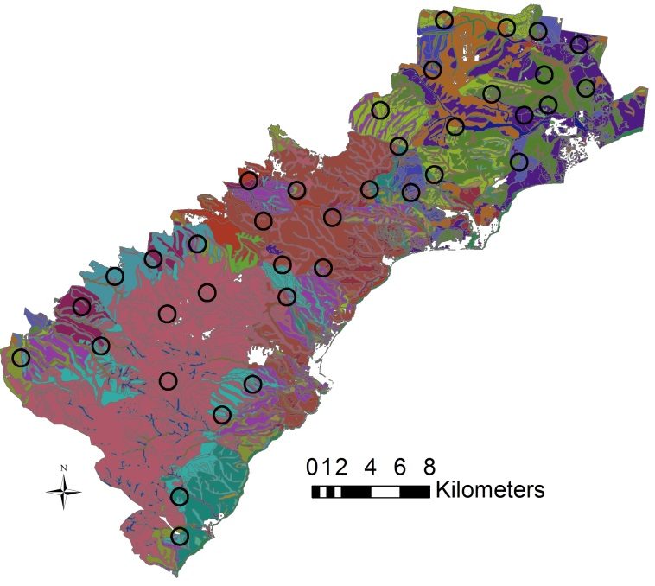
Figure 1: The study area in the Otway Ranges showing circular ‘land mosaics’. Different colours on the map represent different vegetation types and post-fire growth stages, highlighting the heterogeneous nature of this landscape.

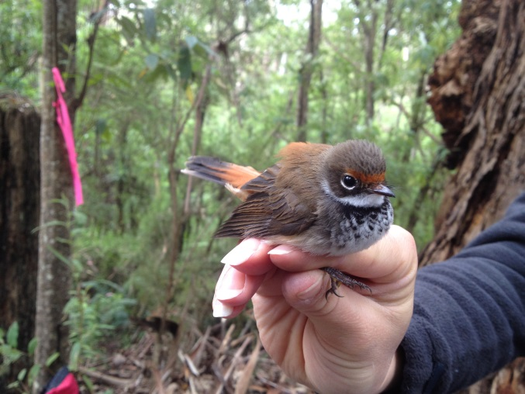Image 2: Rufous Fantail Rhipidura rufifrons (Photo: Holly Sitters)

Project Status (July 2018)
Phases 1 and 2 of the project have been completed and have resulted in an extensive range of scientific publications and a DELWP Fire and Adaptive Management Report (links provided below).
Phase 3 of the project is underway and includes the work of three students. Annalie Dorph (PhD) and Ellen Rochelmeyer (Masters) are undertaking projects focussing on ground-dwelling mammals. Sandra Penman’s research (PhD) is focused on microbats.
Ground-dwelling mammal and habitat surveys were completed in 2017. Statistical models of the effect of fire-mediated heterogeneity on mammal diversity have been developed, and UM are currently investigating change in these relationships over time. Preliminary surveys of microbat communities have been undertaken using call recording, with analyses of these data underway.
For further information, and a list of publications arising from this research, please visit the project website:
http://fireecologyandbiodiversity.com/fire-landscape-pattern-and-biodiversity.html
DELWP Fire and Adaptive Management Reports can be accessed at:
https://www.ffm.vic.gov.au/research-and-publications/fire-research-and-adaptive-management-publications

