Fire and fuel treatment interactions during the Bayindeen Rocky Road fire 2024

Research Report No. 106
Table of Contents
1. Executive summary 3
2. Situation and aims 5
3. Methods 5
3.1 Site and plot data 6
3.2 Data capture 9
3.2.1 Field data and analysis 9
3.2.2 Fuel moisture content (FMC) 9
3.2.3 TLS data capture and analysis 9
3.3 Fire behaviour analysis 10
4. Results and discussion 11
4.1 Fire behaviour 11
4.1.1 Mt Cole – Little Wimmera Track North 13
4.1.2 Beaufort – Larkin Road 14
4.1.3 Beaufort – Mt Lonarch Road 16
4.2 Fuel treatments and operational decision-making 17
4.3 Fire effects 19
4.3.1 Fire severity 19
4.3.2 Fuel structure 21
4.4 Fuel moisture content (FMC) 29
5. Conclusions and future work 31
6. Appendix 32
6.1 TLS processing 32
6.2 Fire severity 34
6.3 Fuel structure 35
7. Reference list 37
Publication information 39

Executive summary
The MIDLANDS 104 – BAYINDEEN – ROCKY ROAD fire was reported at 10:24hrs on 22 February 2024. Over the next 2 days, the fire spread through 3 areas with recent (< 5 years) planned burn treatments. Researchers from Forest Fire Management Victoria (FFMVic) and Country Fire Authority (CFA) conducted fieldwork in March 2024 to increase our understanding of fuel treatment and bushfire interactions. This study included assessing the effect of treated areas on fire behaviour, post-fire effects (including vegetation structure and severity) and fuel moisture at the time of the fire. 3D remote sensing was also used to objectively quantify fuel structure. The key findings are as follows:
- All 3 fuel treatments appeared to slow or halt the spread of the fire. In the case of 2 planned burns, the fire still burned through previously fuel-treated areas; however, this occurred after the main fire front had passed and from linescan analysis appeared to be at lower intensity.
- Where the fire passed through an area that had a recent fuel treatment, generally lower severity was observed in comparison to areas that had not been recently treated.
- Areas where fuels were recently treated provided tactical opportunities for operational staff to undertake active fire suppression due to a reduced amount of fuel, overall lower fuel heights and the knowledge that potentially hazardous trees had been assessed and treated.
The length of time that fuel-reduced areas may moderate fire behaviour varies depending on fuel type, fire severity and climate conditions. In the recent burns assessed here, a reduction in fire rate of spread, intensity and post-fire severity was observed. Future research and monitoring programs should continue to study fuel treatment and fire interactions across Victoria’s diverse vegetation types to understand variability across space and time, as well as increasing the documented evidence base and circumstances where fuel treatments support effective active fire suppression.
Figure 1: Post-fire severity mapping of the Bayindeen – Rocky Road fire at 3 recently fuel-reduced areas. The burn perimeters are outlined in black. Lower post-fire severity values are indicated by darker colours, lighter colours indicate high post-fire severity.
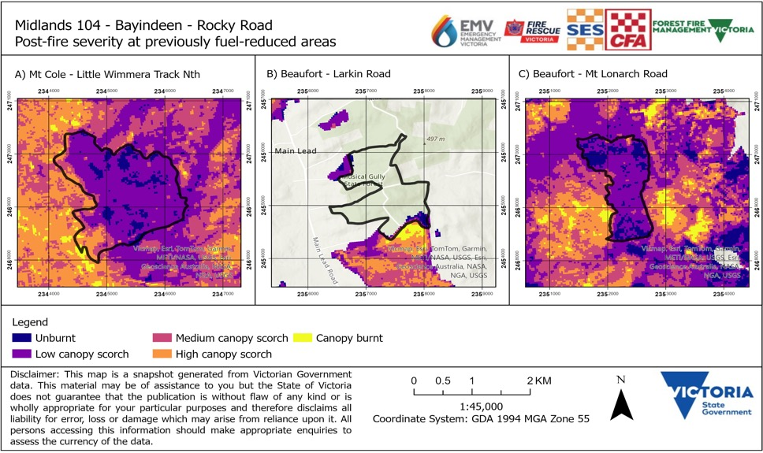

Situation and aims
The MIDLANDS 104 – BAYINDEEN – ROCKY ROAD fire interacted with 3 recent planned burns.
- Mt Cole – Little Wimmera Track Nth (2021)
- Beaufort – Larkin Road (2023)
- Beaufort – Mt Lonarch Road (2021)
The aim of this project was to conduct a pilot investigation into 3 main areas of interest:
- Interactions or effects of recent fuel treatments on fire behaviour in the fire footprint. ‘Recent’ was defined as burn history within 5 years following Collins et al. (2023),
- The resultant fire effects (structure and severity) in areas that were previously fuel treated and those which had not had recent fuel treatment, and
- Fuel moisture conditions in the lead-up to the fire to provide context to the interactions explored.

Methods
A field team of 4 people from FFMVic and CFA conducted assessments within the Bayindeen – Rocky Road fire footprint on 14 and 15 March 2024. Conversations with local fire managers about their experiences during both the planned burn operations and the fire suppression effort were invaluable and helped the field team establish field sites and plot locations.

Site and plot data
There were 3 locations that satisfied the criteria of recent planned burn history, ranging from one to 3 years post-fuel treatment. Across the 3 planned burns, 7 sites were assessed with a total of 17 data collection plots captured (Table 1). Sites were selected using a stratified random approach, with the following protocol:
All plots were accessed from the burn boundary. Internal tracks had not been assessed for tree hazard and thus were not safe.
After reaching the burn boundary by road, a random number generator was used to determine the site distance from this intersection. Plots were located 30-100 m from the road.
Plots that were sampled included: bushfire-only, planned burn and bushfire, planned burn only and unburnt. Consequently, each site assessed contained plots with a unique fire history or previous treatment. (Table 1).
Data characterising fuel treatments were extracted from the Victorian Fuel Management System (FMS).
This report details fieldwork undertaken immediately after the bushfire. Due to operational and safety constraints, the number and location of field sites were limited, as was the number of fuel treatments that could be assessed. Nevertheless, we believe the findings of this work provide valuable insights to the effects of fuel treatments on fire activity.
Table 1: Site and plot information captured across the Bayindeen – Rocky Road fire. Plots were systematically captured to ensure a range of fire history patterns was observed.
Site – Planned burn | Plot | Fire history
1. Beaufort – Larkin Road (2023 burn) | 1 | Bushfire
 | 2 | Planned Burn/Bushfire
 | 3 | Planned Burn
2. Beaufort – Larkin Road (2023 burn) | 4 | Bushfire
 | 5 | Unburnt
 | 6 | Planned Burn
3. Beaufort – Larkin Road (2023 burn) | 7 | Planned Burn
 | 8 | Bushfire
 | 9 | Unburnt
4. Beaufort – Mt Lonarch Road (2021 burn) | 10 | Planned Burn/Bushfire
 | 11 | Planned Burn/Bushfire
5. Beaufort – Mt Lonarch Road (2021 burn) | 12 | Planned Burn/Bushfire
 | 13 | Bushfire
6. Mt Cole – Little Wimmera Track (2021 burn) | 14 | Planned Burn/Bushfire
 | 15 | Bushfire
7. Mt Cole – Little Wimmera Track (2021 burn) | 16 | Bushfire
 | 17 | Planned Burn/Bushfire
Figure 2: Site locations of field observations (yellow crosses) captured across the Bayindeen – Rocky Road fire. Sites were selected at each of the 3 planned burns. The planned burn areas are depicted in grey fill and the fire area is outlined in black.
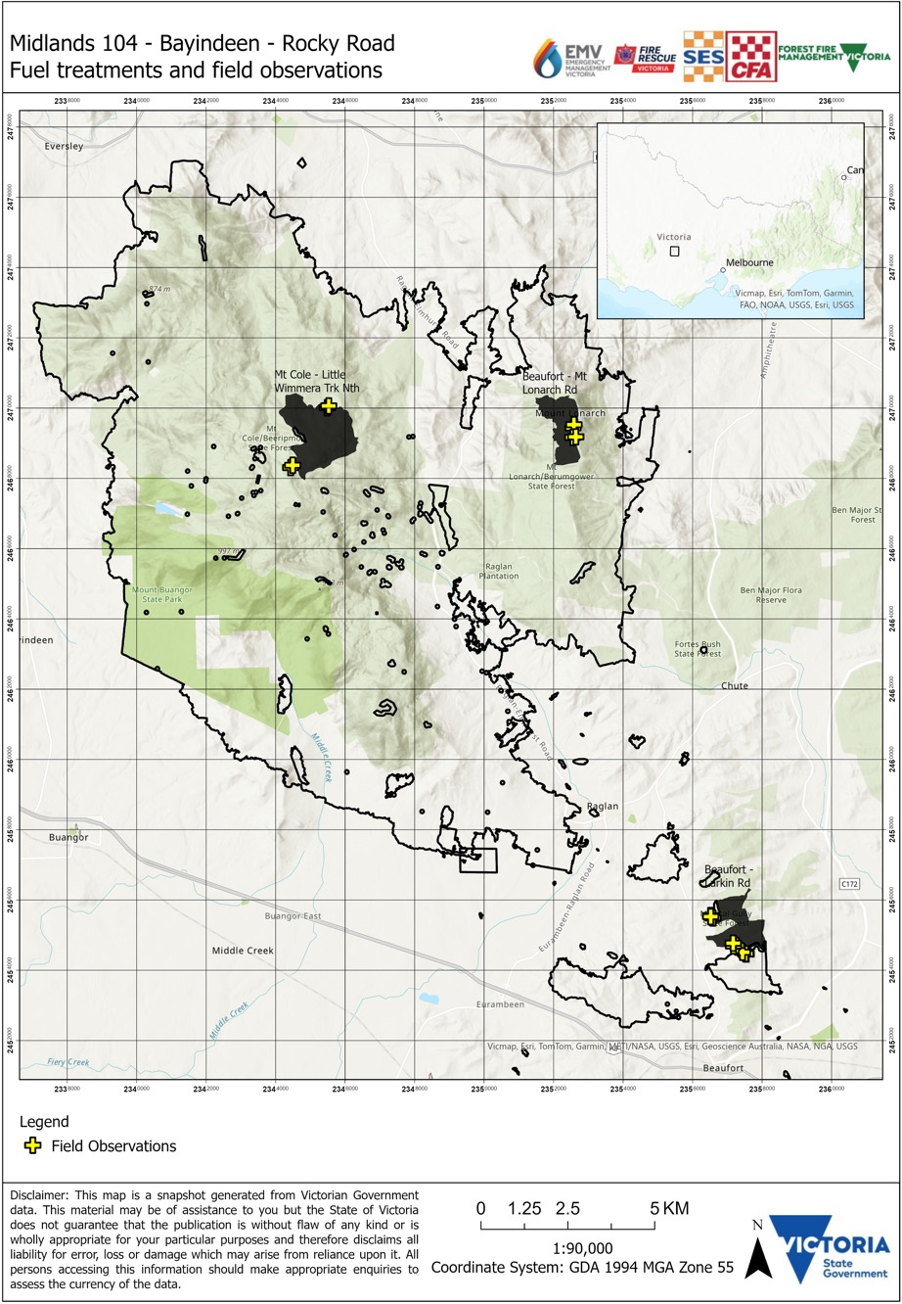

Data capture

Field data and analysis
At each plot, a centre point and 20 m radius were identified. Within this 20 m, fire severity and fuel structure assessment and measurements were undertaken. Visual fire severity assessments were undertaken using the schema developed by Smith (2024). Visual fuel assessments were undertaken in accordance with the protocol outlined in the Overall Fine Fuel Hazard Assessment Guide (Hines et al., 2010). Additional simple visual observations were taken to support the future expansion of fuel assessment protocols. These observations included: grass, shrub, woody sapling, canopy condition, distribution and height metrics as well as an overall assessment of vegetation connectivity.
Due to operational feasibility, a limited number of sites and plots were captured within a
2-day window. Consequently, care must be taken when interpreting results due to limited sites and thus data. In the future, a greater number of field sites and plots could be established across the fuel-treated and fire-affected area, that would enhance our understanding of these interactions. Nevertheless, the data presented here give valuable insight into the effects of fuel treatments on fire behaviour and fire effects.

Fuel moisture content (FMC)
FMC measurements were not captured during this study. However, dead fuel moisture data from the Beaufort Automatic Fuel Moisture (AFM) Station, which was inside the fire footprint, are reported to provide context regarding the conditions under which the fire interacted with the recent fuel-treated areas.

TLS data capture and analysis
A FARO M70 terrestrial laser scanner (TLS) was used to capture vegetation structure information across the sites (Figure 3). FFMVic has 5 scanners that are currently being trialled around the state. Due to time and safety constraints, a single scan approach consistent with Pokswinski et al. (2021) was undertaken with scans clipped to a 10 m radius.
TLS point cloud data were processed following Hillman et al. (2021) to extract 3 fuel height classes: surface and near-surface combined fuel layer (<0.60 m), elevated (0.60 m to 3 m) and canopy (>5 m). Mean cover and height metrics were determined for each of these layers or functional types. A detailed description of the processing steps is outlined in Appendix 6.1 – TLS processing.

Fire behaviour analysis
Linescan images were captured at high frequency between 22 and 24 February. This facilitated a detailed analysis of the interaction between the fire and previously fuel-treated areas. Manual interpretation of the fire behaviour and intensity in the lead up to, and the time the fire impacted the fuel-treated areas were assessed from the linescan images.
On-ground observations from firefighting personnel were also used to support the analysis.
Figure 3: Terrestrial laser (TLS) scanner data capture.
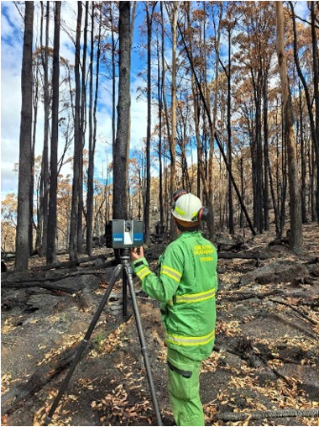

Results and discussion

Fire behaviour
The MIDLANDS 104 – BAYINDEEN – ROCKY ROAD was one of several fires that started in western Victoria in February 2024. These bushfires occurred under elevated fire weather conditions, significantly impacting both public and private land. This fire was reported at 10:24 hrs on 22 February and burned a total 20,496 ha. A detailed analysis of the fire behaviour is outlined in the 2024 Major Fires Summary report.
Between 22 and 24 February, the fire interacted with 3 areas that had been part of the recent planned burning program, ranging from one to 3 years since fuel treatment. The following results and discussion relate to fire behaviour and fire effects associated with the 3 fuel treatment areas within the fire perimeter.
Figure 4: Photos from paired plots within the Bayindeen fire footprint. The bottom row depicts a plot within each fuel treatment area that was recently (< 5 years) fuel treated and then impacted by the bushfire. The top row depicts a paired plot with bushfire only and no recent fuel treatment history.
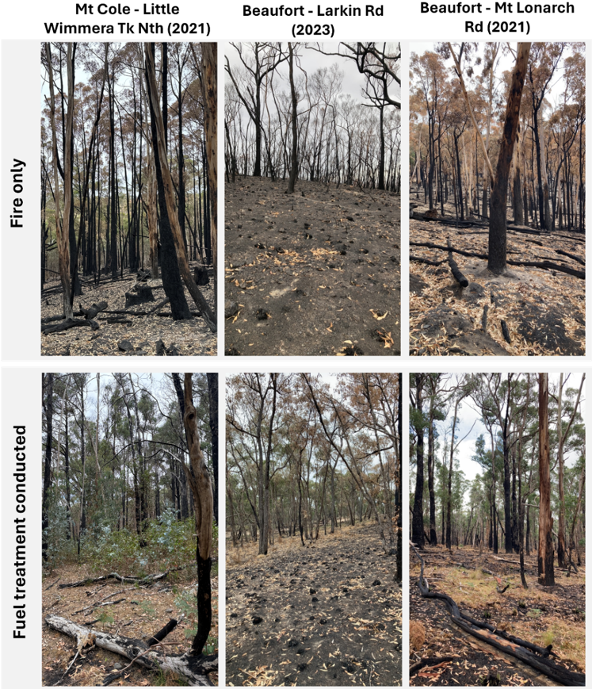

Mt Cole – Little Wimmera Track North
The fire impacted the Mt Cole – Little Wimmera Track North burn on 22 February at approximately 23:30hrs (Figure 5). This burn was completed in 2021, and FMS reports the coverage target of 50-70% was achieved and that fuel hazard was reduced from Extreme to Moderate or Low within the treated area. A headfire interacted with the southern edge of the burn at approximately 23:30hrs. Although the fire does penetrate the southern edge of the burn area, linescan imagery shows high intensity fire running more quickly around the sides of the burn, and lower intensity fire moving through the treated area (Figure 5). In subsequent days, low intensity fire continued to move through the burn block.
In addition to reducing fire rate of spread and intensity within the planned burn area, there also appears to be a ‘shadow’ effect of the burn in reducing fire intensity to the northeast of the treated area. This can be seen in Figure 5 (23 Feb 04:50hrs), where higher intensity fire activity (in red) to the north of the burn area continues to be an intense (bright red) fire front, whereas there is less fire activity detected on the linescan coming out of the fuel-treated area. This is an example of ‘leverage’ in a fuel-treated area, where the fuel treatment has had an impact outside of the original treated area.
Figure 5: Progression of the Bayindeen – Rocky Road fire as it impacted the Little Wimmera Trk North planned burn. The planned burn area is depicted in the grey polygon with the “2021” label, indicating the year it was last burnt. Fire intensity is depicted in the linescan data in red, and the images indicate reduced fire intensity near the planned burn, as well as on the northeastern leeward side. Images also indicate fire moved more slowly through the fuel-reduced area and was still active move than 36 hours after the front first impacted the planned burn.
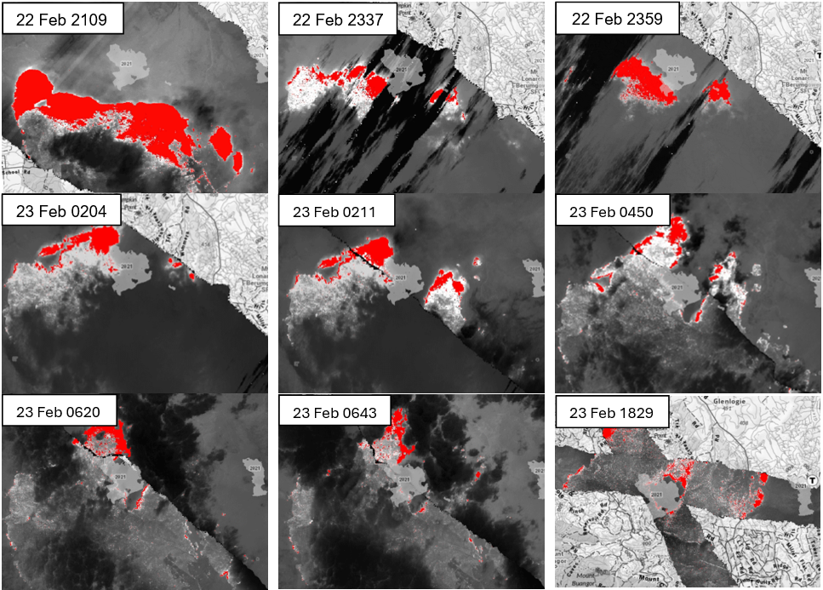

Beaufort – Larkin Road
The Beaufort – Larkin Road burn area was impacted by bushfire on 22 February at approximately 19:00hrs. The burn was completed over a series of 4 months, with the final block completed in March 2023. Overall, the burn achieved its coverage target of 70-90% and reduction of fuel hazard from Extreme to Moderate or Low in the treated areas as recorded in FMS.
A spotfire that grew and developed into an independent fire interacted with the southern edge of the Beaufort – Larkin Road burn. Analysis of the linescan imagery as well as on-ground observations highlight that the fire behaviour within the burn was reduced (Figure 6). Lower near-surface coverage and decreased bark hazard are likely to have been significant factors in lowering the rate of spread and flame heights when the fire crossed into the fuel-treated area. Linescan analysis, as well as conversations with operational personnel who were deployed to this area suggest that the location of this burn held the fire, while also providing an opportunity for heavy plant operators and ground crews to successfully track and establish a containment line on the northern edge of this fire.
Figure 6: Progression of the Bayindeen – Rocky Road fire as it impacted the Larkin Road planned burn.
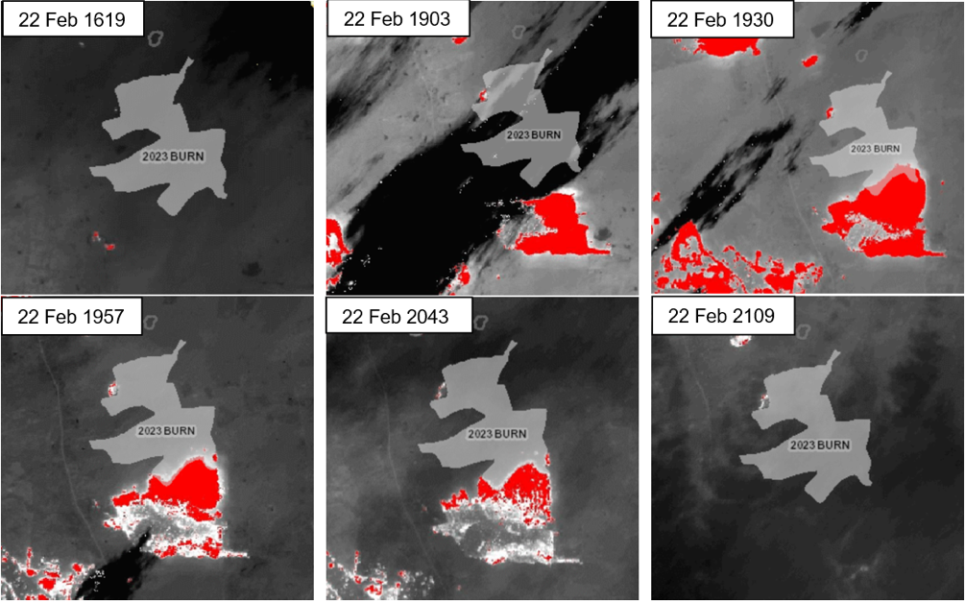

Beaufort – Mt Lonarch Road
The fire interacted with the Beaufort – Mt Lonarch Road planned burn on 25 February at approximately 00:50hrs. The burn was completed in 2021 and achieved its coverage target of 70-90% and reduction of fuel hazard from Extreme to Moderate or Low in the treated areas according to records in FMS.
The fire interacted with the burn over an approximately 24-hour period (Figure 7). First, a headfire impacted the northern edge of the burn at 00:50hrs on February 25. Linescan analysis suggests that the fire was fragmented by the burn with the majority of fire activity continuing on the western edge of the burn. At this time, the lower fuel height and reduced bark hazard appears to have moderated the fire behaviour (with lower flame heights and reduced rate of spread) with minimal fire activity detected by linescan in the planned burn area. Operational staff advised that crews were actively cooling the western edge of the burn area prior to falling back to asset protection, before the fire crossed Mt Lonarch Road. During the afternoon of February 25, the fire moved in a southerly direction along the western edge of the burn. A westerly wind change caused a run of fire around the southern edge of the burn and then across Mt Lonarch Road. A low intensity fire subsequently moved through the burn area.
Figure 7: Progression of the Bayindeen – Rocky Road fire as it impacted the Mt Lonarch planned burn. The planned burn is depicted in the light grey polygon with “2021 BURN” label.
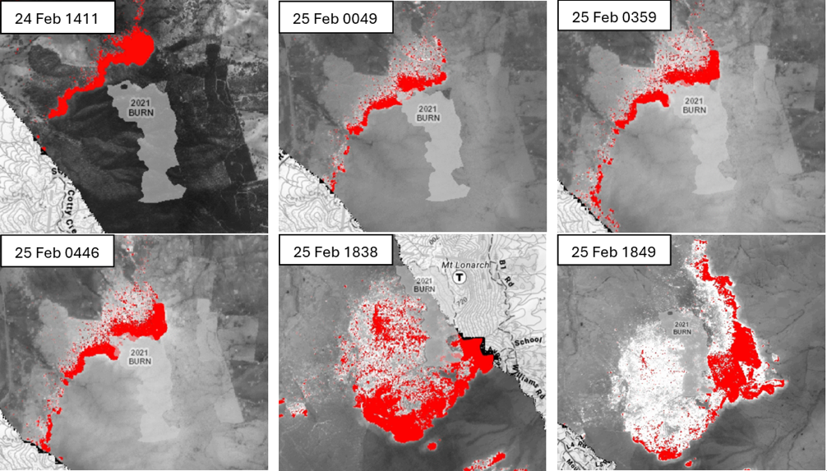

Fuel treatments and operational
decision-making
Conversations with field-based forest firefighters highlighted that areas with recent fuel treatments supported suppression by ground crew by providing strategic locations to anchor direct control activities to. In addition, the knowledge of fuel reduced areas, where tree hazard had already been assessed and treated (if necessary) during planned burn operations, aided faster and more effective suppression. These anecdotal reports from operational fire suppres-sion were not the focus of our study, however, they offer a valuable perspective on fuel treat-ment effectiveness that is not often captured in typical research approaches.
Direct control strategies where fire fighters worked close to the fire front were successfully implemented when the fire interacted with the Beaufort - Larkin Road treatment. As fire be-haviour subsided upon the fire interacting with the burn area, this enabled heavy plant operators and crews to successfully track and establish a containment line on the northern edge of the fire. Similarly, when the fire first interacted with the Beaufort – Mt Lonarch fuel treatment as a flanking fire, crews were able to safely work along Mt Lonarch Road actively cooling the western edge of the track, delaying the fire crossing the road for several hours. In both cases, safe and efficient crew access was facilitated by prior hazard tree assessment and treatment, and a well-maintained road network—both critical components of fuel treatment planning.
Whilst this fire did not result in the implementation of indirect suppression options (e.g. back burning), indirect suppression has successfully been implemented in many other fires including those in the 2023–24 fire season. For example, at the MIDLANDS 99 – STAFFORDSHIRE REEF – STAFFORDSHIRE REEF ROAD fire, backburning was completed along a section of a planned burn that had been prepared for scheduled treatment later in the season. The operation effectively reduced the size and impact of the fire.
Research indicates that fuel treatment offers associated benefits beyond direct impacts on fire behaviour (Dickson-Hoyle et al., 2021). In discussing the area with local fire management personnel, it was clear that the process of preparing, executing and delivering burns enhanced crew familiarity with the landscape, improving their understanding of potential control line op-tions and fire behaviour within specific vegetation types. Conducting fuel treatment:
- allows real-time testing of equipment
- promotes familiarisation with local weather effects, personnel and equipment
- provides opportunities for skills development, training accreditation and knowledge sharing
- supports improvements to practices
- generates social capital with crews and communities.
These benefits can have strong effects on readiness, response and recovery operations.

Fire effects
Plot level observations were captured at 17 plots. Whilst this number of plots provided an initial insight into the effects of fuel treatments on the fire effects, more sites would need to be sampled to make statistically significant conclusions. Furthermore, due to safety considerations from tree hazard, plots were generally within 100 m of roads. Nevertheless, these interface areas are the first impacted by bushfire and play a key role in influencing fire behaviour and providing strategic suppression operations.

Fire severity
Field data collected highlighted that recent fuel treatment areas had overall lower fire severity compared to plots that had not had a planned burn treatment recently (Figure 8-10). For example, fire severity data captured in the field at the Mt Cole – Little Wimmera Track North burn and Beaufort – Mt Lonarch Road burn support satellite assessments that the fire severity was lower in these burn areas with lower char height and canopy scorch than in areas that were subject to bushfire but had not been subject to recent fuel treatment (Appendix Table 1). Furthermore, field captured post-fire severity analysis at the Beaufort – Mt Lonarch Road burn highlights that recently fuel-treated areas had lower canopy scorch or understorey burn in comparison to the areas directly adjacent which had not been treated. Unburnt or low-severity patches of vegetation are known to provide refugia for flora and fauna survival and recovery (Robinson et al., 2013), suggesting fuel treatment may provide longer-term benefits beyond assisting fire suppression. Across all plots, char height was observed to be lower in plots that had been recently fuel treated. Char height in areas that had not been subject to recent fuel treatments was also observed to be more variable than in recently fuel-treated plots.
Figure 8: Post-fire severity mapping of the Bayindeen – Rocky Road fire. Recent fuel-treated areas are outlined in black. The darker purple colours in the recently fuel-treated areas suggest these areas burned at lower severity during the fire.
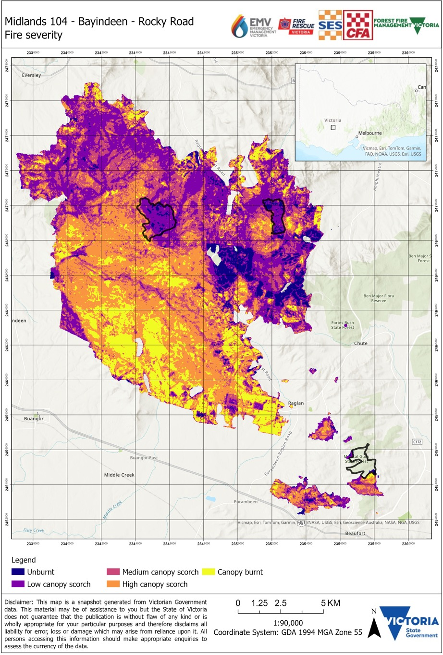
Figure 9: Post-fire severity mapping of 3 recently-treated areas within the Bayindeen – Rocky Road fire. The recent fuel-treated areas include: a) Mt Cole Little Wimmera Track North burn, b) Beaufort – Larkin Road burn and (c) Beaufort – Mt Lonarch Road burn. The boundary of the fuel treatments are outlined in black.
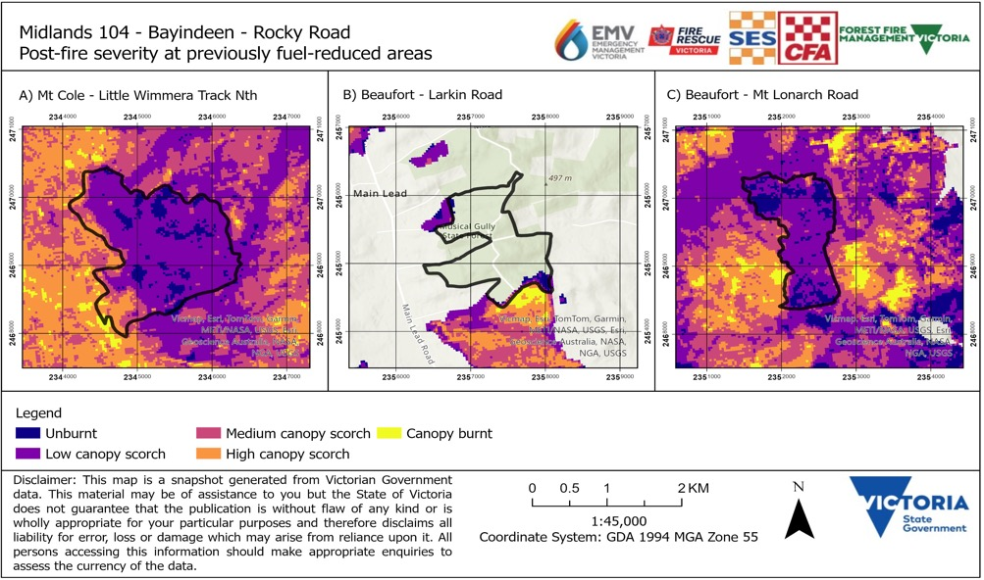

Fuel structure
Across all fuel strata and vegetation types assessed here, post-fire cover and height were typically greater in areas that had recent fuel treatment prior to being impacted by the fire. Key findings are outlined below in bold, more detailed information is provided below each key point.
- Near-surface fuel height and cover were higher in fuel-treated plots than those areas that were only impacted by bushfire
Based on visual assessments, average near-surface fuel height was greater in areas that were previously fuel treated than areas that were only subject to the bushfire (Appendix Table 2, Figure 10C). Similarly, near-surface cover was higher in areas that had been recently treated (Appendix Table 2, Figure 10D). Additional measures captured included grass and shrub height – which showed a similar relationship to near-surface fuel height (Figure 11). Adding these measures enabled identification of the proportion of grasses and shrubs at each plot. Generally, plots which had recently been fuel treated had a mixture of low grasses (approximately 0.1m) with woody shrubs over the top (approximately 0.8m). Only one plot (located in a recently treated planned burn area) had non-woody shrubs present.
Figure 10: Box plots showing the distribution of values captured at plots which were only burnt by the bushfire and plots which had also been treated with planned burning.
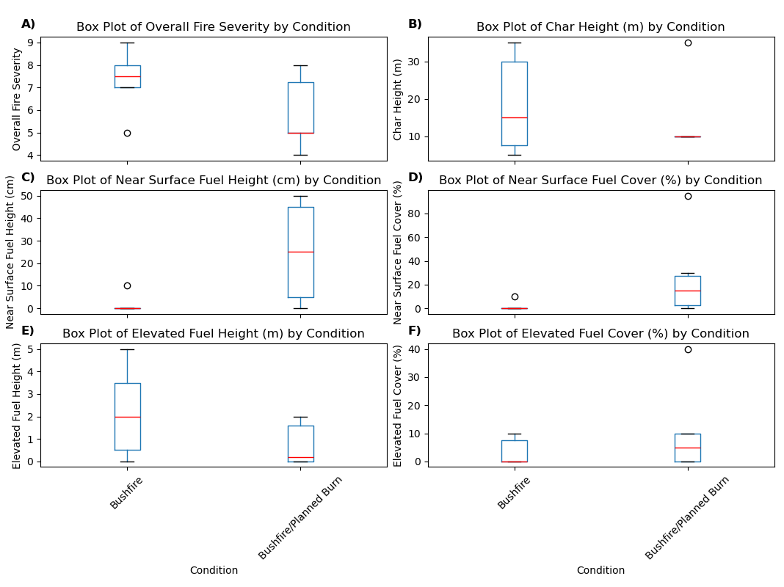
- Elevated cover and height were higher in fuel-treated plots than those areas that were only impacted bushfire
Due to the limited number of sites which had elevated or woody sapling fuel present, only limited conclusions can be drawn. Nevertheless, visual assessments of elevated fuel cover were higher in plots that had recently been fuel treated, however the difference was small (<5%) (Appendix Table 2, Figure 10F). This was also reflected in the additional woody sapling data collected (Figure 11). In contrast, elevated fuel height was higher in plots that had been subject to bushfire only (Figure 10E). Woody sapling height, however, was marginally higher in plots with recent fuel treatment compared to those which were burnt by bushfire only. These opposing outcomes could be related to the relatively small sample size, recent fuel treatments removing vegetation in the elevated fuel strata (particularly on the edge of tracks close to ignition), or variability in the assessment of these fuel strata by assessors, with some fuel being included in the near-surface or canopy layers. Future assessments should increase the number of plots assessed and integrate pre- and post- planned burn monitoring data to understand whether these impacts are from the planned burn or bushfire event.
- Temporal monitoring required to understand leaf fall interactions with surface and canopy fuels
Surface fuel results were excluded from this report due to the presence of leaf fall following fire confounding results. Surface fuel measurements are recommended to be taken as part of long-term monitoring. In addition, despite the canopy scorch varying between sites and treatment history, canopy cover averages were similar between areas that been burnt only by bushfire and those areas which had also been treated with recent planned burning. The research team believe this is due to the limited number of sites able to be assessed in the time available, and that due to safety concerns, these sites had to be located close to the road which may have introduced variability related to edge effects. For future work, increasing the number of replicates per site would help to address some of these limitations.
- Extra fuel descriptions improved clarity of fuel observations
Additional fuel descriptors were captured by the field team to test options to improve fuel assessment protocols in the future. These extra observations included descriptors for grass and shrub, woody saplings and overall connectivity. The field team commented that these metrics were easier to characterise in the context of not needing to decide which strata (near-surface, elevated) vegetation appeared in; instead, users only needed to identify basic functional types and determine the relevant cover, height and distribution metrics. These descriptions may aid in providing a more nuanced description of fuel recovery over time. Furthermore, these metrics describe may feed into future fire behaviour models that require these descriptions.
Figure 11: Box plots showing the distribution of values captured at plots which were burnt by bushfire and plots which had also been recently treated with planned burning. The shrub, grass, and woody sapling functional types were collected in addition to fuel hazard assessments to more fully understand the impact of recent fuel treatments.
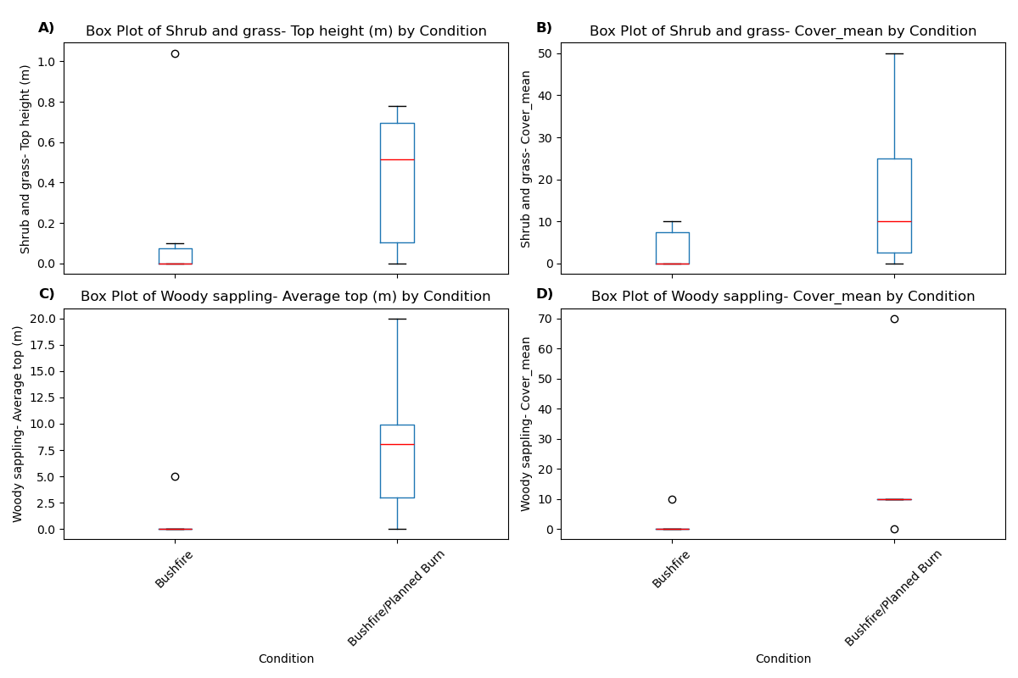

Terrestrial Laser Scanning (TLS)
A TLS was used at each plot to capture a 3D representation of the environment, example data are provided in Figures 12 and 13. Previous studies have demonstrated the utility of point clouds captured using TLS in describing the fuel complex in SE Australian forests (Spits et al., 2017, Hillman et al. 2021, Wallace et al. 2022). TLS data provides an objective and detailed way to describe the environment, key findings are reported below.
- TLS measurements support trends identified in visual assessment data.
As observed in the visual assessments, co-located TLS measurements highlighted the presence of higher near-surface and elevated cover and height in previously fuel-treated areas compared to areas only impacted by bushfire.
At the Mt Cole – Little Wimmera planned burn, TLS-derived measurements of near surface cover and height were higher in previously treated areas (35.6% and 0.24m) compared to areas only impacted by the bushfire (21% and 0.12m). A similar pattern is observed in the elevated strata where previously treated areas were measured to have higher elevated cover (31.2%), compared to an adjacent bushfire only plot (2.3%) (Figure 13). When compared to visual assessments, the cover assessments derived from TLS for this site are higher. This is likely due to the inclusion of rocks and other surface debris being included in the TLS assessments with future refinement of the algorithm required to classify these objects.
Differences in understorey structural metrics derived from TLS captured inside the Beaufort – Mt Lonarch planned burn and in the adjacent fire only area were not as substantial as the other burns. Results suggest that whilst elevated cover and height was marginally higher in the previously treated site compared to the adjacent fire only site (5.2% and 1.0m compared to 2.1% and 0.5 m), near-surface cover was observed to marginally increase between the planned burn and bushfire site (14.4% to 16.6%). This increase in near-surface coverage does not reflect ground observations (Figure 4) or raw point cloud interpretation. We predict that the higher near-surface coverage is a result of scanner characteristics (not being able to penetrate through dense grass and shrub layers) and misclassification of a) bracken into the elevated fuel layer and b) incorporation of grasses and close to ground shrubs into the ground algorithm resulting in a lower near-surface cover than what was observed visually. These issues may be resolved through an increased number of scans and adjustments to the classification algorithm.
Figure 12: Comparison of TLS scans captured at the Beaufort - Larkin Road planned burn showing the greater canopy cover in areas that were previously fuel treated compared to those that had only been impacted by fire.
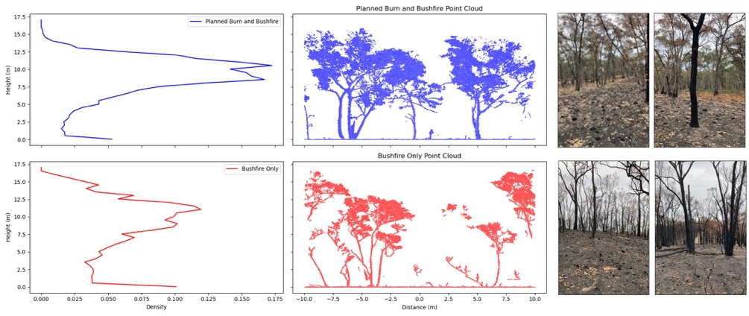
Figure 13: Comparison of TLS scans captured at the Mt Cole – Little Wimmera Track planned burn showing the greater understorey vegetation below the canopy in areas that were previously fuel treated despite a lower canopy cover.
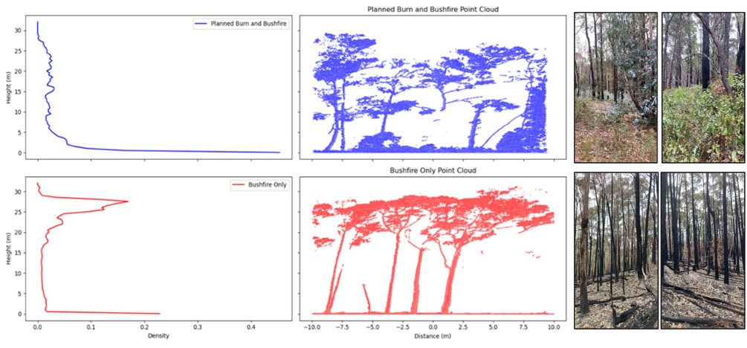
- Moderate to high correlation was observed between visual observations and TLS-derived metrics.
Overall, moderate to high correlation was observed between TLS and visual observations. Near-surface fuel cover derived from visual assessments and TLS assessments had moderate correlation (R2 = 0.58) whilst higher correlation was observed between the grass and shrub cover estimates (R2 = 0.71). Averaged across all plots, TLS-derived measurements of cover were generally lower than visually estimated cover assessments of near-surface (mean bias error (MBE) - 4.89%) and grasses and shrubs (MBE -1.65%). This is in contrast with prior research where TLS-derived measurements of near-surface cover were generally higher than those observed visually (Wallace et al. 2022). Near-surface height estimates derived from visual and TLS-derived estimates were strongly correlated (R2 = 0.71) and were observed to slightly under-predict (MBE = 0.01m) visual estimates which is consistent with prior studies. High correlation between elevated and woody sapling cover TLS-derived and visual assessments was observed (R2 = 0.81 – 0.84) with height being poorly correlated (R2 = 0.13).
Underprediction of cover in this study might be due to assessor decisions on the delineation between surface, near-surface and elevated fuel layers not being reflected in TLS processing heights (which are fixed) as well as TLS scan set-up (using a single scan approach which may be impacted by occlusion). Poor correlation in height estimates is predicted to be due to misclassification errors where lower branches of trees were assigned to the elevated fuel layer. This phenomenon is most likely an artefact of a single scan approach and could potentially be reduced with multiple scans being taken across a site. Further work should continue the validation of TLS-derived estimates with intensive ground survey work.
Nevertheless, these results are promising given that TLS provides a more consistent and robust approach to measuring vegetation structural characteristics. These approaches would benefit from research aiming to enhance classification algorithms.
- TLS data presents numerous advantages (objective, repeatable and precise) over visual assessments.
TLS data presents a number of advantages over traditional visual assessments. Firstly, point clouds captured using 3D remote sensing can be reanalysed into the future providing an opportunity to refine the processing and calculate new metrics. Secondly, due to the objective way in which the data is collected, long-term monitoring can be completed in a robust way that limits bias between assessors. Lastly, new metrics that describe the fuel complex in novel ways can be extracted, for example metrics describing the 3D connectivity of fuel that are important to fire behaviour and are aimed to be reduced through prescribed burning are actively being developed. Victoria is at the forefront of utilising this technology operationally.
- Cutting edge technology requires parallel investment in research to fully understand the capabilities and limitations.
While there are several advantages of using TLS, there are known caveats that influence the results and areas of ongoing research. Firstly, surface fuel (fuel laying horizontally on the ground) appears very similar to the ground itself within 3D point-cloud space and as such may result in over or under estimation (depending on the environment) of combined near-surface/surface cover and height. Secondly, the classification metrics utilised in this report are not able to separate fine and coarse fuel which may contribute to an over-estimation of cover and height in some plots. Lastly, processing of these point clouds requires specialist knowledge and can be time consuming. This limitation is actively being addressed with the development of the Point Cloud Processing Hub for Victorian fire agencies. This hub will enable automatic processing of point clouds to derive cover and height estimates.

Fuel moisture content (FMC)
Detailed FMC data were not captured at each field site. However, in the lead up and first few hours of the fire the Forest Fire Management Victoria (FFMVic) Automatic Fuel Moisture (AFM) station was transmitting FMC data that provides some context for conditions when the treated areas were impacted by fire. The efficacy of a fuel reduced area in passively limiting fire spread is relative to fire weather conditions on the day, the drier the conditions the less effective fuel reduced areas are expected to be at limiting fire spread.
A FFMVic AFM site was located within the fire footprint, approximately 5.5km to the NE of the ignition point. The AFM site was 1.3km km to the east of the Little Wimmera Track burn, 8.7 km to the east of the Mt Lonarch burn, and 19.4 km to the NE of the Larkin Road burn. The distance between the station and burns, topographical complexity, and that the stations are not calibrated, means that only FMC trends, and not actual values, should be interpreted from the figures below.
A general drying trend was observed for surface and sub-surface fuels in the week leading up to ignition (Figure 14). Although the station is not calibrated to local FMC conditions, the general trend in FMC is informative, particularly the dry overnight conditions and large drop in FMC on the morning of 22 February. The fire ignited at approximately 10:30 AEDT (dashed line in Figure 15) and the site went offline at 22:00 AEDT, assumed to be when fire impacted the AFM station. These data suggest that even under very dry FMC conditions, the recent fuel-treated areas had a positive impact on limiting fire rate of spread and intensity.
Figure 14: Summary of long-term (Jan 2024 to the day of fire) fuel moisture data at the Beaufort AFM station. The dashed line is the time of fire ignition. Surface dead fuel moisture content (FMC) is depicted in blue and sub-surface FMC in red.
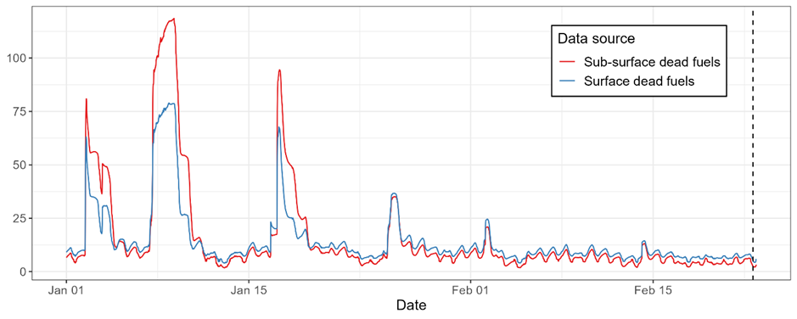
The temperature, relative humidity, wind sensors and rain gauge at the AFM station were not working, thus these data are unavailable. Soil moisture data (not presented here) shows similar trends to FMC. Solar radiation recorded consistent daily patterns leading up to the fire. Total radiation on 22 February was low compared to other days, potentially due to shading from the convection column during the day resulting in lower overall radiation inputs.
Figure 15: Summary of FMC data from the Beaufort AFM station. Surface (blue) and sub-surface (red) FMC from 2 AFM sticks located inside the fire footprint. The plots show FMCs in the week prior to the fire (a) and in the immediate lead up (b). The dashed line is the approximate time the fire was reported. Note, AFM sites are not calibrated to local conditions, so interpreting trends rather than absolute values is recommended.
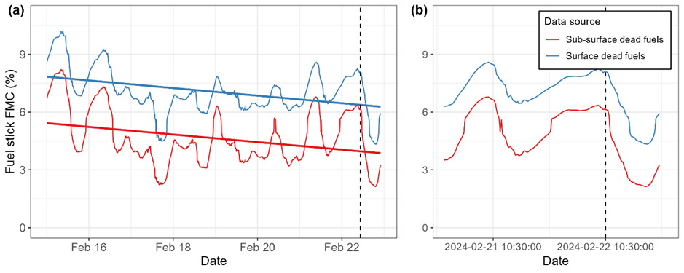

Conclusions and future work
The MIDLANDS 104 – BAYINDEEN – ROCKY ROAD was reported at 10:24 AEDT on 22 February 2024. Over the next 2 days, the fire spread through 3 areas that had recent (< 5 years) planned burn treatments. This pilot study was conducted to investigate fire interactions with recent fuel treatments. The study also explored the use of novel 3D remote sensing products to understand fuel structure. The key findings of this study are:
- All 3 recent fuel treatments appeared to slow or halt the spread of the fire. In the case of 2 planned burns, the fire still burned through recently fuel-treated areas; however, this occurred after the main fire front had passed and from linescan analysis appeared to be at lower intensity.
- Where the fire passed through an area that had been previously burnt, generally lower fire severi-ty was observed in comparison to areas that had not been previously treated.
- Areas where fuels were recently treated provided tactical opportunities for operational staff to undertake active fire suppression due to a reduced amount of fuel, overall lower fuel heights and the knowledge that potentially hazardous trees had been assessed and treated.
The length of time that fuel-reduced areas may moderate fire behaviour varies depending on fuel type, fire severity and climate conditions. In the recent burns assessed here, a reduction in fire rate of spread and intensity and post-fire severity was observed. Future research and monitoring programs should continue to study fuel treatment and fire interactions across Victoria’s diverse vegetation types to understand variability across space and time, as well as increasing the documented evidence base and circumstances where fuel treatments support effective fire suppression.

Appendix

TLS processing
The scanner utilises a phase-shift method of range measurement. This system uses an emitted laser pulse, however with phase-based systems, the range is determined by the phase difference between the sent and received waveforms. Scan data were captured using a FARO M70 using settings of ½ of full capture scanned 2x with 3.1 mm point resolution at 10 m, for an average scan time of 7 minutes and 40 seconds. Due to time and safety constraints, a single scan approach consistent with Pokswinski et al. (2021) was undertaken.
Point cloud processing and analysis was completed using Python code that was developed in-house specifically for TLS point cloud processing. The following steps were undertaken:
To provide a discrete representation of the environment, point clouds were translated into 3D voxels. A voxel model for these purposes is a 3D grid domain, with the size of the grid cells determining the resolution of the 3D grid. In this case, all point clouds were transformed into 2 cm resolution voxel spaces (with each voxel having a volume of 8 cm3). This was complet-ed by attributing each point to a voxel and considering any voxels containing at least one point to be filled. Spurious points not emanating from actual vegetation were removed using a noise filter as outlined in Rusu et al. (2008) and implemented in Wallace et al. (2022). Fol-lowing the removal of these points, a cloth simulation filter was applied to determine which voxels originated from the ground (Serifoglu Yilmaz et al., 2018). Settings for this filter were as per Wallace et al. (2022).
To replicate the strata based observations used in the OFHAG, the layer pouring algorithm pre-sented in Hillman et al. (2019) was used. This approach aims to define objects within voxel space based on vertical connectivity. Vertical voxel layers are traversed from the top down. In each layer, all horizontally connected voxels are considered a segment. If this segment overlaps (horizontally) with a segment from the above layer, they are considered as being from the same object. To avoid a reliance on the complete 3D representation of the environ-ment, the voxel space is diluted using a sphere-shaped structuring element with a diameter of 3 voxels.
Whilst not explicitly defined within the guide, height thresholds consistent with fuel studies in eucalypt forests were applied to separate strata. This created 3 classes which capture the surface and near-surface combined fuel layer (<0.60 m), elevated (0.60 – 3 m) and canopy (>5 m) fuel layers [6,7]. As the separation of the objects from the surface strata and the ground remains difficult to achieve within TLS, we provide an analysis for the derivation of a fuel layer which combines some elements of the surface (those adequately separated from the ground) with the fuel elements from the near-surface layer. Estimates of bark fuel were not considered, as no method currently exists to achieve the classification of bark fuel type from TLS data. Objects derived from the layer-pouring process were assigned to the layer based on the highest included voxel.
The primary metrics derived from the TLS point clouds were mean height and cover. Mean height was calculated on the top surface of each fuel layer. The top surface was determined as the highest point within each voxel column. Cover was determined as the number of voxel columns containing at least one voxel from each layer divided by the number of voxel columns containing any filled voxels (ground, fuel or noise).

Fire severity
Appendix Table 1: Fire severity results from 3 sites and 17 plots captured across the Bayindeen-Rocky Road fire footprint on 13 and 14 March 2024.
Site | Plot  number | Fire history | Vertical scorch  profile | Char height (m) | Canopy top height (m) | Canopy cover (%) | Overall fire severity
Beaufort – Larkins Rd | 1 | Bushfire | Whole Canopy | 15 | 15 | 0-20 | Canopy Burnt
 | 2 | Planned Burn/Bushfire | Whole Canopy | 10 | 20 | 40-60 | High canopy scorch with majority understorey burn
 | 3 | Planned Burn | None | 10 | 30 | 20-40 | Unburnt
 | 4 | Bushfire | Lower Canopy Only | 15 | 35 | 60-80 | Medium canopy scorch with majority understorey burn
 | 5 | Unburnt | None | 0 | 35 | 40-60 | Unburnt
 | 6 | Planned Burn | None | 3 | 35 | 40-60 | Unburnt
 | 7 | Planned Burn | None | 3 | 20 | 40-60 | Unburnt
 | 8 | Bushfire | Lower Canopy Only | 5 | 20 | 20-40 | Low canopy scorch with majority understorey burn
 | 9 | Unburnt | None | 25 | 20 | 40-60 | Unburnt
Beaufort – Mt Lonarch Rd | 10 | Planned Burn/Bushfire | None | 10 | 45 | 20-40 | Low canopy scorch with majority understorey burn
 | 11 | Planned Burn/Bushfire | None | 10 | 35 | 20-40 | Low canopy scorch with majority understorey burn
 | 12 | Planned Burn/Bushfire | None | 10 | 30 | 40-60 | Low canopy scorch with majority understorey burn
 | 13 | Bushfire | Whole Canopy | 5 | 35 | 40-60 | High canopy scorch with majority understorey burn
Mt Cole – Little Wimmera Tk | 14 | Planned Burn/Bushfire | None | 10 | 35 | 0-20 | Low canopy scorch with minority understorey burn
 | 15 | Bushfire | Lower Canopy Only | 35 | 35 | 40-60 | Medium canopy scorch with majority understorey burn
 | 16 | Bushfire | Whole Canopy | 35 | 35 | 20-40 | High canopy scorch with majority understorey burn
 | 17 | Planned Burn/Bushfire | Whole Canopy | 35 | 35 | 40-60 | High canopy scorch with majority understorey burn

Fuel structure
Appendix Table 2: Fuel hazard assessment results at each plot with in the 3 sites assessed from 3 sites and 17 plots captured across the Bayindeen-Rocky Road fire footprint on 13 and 14 March 2024.
Site | Plot  number | Fire history | Surface  fuel  cover (%) | Surface  fuel depth  (mm) | Surface  fuel  hazard | Near  surface  fuel  burnt  area (%) | Near  surface  fuel  cover (%)  (visual) | Near  surface  fuel  cover (%) (TLS) | Near  surface  fuel  cover  (cm)  (visual) | Near  surface fuel height (cm)  (TLS) | Near  surface  fuel  hazard | Elevated fuel fuel cover  (%)  (visual) | Elevated fuel fuel cover  (%)  (TLS) | Elevated  fuel fuel height (m)  (visual) | Elevated  fuel fuel height  (m)  (TLS) | Elevated  fuel  hazard | Canopy cover  (%)  (TLS) | Canopy cover  (m)  (TLS) | Bark  hazard | Overall  fuel  hazard
Beaufort –  Larkins Rd | 1 | Bushfire | 0 | 0 | Low | 100 | 0 | 1 | 0 | 14 | Low | 0 | 2 | 0 | 1.5 | Low | 29 | 14.7 | Moderate | Low
 | 2 | Planned Burn/Bushfire | 10 | 5 | Low | 100 | 0 | 2 | 0 | 15 | Low | 0 | 1 | 0 | 1.5 | Low | 50 | 12.7 | Moderate | Low
 | 3 | Planned Burn | 50 | 4 | Low | 0 | 65 | 40 | 50 | 22 | Very High | 0 | 7 | 0 | 0.9 | Low | 41 | 15.2 | Moderate | Moderate
 | 4 | Bushfire | 50 | 3 | Low | 100 | 0 | 2 | 0 | 14 | Low | 0 | 0 | 2 | 1.1 | Low | 56 | 17.6 | Moderate | Low
 | 5 | Unburnt | 90 | 25 | High | 0 | 65 | 40 | 20 | 14 | High | 10 | 4 | 1 | 1.2 | Moderate | 60 | 15.2 | Extreme | Extreme
 | 6 | Planned Burn | 50 | 6 | Moderate | 0 | 60 | 39 | 30 | 25 | High | 0 | 6 | 0 | 0.7 | Low | 71 | 18.0 | Moderate | Moderate
 | 7 | Planned Burn | 65 | 8 | Moderate | 0 | 20 | 26 | 20 | 17 | High | 10 | 4 | 1 | 1.0 | Low | 54 | 12.9 | Very High | Very High
 | 8 | Bushfire | 50 | 5 | Low | 90 | 10 | 7 | 10 | 16 | Low | 10 | 8 | 2 | 1.5 | Low | 56 | 14.6 | High | Low
 | 9 | Unburnt | 100 | 38 | High | 0 | 50 | 36 | 30 | 15 | Very High | 20 | 6 | 2 | 1.1 | High | 69 | 14.8 | Extreme | Extreme
Beaufort –  Mt Lonarch Rd | 10 | Planned Burn/Bushfire | 50 | 18 | Moderate | 70 | 20 | 14 | 50 | 18 | Low | 0 | 5 | 0 | 1.0 | Low | 60 | 20.0 | Moderate | Moderate
 | 11 | Planned Burn/Bushfire | 60 | 6 | Low | 90 | 10 | 9 | 30 | 15 | Low | 10 | 2 | 2 | 0.9 | Low | 49 | 23.8 | Moderate | Low
 | 12 | Planned Burn/Bushfire | 40 | 8 | Low | 0 | 95 | 12 | 20 | 19 | Low | 10 | 3 | 0.4 | 1.2 | Low | 63 | 26.3 | Moderate | Low
 | 13 | Bushfire | 40 | 11 | Low | 100 | 0 | 17 | 0 | 12 | Low | 0 | 2 | 0 | 0.5 | Low | 58 | 25.7 | Moderate | Low
Mt Cole –  Little Wimmera Tk | 14 | Planned Burn/Bushfire | 80 | 7 | Moderate | 20 | 30 | 36 | 50 | 25 | High | 40 | 31 | 2 | 1.3 | High | 69 | 25.5 | Moderate | High
 | 15 | Bushfire | 40 | 5 | Low | 100 | 0 | 21 | 0 | 12 | Low | 10 | 2 | 5 | 1.4 | Low | 70 | 28.4 | Moderate | Low
 | 16 | Bushfire | 20 | 4 | Low | 100 | 0 | 25 | 0 | 19 | Low | 0 | 3 | 4 | 0.6 | Low | 68 | 30.7 | Moderate | Low
 | 17 | Planned Burn/Bushfire | 50 | 4 | Low | 100 | 0 | 15 | 0 | 14 | Low | 0 | 3 | 0 | 0.6 | Low | 57 | 25.5 | Moderate | Low

Appendix Table 3: Visual assessment of extra fuel characteristics
Site | Plot number | Fire history | Grass cover (%) | Grass height  (m) | Woody shrub cover (%) | Woody shrub top height  (m) | Woody sapling cover (%) | Woody sapling average top height  (m) | Canopy DBH (cm) | Canopy top height (m) | Canopy cover  (%)
Beaufort – Larkins Rd | 1 | Bushfire | 0 | NA | 0 | NA | 10 | 5 | 20.6 | 15 | 0-20
 | 2 | Planned Burn/Bushfire | 0 | NA | 0 | NA | 10 | 8 | 28.6 | 20 | 40-60
 | 3 | Planned Burn | 15 | 0.14 | 15 | 0.66 | 0 | 0 | 26.4 | 30 | 20-40
 | 4 | Bushfire | 10 | 0.1 | 0 | NA | 0 | 0 | 31.2 | 35 | 60-80
 | 5 | Unburnt | 50 | 0.34 | 10 | 0.67 | 15 | 3.5 | 32.6 | 35 | 40-60
 | 6 | Planned Burn | 10 | 0.16 | 50 | 0.98 | 15 | 4.5 | 29.6 | 35 | 40-60
 | 7 | Planned Burn | 30 | 0.24 | 10 | 0.96 | 10 | 2 | 23.2 | 20 | 40-60
 | 8 | Bushfire | 0 | NA | 15 | 1.04 | 0 | 0 | 24.2 | 20 | 20-40
 | 9 | Unburnt | 95 | 0.45 | 10 | 1.52 | 10 | 7.4 | 27.4 | 20 | 40-60
Beaufort – Mt Lonarch Rd | 10 | Planned Burn/Bushfire | 15 | 0.11 | 50 | 0.78 | 10 | 8.2 | 38.2 | 45 | 20-40
 | 11 | Planned Burn/Bushfire | 10 | 0.08 | 10 | 0.72 | 0 | 0 | 37 | 35 | 20-40
 | 12 | Planned Burn/Bushfire | 15 | 0.22 | 10 | 0.62 | 10 | 10.5 | 45 | 30 | 40-60
 | 13 | Bushfire | 0 | NA | 0 | NA | 0 | 0 | 39.4 | 35 | 40-60
Mt Cole – Little Wimmera Tk | 14 | Planned Burn/Bushfire | 35 | 0.23 | 10 | 0.41 | 50 | 1.34 | 28.8 | 35 | 0-20
 | 15 | Bushfire | 0 | NA | 0 | NA | 0 | 0 | 37.6 | 35 | 40-60
 | 16 | Bushfire | 0 | NA | 0 | NA | 0 | 0 | 33.2 | 35 | 20-40
 | 17 | Planned Burn/Bushfire | 0 | NA | 0 | NA | 10 | 20 | 26 | 35 | 40-60

Reference list
Collins, L., Trouvé, R., Baker, P.J., Cirulus, B., Nitschke, C.R., Nolan, R.H., Smith, L., Penman, T.D., 2023. Fuel reduction burning reduces wildfire severity during extreme fire events in south-eastern Australia. J. Environ. Manage. 343, 118171. https://doi.org/10.1016/j.jenvman.2023.118171
Dickson-Hoyle, S., Beilin, R., Reid, K., 2021. A culture of burning: Social-ecological memory, social learning and adaptation in Australian volunteer fire brigades. Soc. Nat. Resour. 34, 311–330.
Hillman, S., Wallace, L., Lucieer, A., Reinke, Jones, S., 2021. A comparison of terrestrial and UAS sensors for measuring fuel hazard in a dry sclerophyll forest. Int. J. Appl. Earth Obs. Geoinformation 95, 102261. https://doi.org/10.1016/j.jag.2020.102261
Hillman, S., Wallace, L., Reinke, K., Hally, Saldias, D.S., 2019. A method for validating the structural completeness of understory vegetation models captured with 3D remote sensing. Remote Sens. 11, 2118. https://doi.org/10.3390/rs11182118
Hines, F., Tolhurst, K.G., Wilson, A.A.G., McCarthy, G.J., 2010. Overall fuel hazard assessment guide, Department of Sustainability and Environment (Ed.), Research Report Series. Victorian Government, Department of Sustainability and Environment.
Pokswinski, S., Gallagher, M.R., Skowronski, N.S., Loudermilk, E.L., Hawley, C., Wallace, D., Everland, A., Wallace, J., Hiers, J.K., 2021. A simplified and affordable approach to forest monitoring using single terrestrial laser scans and transect sampling. MethodsX 8. https://doi.org/10.1016/j.mex.2021.101484
Robinson, N.M., Leonard, S.W., Ritchie, E.G., Bassett, M., Chia, E.K., Buckingham, S., Gibb, H., Bennett, A.F., Clarke, M.F., 2013. Refuges for fauna in fire‐prone landscapes: their ecological function and importance. J. Appl. Ecol. 50, 1321–1329.
Rusu, R.B., Marton, Z.C., Blodow, N., Dolha, M., Beetz, M., 2008. Towards 3D Point cloud based object maps for household environments 56, 927–941. https://doi.org/10.1016/j.robot.2008.08.005
Serifoglu Yilmaz, C., Yilmaz, V., Güngör, O., 2018. Investigating the performances of commercial and non-commercial software for ground filtering of UAV-based point clouds. Int. J. Remote Sens. 00, 1–27. https://doi.org/10.1080/01431161.2017.1420942
Smith, L., 2024. On Ground Fire Severity Assessment.
Spits, C., Wallace, L., Reinke, K., 2017. Investigating Surface and Near-Surface Bushfire Fuel Attributes: A Comparison between Visual Assessments and Image-Based Point Clouds. Sensors 17, 910. https://doi.org/10.3390/s17040910
Wallace, L., Hillman, S., Hally, B., Taneja, R., White, A., McGlade, J., 2022. Terrestrial Laser Scanning: An Operational Tool for Fuel Hazard Mapping? Fire 5. https://doi.org/10.3390/fire5040085
safertogether.vic.gov.au

Publication information

Acknowledgements
This report was made possible with the support of the MIDLANDS 104 – BAYINDEEN – ROCKY ROAD Incident Control Centre (ICC) and the Forest Fire Management Victoria Midlands District. The authors are grateful to Midlands District personnel, including but not limited to Alyshia Whitworth, Aaron Baker, Tony Venes and Aaron Faulkhead for providing operational and safety support during the research deployment, and for valuable discussions over the map table regarding suppression activities, planned burn information and local knowledge.
The authors are grateful to Trevor Howard (National Manager, Prescribed Burning Strategy) at the Australasian Fire and Emergency Service Authorities Council (AFAC) for review of this work.

Author
Samuel C Hillman (FFMVic), Amber Eutsler (CFA), Tegan P Brown (CFA & FFMVic), Peter Ashton (FFMVic)

Photo credits
Amber Eutsler (Cover)
Jacque Quaine (P4 and P22)
Sam Hillman (P7 and P18)

Acknowledgement of Victorian Traditional Owners
We acknowledge and respect Victorian Traditional Owners as the original custodians of Victoria’s land and waters, their unique ability to care for Country and deep spiritual connection to it.
We honour Elders past and present whose knowledge and wisdom has ensured the continuation of culture and traditional practices.
DEECA is committed to genuinely partnering with Victorian Traditional Owners and Victoria’s Aboriginal community to progress their aspirations.

Copyright
© The State of Victoria Department of Energy, Environment and Climate Action, November 2025.

Creative Commons
This work is licensed under a Creative Commons Attribution 4.0 International licence, visit the Creative Commons website (http://creativecommons.org/licenses/by/4.0/).
You are free to re-use the work under that licence, on the condition that you credit the State of Victoria as author. The licence does not apply to any images, photographs or branding, including the Victorian Coat of Arms, and the Victorian Government and Department logos.
ISBN 978-1-76176-626-8 (pdf/online/MS word)

Disclaimer
This publication may be of assistance to you but the State of Victoria and its employees do not guarantee that the publication is without flaw of any kind or is wholly appropriate for your particular purposes and therefore disclaims all liability for any error, loss or other consequence which may arise from you relying on any information in this publication.

Accessibility
To receive this document in an alternative format, phone the Customer Service Centre on 136 186, email customer.service@delwp.vic.gov.au, or contact National Relay Service on 133 677. Available at DEECA website (www.deeca.vic.gov.au).
End of document.

