FENCING FACTSHEET
BUSHFIRE RECOVERY INFORMATION
Information for private landholders impacted by bushfires

Fencing repair and replacement – National Parks, State Forest and State Park.
The “Repair of rural fencing and fire control line and stabilisation policy” enables the Victorian Government to pay half the cost of materials to repair or replace bushfire damaged fencing of agricultural land bordering national parks, State parks and State forests to its pre-existing standard.
Under the Fences Act 1968 the government is not liable for any maintenance, or contribution towards fences that adjoin crown land and private property. However, this policy, managed by Forest Fire Management Victoria (FFMVic) is designed to provide support to landholders.

What support is provided
Under this policy, half the costs of materials up to a maximum of $5000 per km is funded. Payment will consider the type of fence being replaced. This includes fences damaged by a backburn which are treated the same as damage by bushfire.
Labour costs are to be met by the landholder.
Where fences (boundary and internal) have been damaged by firefighters either by machinery or cutting of the fence to gain access, FFMVic will fully cover the cost of repairs or replacement of the damaged section of the fence to the pre-existing standard.
Landholders are ineligible for support if their fences are covered by insurance, and they chose to use it.

What is not covered under the policy
- Internal fences burnt by bushfire. Landholders are responsible for internal fences on private land.
- Repair or replacement of any assets, other than fencing or other fencing assets.
- Fences that were not functioning for their intended use before they were damaged.
- Damage to fences from floods, storms, debris flow and erosion.
- Replanting of trees, re-establishment of pasture, or any other agricultural crop.

How landholders can access the program
Landholders can access further information including the policy and contact details for FFMVic through the Department of Energy, Environment and Climate Action (DEECA) website - https://www.ffm.vic.gov.au/recovery-after-an-emergency/public-land-recovery
Alternatively, landholders can contact the Customer Contact Centre on ph. 136 186, Monday to Friday, 8am - 6pm.

Timelines
Landholders have 12 months to lodge a claim from when the damage occurred.

Conducting the works - FFMVic
FFMVic will send out a fencing assessor, when it is safe to do so, to explain the process, determine eligibility and assistance level.
Once parties formally agree through a signed funding deed, the claim is processed, and monies are paid to the landholder.
After an assessment has been conducted and the claim lodged with FFMVic, landowners can engage a fencing contractor of their choice or complete the work themselves.
Alternatively, where FFMVic have damaged the fence, FFMVic will arrange for the fence to be repaired.
However, landholders may choose to conduct these works themselves. This should be discussed at the time of the assessment.
If the landholder has not been visited by a fencing assessor, FFMVic may accept photos from landholders as evidence for damaged and/or burnt fences The information provided will need to be confirmed by a fencing assessor before the claim is finalised.

Specialised fences or steep/rocky terrain
Fences are replaced like-for-like. Some fence types or fences in locations such as on steep or rocky terrain, replacement may incur significant additional costs. These will be assessed on a case-by-case basis. FFMVic will discuss this with the landholder.


OFFICIAL

FENCING FACTSHEET
BUSHFIRE RECOVERY INFORMATION

Fences adjoining other government owned or managed land
This policy does not cover the repair and replacement of fences that adjoin other government owned or managed land, including land managed by local councils, Regional Roads Victoria, water authorities or VicTrack.
The Victorian Government may repair or replace damaged riparian fences (fences along waterways) if the fence was erected with government funds.

Disputes about fence lines
Where fence line positioning is disputed, FFMVic will use statewide fencing guidelines to determine fencing replacement arrangements with the landholder.

Will the government maintain the fence after it has been repaired or replaced?
No. The fence, once repaired or replaced, will remain an asset of the landholder and the Victorian Government will have no financial stake, on-going maintenance responsibility or liability for it.

Fires that start on private land
In the event of bushfires that start on private land that are under the control of the Country Fire Authority (CFA) or Fire Rescue Victoria (FRV), the control agency will provide limited assistance to repair fences damaged by machinery or firefighters.
The landholder will need to contact their local CFA/FRV District Headquarters to report damage to their fences.

Hazardous trees removal
FFMVic is not responsible for clearing hazardous trees on fence lines after a bushfire unless there is a special determination from the Victorian government.
This is no different to a tree falling or a branch dropping on a fence that hasn’t been burnt. The landholder will need to adhere to the “Clearing along a fenceline rule” which can be found at https://www.planning.vic.gov.au/guides-and-resources/guides/all-guides/bushfire-controls/vegetation-removal.
However, landholders can approach FFMVic who may be able to assist with the removal of hazardous trees along a fence bordering national parks, State parks and State forests that needs to be either repaired or replaced after a bushfire.

Blaze Aid
BlazeAid is a volunteer organisation providing assistance with clearing, repairing or re-establishing fencing. FFMVic will still fund half the cost of materials even if labour is provided by volunteer organisations. Visit blazeaid.com.au for information on how to access this assistance.
For other recovery support that may be available, refer to Vic Emergency for further information:https://emergency.vic.gov.au/relief/#gener al_information

Stabilisation of fire control lines constructed by fire agencies during a bushfire
In the event of bushfires that start on public land, FFMVic will assist private landholders with the stabilisation of fire control lines, established by fire agencies, during the suppression of bushfires.
Fire control line stabilisation involves pushing back topsoil and undertaking erosion control measures to protect the land from soil erosion and protect water quality but excludes reseeding or replacing crops.

Examples of different scenarios where this policy may be applied
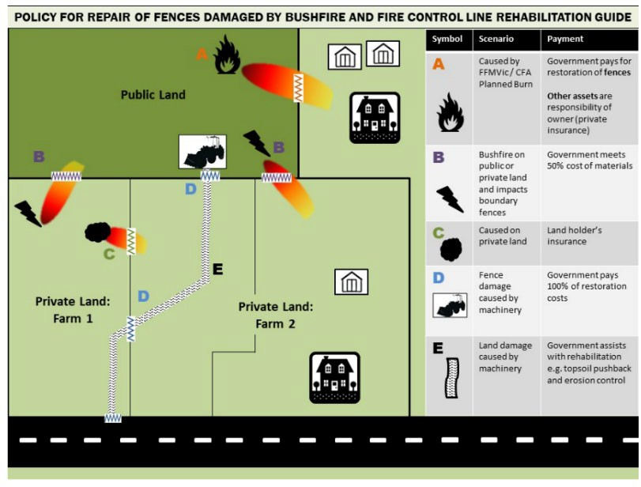

ffm.vic.gov.au August 2024

